

Owner’s Manual

EchoTable®

Owner \_\_\_\_\_\_\_\_\_\_\_\_\_\_\_\_\_\_\_\_\_

Model \_\_\_\_\_\_\_\_\_\_\_\_\_\_\_\_\_\_\_\_\_

Serial # \_\_\_\_\_\_\_\_\_\_\_\_\_\_\_\_\_\_\_\_\_

Date \_\_\_\_\_\_\_\_\_\_\_\_\_\_\_\_\_\_\_\_\_

Medical Positioning, Inc.

1146 Booth Street, Kansas City, Kansas 66103 | T: 816-474-1555 | 1-800-593-3246

[www.MedicalPositioning.com](http://www.MedicalPositioning.com)

Table of Contents

[Table of Contents 2](#_Toc2104298)

[Symbols and Definitions 4](#_Toc2104299)

[European Union Representative 5](#_Toc2104300)

[Precautions 6](#_Toc2104301)

[Intended Use 9](#_Toc2104302)

[Set Up 10](#_Toc2104303)

[Safety Features 11](#_Toc2104304)

[Operation 12](#_Toc2104305)

[Hand-Wand 13](#_Toc2104306)

[Individual Locking Casters 16](#_Toc2104307)

[Single Pedal Brake (Option) 17](#_Toc2104308)

[Drop Sections 18](#_Toc2104309)

[2-Way Back Rest 20](#_Toc2104310)

[Non-Pinch Closure 20](#_Toc2104311)

[Patient Positioning Procedure 22](#_Toc2104312)

[Sonographer Positioning 23](#_Toc2104313)

[Accessories 24](#_Toc2104314)

[Safety Rails 24](#_Toc2104315)

[Sonographer’s Extension 26](#_Toc2104316)

[Patient Positioning Safe-T-Wedges™ 27](#_Toc2104317)

[Paper Roll Holder 27](#_Toc2104318)

[IV Pole Holder 28](#_Toc2104319)

[Pediatric/Geriatric Adaptor 29](#_Toc2104320)

[Preventative Maintenance 30](#_Toc2104321)

[Remote Release Mechanism Adjustment 31](#_Toc2104322)

[Cleaning 33](#_Toc2104323)

[Troubleshooting Guide 35](#_Toc2104324)

[EchoTable® Parts List 37](#_Toc2104325)

[Specifications and Warranty 39](#_Toc2104326)

[Specifications 39](#_Toc2104327)

[Warranty 41](#_Toc2104328)

**MEDICAL POSITIONING, INC**

1146 Booth Street

Kansas City, KS 66103

**EchoTable®**

|  |  |
| --- | --- |
| **Attribute** | **Rating** |
| Voltage | 120 VAC |
| Amperage | 2.6 Amps |
| Cycle | 50/60 Hz |
| Duty Cycle | 10%, 1 min. on/9 min. off |
| Leakage Current | < 100 µA |
| Maximum Distributed Load | 500 lbs. |

**UL 60601-1 CLASSIFICATIONS:**

* Class 1 Equipment
* Type B Applied Part
* Degree of Protection Against Ingress of Water / IPXO
* Equipment Not Suitable for Use in Flammable Anesthetic Mixture

All electrical circuitry is isolated from chassis.

Grounding reliability can only be achieved when the equipment is connected to an equivalent receptacle marked “Hospital Only” or “Hospital Grade”

The power cord is to be used for mains disconnection.

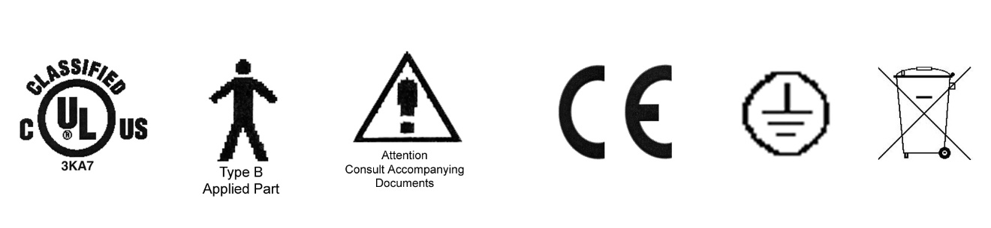

MEDICAL EQUIPMENT WITH RESPECT TO ELECTRICAL SHOCK, FIRE AND MECHANICAL HAZARDS ONLY IN ACCORDANCE WITH UL 60601-1 AND CAN/CSA C22.2 NO. 601.1

Transportation and storage:

Temperature range within -40 to 70 C

Relative humidity range within 10% to 100%

Atmospheric pressure range within 500 to 1080 hPa

Symbols and Definitions

|  |  |
| --- | --- |
| Blue circle with white figure holding book | Warning, follow instructions for use. Failure to comply may result in injury. |
| Red circle with line through it with black figure in background | Warning, stepping is prohibited. Failure to comply may result in injury. |
| TypeB  Type B Applied Part | Applied Part complying with specified requirements for protection against electric shock. Type B Applied Parts are those parts, which are usually Earth referenced. Type B are those parts not suitable for direct cardiac application |
| Attention  Attention | Attention, consult accompanying documents |
| earth  Protective Earth | Any terminal which is intended for connection to an external protective conductor for protection against electric shock in case of a fault |
| weee_symbol | This device contains materials that are potentially hazardous to the environment. In accordance with the DIRECTIVE 2002/96/EC OF THE EUROPEAN PARLIAMENT AND OF THE CONCIL on waste electrical and electronic equipment (WEEE), the EchoTable® electrical system and accessories should not be disposed as unsorted municipal waste. Consult your instructional policies and local regulations regarding disposal. Contact your Medical Positioning, Inc. Service Representative if additional disposal details are required. |

European Union Representative



MDSS GmbH

Schiffgraben 41

30175 Hannover, Germany

Precautions

Your EchoTable® has been pre-assembled and tested to ensure operation on day one. Please closely inspect it when you receive it to ensure no damage has occurred during shipment. Because it is a complex piece of equipment, make note of the following precautions.



**Figure 1**

* WARNING, POTENTIAL FOR INJURY OR DEATH. Do not leave patient unattended while using the table.
* WARNING, POTENTIAL FOR INJURY OR DEATH. Do not modify this equipment without authorization of the manufacturer.
* WARNING, POTENTIAL FOR INJURY OR DEATH. Do not use in oxygen rich environment.
* **WARNING, POTENTIAL FOR INJURY OR DEATH. To reduce the risk of electrical shock, grounding reliability can only be achieved when the equipment is connected to an equivalent receptacle marked “hospital only” or “hospital grade”.**
* **WARNING, POTENTIAL FOR INJURY OR DEATH. To reduce the risk of electrical shock, do not remove secured covers. Refer servicing to qualified personnel.**
* **WARNING, POTENTIAL FOR INJURY OR DEATH. To reduce the risk of a potential fall, lock all casters before using equipment.**
* **WARNING, POTENTIAL FOR INJURY. Verify the area around the product is free of impediments before articulating the product to prevent injury or equipment damage.**
* **WARNING, POTENTIAL FOR INJURY. Keep hands and feet clear from beneath the patient surface when articulating the product to avoid possible injury**
* **WARNING, POTIENTAL FOR INJURY. Never step or rest a foot on the base frame of the product as there is a potential for injury.**
* **WARNING, POTENTIAL FOR INJURY OR DEATH. Once the table and patient have been properly positioned, ensure the casters are locked and the hand wand is placed in a safe position to prevent incidental contact and unwanted movement of the table surface during the procedure.**
* **WARNING, POTENTIAL FOR INJURY. To reduce the risk of a potential fall, do not use the product to transport patient between rooms or over thresholds.**
* **WARNING, POTENTIAL FOR INJURY. Avoid placing your hand in or near the drop section mechanism during operation**
* **WARNING, POTENTIAL FOR INJURY OR DEATH. After closing, always lift up on the drop section to assure that it is totally locked before patient entry or exit.**
* WARNING, POTENTIAL FOR INJURY. Failure to hold the back rest when activating the release lever will result in the back rest lowering suddenly, possibly causing injury to the patient.
* **WARNING, POTENTIAL FOR INJURY. Do not operate drop section or back rest if non-pinch closure flap is absent. The flap is attached to the bed with hook and loop tape and can easily be adjusted whenever necessary.**
* **WARNING, POTENTIAL FOR INJURY OR DEATH. Always verify the safety rail is securely latched in the up position before using the table with the safety rail raised. Failure to have the safety rail latched in the raised position may result in a patient fall.**
* **WARNING, POTENTIAL FOR INJURY OR DEATH. Remove the Pediatric/Geriatric Adaptor when not in use.**
* WARNING, POTENTIAL FOR INJURY. Always read manufactures instructions and warnings before using any cleaning product or disinfectant.
* WARNING, POTENTIAL FOR INJURY OR DEATH. It is recommended that the product be cleaned between patients; please follow your facilities documented policy.
* **CAUTION, PRODUCT DAMAGE MAY RESULT. Secure hand wand with hook and loop fastener or hook when not in use. Keep cable clear of moving parts.**
* **CAUTION, PRODUCT DAMAGE MAY RESULT. The drop sections must be closed or placed in the upright position before the head end of the table is tilted below horizontal (Trendelenburg) when the bed is at a low height. Failure to follow this precaution can result in damage to the drop section upholstery, hinge and/or latch mechanism.**
* **CAUTION, PRODUCT DAMAGE MAY RESULT. It is not necessary to "slam" the drop section closed. Slamming the drop section closed will startle the patient and may result in damage to the mechanism.**
* **CAUTION, PRODUCT DAMAGE MAY RESULT. Do not over tighten the mounting screws. Over tightening may result in stripping threads.**
* CAUTION, PRODUCT DAMAGE MAY RESULT. Substances such as imaging gels and alcohol will not damage the vinyl surface when immediately removed. Studies have shown that exposure for longer than a few minutes can damage the top coat and will eventually discolor vinyl.
* **CAUTION, PRODUCT DAMAGE MAY RESULT. Do not use abrasives to clean surfaces.**

Intended Use

The product is intended for use with ultrasound systems and ECG systems. The product is intended for the environment where ultrasound systems are used, including hospitals, outpatient facilities, and doctor’s offices. The product is contraindicated for patients that cannot safely sit in a chair or lie on an elevated surface.

* **WARNING, POTENTIAL FOR INJURY OR DEATH. Do not leave patient unattended while using the table.**
* **WARNING, POTENTIAL FOR INJURY OR DEATH. Do not modify this equipment without authorization of the manufacturer.**
* **WARNING, POTENTIAL FOR INJURY OR DEATH. Do not use in oxygen rich environment.**

MPI is the only provider of the patented drop section, which optimizes the sonographer’s ability to:

* Place the patient in full left lateral decubitus position,
* Improve image clarity,
* Reduce image acquisition time,
* Provided uninhibited access to the apical window,
* Expand intercostal spaces (with Safe-T-Wedge™), and
* Reduce foreshortening of apical images.

The American Society of Echocardiography provides supporting commentary it eh “Recommendations for Quantitation of Two Dimensional Echocardiograms” on the value of the drop section as well as the optimum patient position for performing an echocardiogram.

It is recommended that for obtaining optimum apical views, the patients be positioned in steep lateral recumbency for examination. Once this position has been achieved, it should be maintained with a wedge or pillow… (When) the patient is in steep left lateral position, it is frequently difficult to transect the true apex unless there is a mattress with scoop or evacuation point where the apex impulse is generally located. Lack of specialized examining tables makes quantitative measurements more difficult in the critical care setting where modifying the bed is not practical.[[1]](#footnote-1)

With your imaging surface from Medical Positioning, Inc., you are well-equipped to start improving the quality of images.

Set Up

Your EchoTable® has been shipped to you in “plug and play” condition. After unpacking the product, we recommend performing an initial test of your EchoTable® to ensure that each function is in correct working order. After reviewing this manual you are ready to begin using your EchoBed®.

**System Test Procedure**

The hand-wand is a low voltage, DC operated device. The cable begins at the hand wand and plugs into the control box.

* **WARNING, POTENTIAL FOR INJURY OR DEATH. To reduce the risk of electrical shock, grounding reliability can only be achieved when the equipment is connected to an equivalent receptacle marked “hospital only” or “hospital grade”.**

| **STEP** | **ACTION** |
| --- | --- |
| 1 | After removing padding and packaging materials, locate primary power supply cord and attach to suitable grounded 120 VAC outlet. |
| 2 | To test actuator function, locate the hand-wand and depress each function button one at a time. (Depressing multiple buttons simultaneously will prevent the motor from operating.) Figure 2. |
| 3 | If any function does not operate, perform the test procedures listed in the Troubleshooting Guide |

Isolation from the external electrical supply can be obtained by unplugging the power cord from the wall outlet or by unplugging the power cord from the control box.

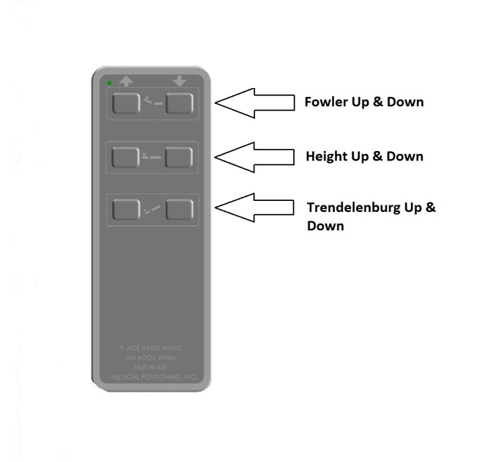

**Figure 2**

Fully featured product, your model may not have all functions listed.

Safety Features

* This product is equipped with multiple automated safety features to prevent danger or damage during use. The entire system is electrically isolated to UL/IEC 60601-1 and CAN/CSA C22.2 No. 601.1 hospital safety standards
* The actuator assemblies are current overload protected. If overloaded, the actuators will stop and reset automatically.
* The sealed hand-wand operates the actuators by directing small amounts of low voltage D.C. current to the control box. All of the actuator drives are equipped with internal limit switches which automatically prevent over-extension.
* The tables are equipped with total locking, sealed bearing, and braking casters at all four corners.
* The EchoTable® is equipped with Single Pedal Braking and Steering casters which are engaged with the stainless steel lever located on either side of the bed at the center of the base frame.

Operation

Your EchoTable® is shipped assembled and ready for use. Each function has been pre-tested to ensure perfect working order on day one.

A **“Troubleshooting Guide”** is included in this manual to assist you in the event of a malfunction.

The EchoTable® is designed for use by sonographers who scan left-handed or right-handed. The EchoTable® is equipped with two drop-sections:

* An imaging window drop-section, and
* The Sonographer’s entry drop-section

Left-handed scanners sit in a chair beside the bed and utilize the imaging window drop section. The Sonographer's entry drop-section on the right of the patient provides a place for the sonographer to sit behind the patient, reaching over to scan right-handed. See Figure 3

****

**Figure 3**

This position, close to the patient, provides several advantages for the right sided sonographer. First, the sonographer’s drop-section allows increased control of patient location and greater access to the intercostal imaging areas. In addition, it allows the sonographer to maintain a more upright position and should reduce stress to the shoulder, back and wrist of the sonographer.

**Functionality in this section**

* Hand-wand
* Single Pedal Brake (EchoBed®)
* Individual Locking Casters
* Single Pedal Brake (Option)
* Drop Sections
* 2-Way Back Rest
* Non-Pinch Flap
* Patient Positioning Procedure
* Sonographer Positioning

Hand-Wand

The hand wand is a low voltage device. The cable begins at the hand wand and plugs into the control box on the other end.

* **WARNING, POTENTIAL FOR INJURY. Verify the area around the product is free of impediments before articulating the product to prevent injury or equipment damage.**
* **WARNING, POTENTIAL FOR INJURY. Keep hands and feet clear from beneath the patient surface when articulating the product to avoid possible injury**
* **WARNING, POTIENTAL FOR INJURY. Never step or rest a foot on the base frame of the product as there is a potential for injury.**
* **WARNING, POTENTIAL FOR INJURY OR DEATH. Once the table and patient have been properly positioned, ensure the casters are locked and the hand wand is placed in a safe position to prevent incidental contact and unwanted movement of the table surface during the procedure.**

| **STEP** | **ACTION** |
| --- | --- |
| 1 | Initialize all of the actuators by running each actuator (one at a time) to its fully retracted position. Lower the height actuator all the way down. Position the lateral tilt actuator to level. Place the bed in reverse Trendelenburg position (the Trendelenburg actuator is fully retracted in this position). See Figure 4 |
| 2 | Using the buttons on the hand-wand, utilizing as many of the actuator motors as necessary but running only one actuator at a time, place the bed in the desired position for the first memory selection. When you are satisfied with the position attained, press and hold the [P1] and [M] buttons at the same time. An audible tone will be produced by the actuator control box when the memory position is stored. |
| 3 | Repeat step 2 for memory positions 2 and 3, using the [P2] button for memory position 2 and the [P3] button for memory position 3. |
| 4 | To change any of the stored memory positions, repeat steps 1 and 2 for the position you wish to change. It is not necessary to reprogram all of the positions each time |



**Figure 4**

Fully featured product, your model may not have all functions listed.

The Hand-Wand attaches to the bed by utilizing the hook and loop fastener See Figure 5. If the EchoTable® is equipped with Safety Rails, the hook on the backside of the Hand-Wand is designed to hang on the safety rail. See Figure 6

****

**Figure 5**

****

**Figure 6**

* **CAUTION, PRODUCT DAMAGE MAY RESULT. Secure hand wand with hook and loop fastener or hook when not in use. Keep cable clear of moving parts.**
* **CAUTION, PRODUCT DAMAGE MAY RESULT. The drop sections must be closed or placed in the upright position before the head end of the table is tilted below horizontal (Trendelenburg) when the bed is at a low height. Failure to follow this precaution can result in damage to the drop section upholstery, hinge and/or latch mechanism.**

Individual Locking Casters

The standard casters installed on your EchoTable® are total locking casters. When in the locked position, the caster is prevented from both rolling and swiveling.

* **WARNING, POTENTIAL FOR INJURY OR DEATH. To reduce the risk of a potential fall, lock all casters before using equipment.**
* **WARNING, POTENTIAL FOR INJURY OR DEATH. Once the table and patient have been properly positioned for compression, ensure the casters are locked and the Hand Wand is placed in a safe position to prevent incidental contact and unwanted movement of the table surface during the procedure.**
* **WARNING, POTENTIAL FOR INJURY. To reduce the risk of a potential fall, do not use the product to transport patient between rooms or over thresholds.**

|  |  |
| --- | --- |
| **STEP** | **ACTION** |
| 1 | To lock the caster, step down on the outermost edge of the locking tab located at the top of the caster wheel. (See Figure 7) |
| 2 | To unlock the caster step down on the top, innermost edge of the locking tab OR lift up on the outermost edge of the tab. (See Figure 8) |

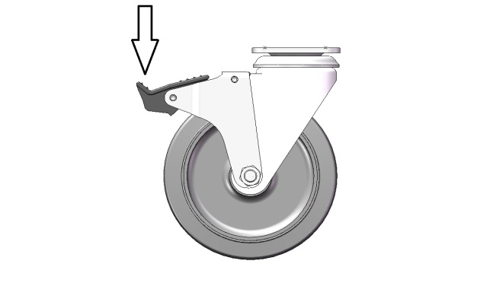

**Figure 7**

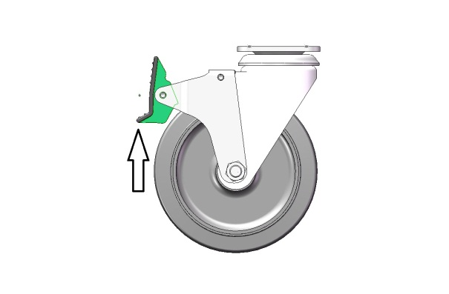

**Figure 8**

Single Pedal Brake (Option)

The casters installed on your EchoTable® with the optional Single Pedal Break are total locking casters when in the locked position; the caster is prevented from both rolling and swiveling. When in the neutral position, all casters are free to roll and swivel. The last position is the steer position; with the casters at the head end free to swivel and roll while the casters at the foot end are free to roll but locked from swiveling.

* **WARNING, POTENTIAL FOR INJURY OR DEATH. To reduce the risk of a potential fall, lock all casters before using equipment.**
* **WARNING, POTENTIAL FOR INJURY OR DEATH. Once the table and patient have been properly positioned, ensure the casters are locked and the Hand Wand is placed in a safe position to prevent incidental contact and unwanted movement of the table surface during the procedure.**
* **WARNING, POTENTIAL FOR INJURY. To reduce the risk of a potential fall, do not use the product to transport patient between rooms or over thresholds.**

|  |  |
| --- | --- |
| **STEP** | **ACTION** |
| 1 | To lock the casters, step down on pedal labeled lock on either side of the table. See Figure 9 |
| 2 | To unlock the casters and obtain the neutral position, step down on the raised pedal on either side of the table until the pedals are level. |
| 3 | To utilize the steer function, step down on the pedal labeled steer on either side of the table. |

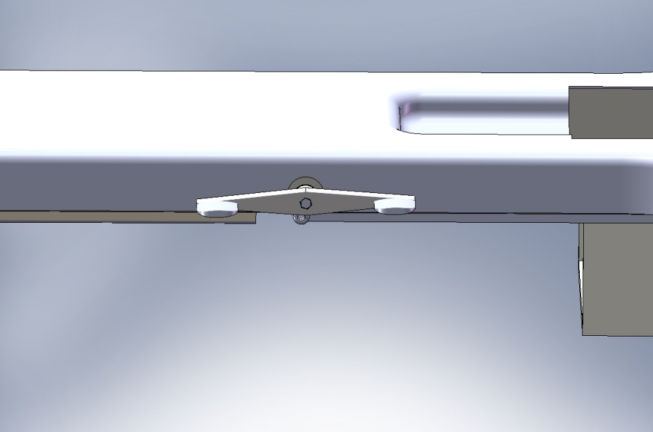

**Steer**

**Lock**

**Figure 9**

Drop Sections

The EchoTable® is designed to both improve images and maximize sonographer ergonomics. The two drop-sections built into the table are identified as the “Imaging drop section” and the “Sonographer’s drop section”. The Sonographer's drop-section on the right of the patient provides a place for the right-handed sonographer to sit close to the patient while maintaining an upright position during imaging. Once you have properly positioned the patient on his or her left side over the imaging window drop-section (see Patient Positioning section) you are ready to place yourself in the proper position, open the imaging window drop-section and when imaging the apical views on the patient.

The drop sections are designed to be opened or closed easily with one hand.

* **WARNING, POTENTIAL FOR INJURY. Avoid placing your hand in or near the drop section mechanism during operation**
* **WARNING, POTENTIAL FOR INJURY OR DEATH. After closing, always lift up on the drop section to assure that it is totally locked before patient entry or exit.**

| **STEP** | **ACTION** |
| --- | --- |
| 1 | To open the drop section, locate the metal handle mounted on the bottom of the drop section at the front edge. See Figure 10 |
| 2 | Pulling the handle to the left or towards the foot of the bed, from under the drop section, will release the latch mechanism and allow the drop section to swing open. Do not abruptly yank or jerk on handle, it is designed to work with a smooth, steady pull |
| 3 | To close the drop section lift the drop section smoothly until it is securely in the full, upright and locked position. |

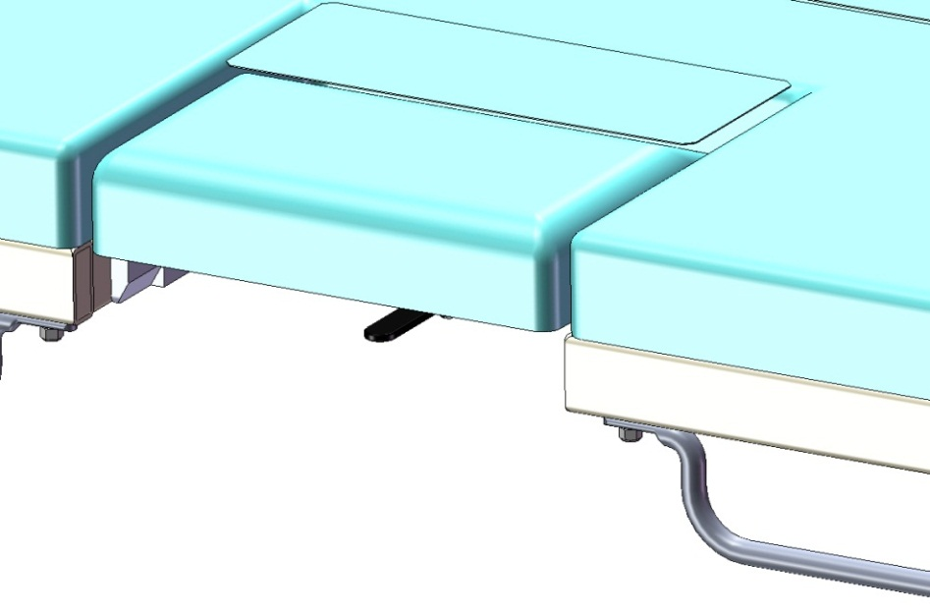

Release Lever

**Figure 10**

Additionally the drop section on the patients left (imagining drop section) can be opened remotely from the left side of the table.

| **STEP** | **ACTION** |
| --- | --- |
| 1 | To open the imagining drop section remotely, locate the remote release on the patient’s right side just next to the right side drop section on the side toward the head of the table. See Figure 11 |
| 2 | Pulling the handle outward will release the latch mechanism and allow the drop section to swing open. |
| 3 | To close the drop section lift the drop section smoothly until it is securely in the full, upright and locked position. |



**Figure 11**

* **CAUTION, PRODUCT DAMAGE MAY RESULT. The drop sections must be closed or placed in the upright position before the head end of the table is tilted below horizontal (Trendelenburg) when the bed is at a low height. Failure to follow this precaution can result in damage to the drop section upholstery, hinge and/or latch mechanism.**
* **CAUTION, PRODUCT DAMAGE MAY RESULT. It is not necessary to "slam" the drop section closed. Slamming the drop section closed will startle the patient and may result in damage to the mechanism.**

2-Way Back Rest

EchoTable® has a convenient patient support back rest integrated into the sonographer’s drop section on the patient’s right side by allowing it to rise in addition to drop. The 2-Way Back Rest is part of a multi-functional feature that also operates as the sonographer’s drop section.

* WARNING, POTENTIAL FOR INJURY. Failure to hold the back rest when activating the release lever will result in the back rest lowering suddenly, possibly causing injury to the patient.

| **STEP** | **ACTION** |
| --- | --- |
| 1 | To raise, lift up on the outside edge of the back rest (drop section on the patient right) until the locking pin engages and holds the back rest in the elevated position. To raise into a steeper position, move lever to the left as you push drop section up, until the locking pin engages again and holds the back rest in a steep left lateral position. |
| 2 | To lower, grasp the top edge of the back rest and exert a little pressure towards the center of the table and pulling the drop section release handle will release the latch mechanism Lower the back rest to the flat position. See Figure 10 |

Non-Pinch Closure

The non-pinch closure flap located at the back edge of the back rest is designed to reduce the possibility of the patient being pinched when the back rest is raised or lowered.

* **WARNING, POTENTIAL FOR INJURY. Do not operate drop section or back rest if non-pinch closure flap is absent. The flap is attached to the bed with hook and loop tape and can easily be adjusted whenever necessary.**

Examine the non-pinch closure flap with the back rest raised and lowered and when the arm rest is open and closed. The flap attaches to the bed surface with hook and loop tape that has been permanently attached to the surface. See Figure 11



**Figure 12**

Occasionally the flap may become bent or creased. When that occurs, remove the flap from the bed surface by separating the hook and loop strips. (See Figure 12) Next, return the flap back to original shape by bending it farther in the opposite direction of the bend or crease and allowing it to spring back to flat.

Should the flap require replacement, you may order one through Medical Positioning, Inc. at 1-800-593-ECHO (3246).

Patient Positioning Procedure

* **WARNING, POTENTIAL FOR INJURY OR DEATH. To reduce the risk of a potential fall, lock all casters before using equipment.**

| **STEP** | **ACTION** |
| --- | --- |
| 1 | Place a Safe-T-Wedge™ flush with the head end of the bed (where the drop section is located). The Safe-T-Wedge™ should be evenly centered between the sides of the bed. |
| 2 | With the drop section closed, ask the patient to lie on their back on the imaging surface. |
| 3 | Explain to the patient that you will be opening the drop section. While the patient will not feel any-thing, do not surprise the patient by opening the drop section without warning. |
| 4 | Adjust the patient so that he or she is in the middle of the bed (side to side) and so that the patient’s armpit or axilla is aligned with the top edge of the drop section. See Figure 13 |
| 5 | If there is any question about proper positioning, roll the patient up onto their left side, open the Imaging Drop Section and locate the patient’s imaging windows. Make any adjustments required to patient position. |
| 6 | When imaging (both resting and stress), it is helpful to ask the patient to place their left hand behind their head. This keeps their arm clear of the imaging window. |
| 7 | Parasternal views can be obtained with the drop section either open or closed. When obtaining apical images, always open the drop section. At the completion of the study, but before the patient gets up to leave the exam surface, be sure to securely close the drop section. |



**Figure 13**

Note: If you are beginning a procedure such as a treadmill exercise echo where the patient will be off and then back on the bed, you should alert the patient to his / her current position and explain to the patient he/she must assume the same position post exercise. Some sonographers use tape on the bed to mark the hip location and tell the patient to return to that marked position following exercise. This technique can be useful, but BE CAREFUL, image windows frequently shift with exercise.

Note: When using this product with small children, senior citizens or well-endowed women, a Pediatric/Geriatric Adapter (available from Medical Positioning, Inc.) may be helpful.

Sonographer Positioning

Before you begin this procedure, please familiarize yourself with the Patient Positioning Procedure Section and the Drop Sections section of the manual. Place your ultrasound unit in close proximity to where you are seated to minimize the reach from the table to the ultrasound unit whether you are scanning left or right-handed. For maximum comfort, it is important that you be able to maintain an upright position while you are operating both the controls on your ultrasound unit and the transducer. With your equipment in the proper place, you are ready to begin working with a patient.

| **STEP** | **ACTION** |
| --- | --- |
| 1 | Prior to beginning an echo procedure, familiarize the patient with the EchoBed®. Explain to him/her that you will be opening the drop-sections; their opening will be slightly noisy, but the patient will be both comfortable and secure throughout the procedure. |
| 2 | Insure the patient is in the correct position as described in the preceding section “Bed Preparation” and “Patient Positioning”. Insert: If you will be scanning right-handed, tell the patient that you will be opening the Sonographer’s entry drop-section. While the patient will not feel anything, do not surprise the patient by opening the drop-section without warning. Open the Sonographer’s entry drop-section and enter the cut-out area of the table. Seat yourself on the table, facing the head of the bed and perpendicular to the patient. The Sonographer’s Extension can be utilized to provide a larger seating space. |
| 3 | Tell the patient that you will be opening the imaging window drop-section. Again, the patient will not feel anything; however, do not surprise the patient by opening the drop-section without warning. Lower the imaging window drop-section by activating the remote release as described in the Drop Sections section of the manual. |
| 4 | You are now ready to begin imaging the patient. |

Accessories

**Functionality in this section**

* Safety Rails
* Sonographer’s Extension
* Patient Positioning Safe-T-Wedges™
* Paper Roll Holder
* IV Pole Holder
* Pediatric/Geriatric Adapter

Safety Rails

The EchoTable® may be equipped with removable safety rails. The safety rails lock in the raised position and removable without the use of tools.

* **WARNING, POTENTIAL FOR INJURY OR DEATH. Always verify the safety rail is securely latched in the up position before using the table with the safety rail raised. Failure to have the safety rail latched in the raised position may result in a patient fall.**

**Safety Rail Deployment**

|  |  |
| --- | --- |
| **STEP** | **ACTION** |
| 1 | From the safety rail’s stored position, grab the center of the top section of the rail and pull upward until the locking mechanism engages and the safety rail is secure in the up position. See Figure 14 |

**Safety Rail Storage**

|  |  |
| --- | --- |
| **STEP** | **ACTION** |
| 1 | To lower the safety rail, lift slightly on the center of the top section of the rail, pull out on rail release knob and lower the rail downward. See Figure 14 |

****

Release Knob

**Figure 14**

**Safety Rail Removal**

|  |  |
| --- | --- |
| **STEP** | **ACTION** |
| 1 | Grab the center of the top section of the rail and pull upward while pulling the safety rail release knob until the safety rail has cleared the release knob. See Figure 14 |

**Safety Rail Insertion**

|  |  |
| --- | --- |
| **STEP** | **ACTION** |
| 1 | To insert the safety rail, pull out on rail release knob while inserting the safety rail and lowering it downward. See Figure 14 |

Sonographer’s Extension

The EchoTable® may be equipped with a removable sonographer’s extension. The sonographer’s extension is designed to increase the usable sitting area and comfort for the sonographer for a right handed scanning sonographer. The sonographer’s extension is removable.

* NOTICE. Sonographer should not be seated on the Sonographer’s Extension when operating the actuators or moving the product.

**Sonographer’s Extension Insertion**

|  |  |
| --- | --- |
| **STEP** | **ACTION** |
| 1 | Rotate the support bracket to the side of the use position. See Figure 15 |
| 2 | Insert the sonographer’s extension pilot tube into the support bracket. See Figure 15 |

**Sonographer’s Extension Removal**

|  |  |
| --- | --- |
| **STEP** | **ACTION** |
| 1 | Pull straight up on the sonographer’s extension until the pilot tube is free of the support bracket. See Figure 15 |
| 2 | Rotate the support bracket to the transport position. See Figure 15 |



**Figure 15**

Patient Positioning Safe-T-Wedges™

The EchoTable® may be used with an optional Safe T Wedge™. The Safe-T-Wedge™ can be used to achieve additional patient positions.

Paper Roll Holder

The EchoTable® may be used with a Paper Roll Holder that also includes a paper cutter.

The Paper Roll Holder was pre-installed at the factory to insure proper fit, and then removed to prevent damage during shipment.

**Tools Required:**  Phillips Head Screwdriver

**Paper Roll Holder Installation**

| **STEP** | **ACTION** |
| --- | --- |
| 1 | Install the paper roll holder at the head of the bed as shown in Figure 16, |
| 2 | Using the 4 (four) #8 screws provided. Carefully place the screws through the paper roll holder mounting brackets and re-install into the bed. Snug the screws tight with a Phillips screw driver. |

****

**Figure 16**

* **CAUTION, PRODUCT DAMAGE MAY RESULT. Do not over tighten the mounting screws. Over tightening may result in stripping threads.**

IV Pole Holder

The EchoTable® may be equipped with an optional IV pole holder for ½ inch diameter IV poles. The IV pole holder is located near the head end of the table for models without Fowler functionality. For models with fowler functionality, the IV pole holder is located near the foot of the table. . See Figure 17

IV Pole Holder location on models with Fowler

IV Pole Holder location on models without Fowler

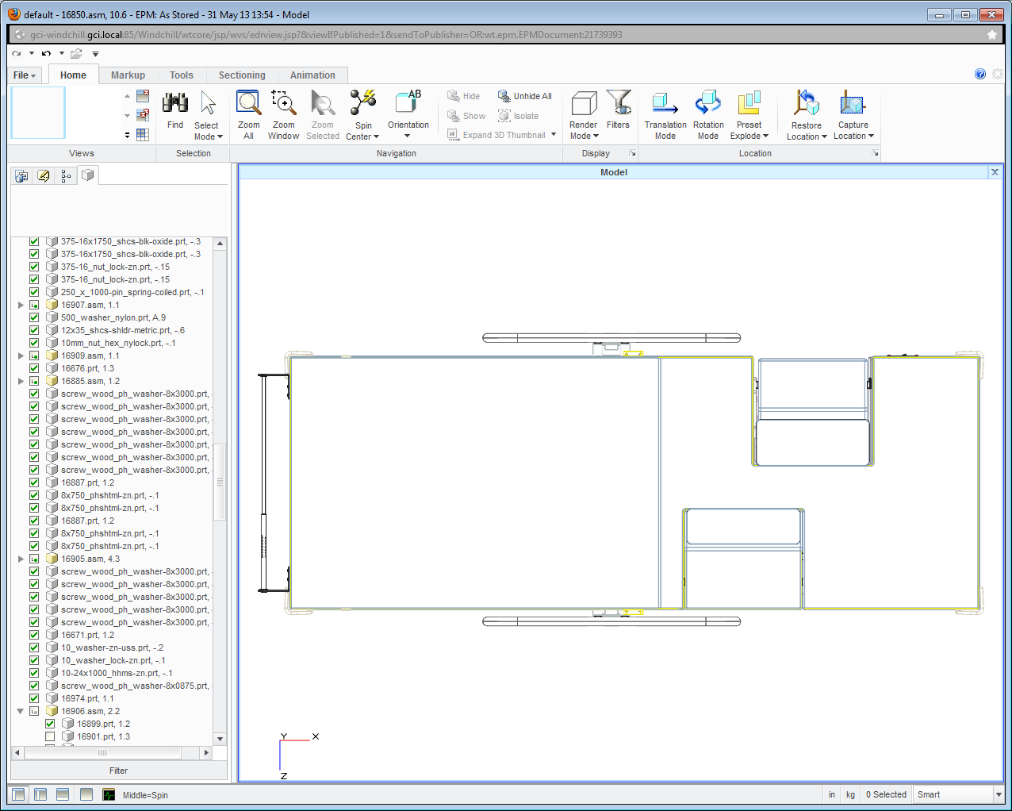

**Figure 17**

Pediatric/Geriatric Adaptor

The EchoTable® can be used with an optional Pediatric/Geriatric Adaptor. This accessory reduces the size of the opening of the imaging drop section when imaging smaller patients.

* **WARNING, POTENTIAL FOR INJURY OR DEATH. Remove the Pediatric/Geriatric Adaptor when not in use.**
* **WARNING, POTENTIAL FOR INJURY. Do not operate drop section or back rest if either the non-pinch closure flap or Pediatric/Geriatric Adaptor is absent. The flap is attached to the bed with hook and loop tape and can easily be adjusted whenever necessary.**

| **STEP** | **ACTION** |
| --- | --- |
| 1 | Lower the Drop Section |
| 2 | Remove the non- pinch closure flap by grasping one side of the flap and gentle separating the hook and loop fastener. |
| 3 | Position the adaptor locator flanges within the imaging area. See Figure 18 |
| 4 | Remove the adaptor when not needed. |
| 5 | With the drop-section lowered, align the top edge of the non-pinch closure flap, (within the access cavity) with the top edge of the bed surface. |
| 6 | Press the hook and loop attachment strips together. |

****

**Figure 18**

Preventative Maintenance

* **WARNING, POTENTIAL FOR INJURY OR DEATH. Do not modify this equipment without authorization of the manufacturer.**

The following Preventative Maintenance should be performed at a minimum annually:

* Visually inspect all mechanical assemblies and moving parts on the product ensuring smooth, steady operation
* Visually inspect all fasteners (bolts, nuts, screws, etc.) to insure all are fully installed. Tighten as necessary.
* Visually inspect all electrical cables and wires for signs of abrasion or other damage. If damaged, replace.
* Visually inspect all electrical connections to insure they are fully and properly connected. Reconnect as necessary.
* Visually inspect the hand wand. If damaged, replace.
* Operate all drop section latch mechanisms to insure proper engagement of latch into receiver. Adjust if necessary.
* Operate the back rest latch mechanisms to insure proper engagement and release. Adjust if necessary.
* Operate all motors to insure full extension, retraction and correct operation. The motors are permanently lubricated and require no lubrication.
* Operate the braking system to insure proper engagement of the wheel and swivel lock mechanism. Replace as necessary.
* Operate all accessories to insure proper attachment and operation. Tighten, adjust or replace if necessary

|  |  |
| --- | --- |
| weee_symbol | This device contains materials that are potentially hazardous to the environment. In accordance with the DIRECTIVE 2002/96/EC OF THE EUROPEAN PARLIAMENT AND OF THE CONCIL on waste electrical and electronic equipment (WEEE), the EchoTable® electrical system and accessories should not be disposed as unsorted municipal waste. Consult your instructional policies and local regulations regarding disposal. Contact your Medical Positioning, Inc. Service Representative if additional disposal details are required. |

Remote Release Mechanism Adjustment

The EchoTable® has a remote release drop-section for right-handed scanners. The remote release mechanism may require minor adjusting after use. If you find that the remote release is not working as smoothly as it should, please proceed with these instructions.

**Tools Required:**  Phillips Head Screwdriver

| **STEP** | **ACTION** |
| --- | --- |
| 1 | Close the imagining drop section |
| 2 | Located under the imaging drop-section is the control cable for the remote release handle. The cable is equipped with an adjustable mounting tab. Should it be necessary, adjustment is performed in the following manner. See Figure 19 |
| 3 | Determine if the Remote Release Cable needs tightening.   * Tighten the cable: When opening the imaging window using the remote release, the drop-section does not respond properly. In this event, follow steps 5, 6, and 8. * Loosen the cable: When closing the drop-section after use, one or both sides of the drop-section do not fully engage or latch securely. In this event, follow steps 5, 7, and 8. |
| 5 | Locate and loosen the Phillips Head screw that holds the mounting tab in place. See Figure 20 |
| 6 | To tighten the cable, (take up the slack in the cable) slide the mounting tab towards the center of the bed. See Figure 21  **Take care to note over tighten the cable by moving the mounting tab. Only tighten enough to take-up slack in the cable. Taking up too much slack in the cable may prevent the drop section latch from fully engaging.** |
| 7 | To loosen the cable, (increase slack to allow more secure closure) slide the mounting tab away from the center of the bed. See Figure 21 |
| 8 | Re-tighten the Phillips head screw in the mounting tab to lock-in the adjustment. See Figure 22 |

****

**Figure 19**

****

**Figure 20**

****

**Figure 21**

Cleaning

* WARNING, POTENTIAL FOR INJURY. Always read manufactures instructions and warnings before using any cleaning product or disinfectant.
* CAUTION, PRODUCT DAMAGE MAY RESULT. Substances such as imaging gels and alcohol will not damage the vinyl surface when immediately removed. Studies have shown that exposure for longer than a few minutes can damage the top coat and will eventually discolor vinyl.

The painted metal and plastic surfaces can be cleaned with normal cleaners and disinfectant.

* **CAUTION, PRODUCT DAMAGE MAY RESULT. Do not use abrasives to clean surfaces.**

| **STEP** | **ACTION** |
| --- | --- |
| 1 | Clean and/or disinfect with liquid cleaner of choice being careful to follow label instructions provided with cleaner. (Always test a small area first to determine suitability of solution) |
| 2 | Wipe the surface clean with a damp cloth after applying cleaners and disinfectant to remove excess residue buildup. |

The vinyl upholstered surfaces can be cleaned in one of the following ways:

* WARNING, POTENTIAL FOR INJURY OR DEATH. It is recommended that the product be cleaned between patients; please follow your facilities documented policy.

The preferred method of everyday cleaning is using a soft cloth or sponge with mild soap and water or disinfectant. Spills and accidents require immediate attention for best results. When caught quickly, most stains such as grease, blood and black felt tip pens can be wiped right off. Mild soap and water is the preferred method; however, typical hospital-grade antiseptic wipes work as well. For more stubborn stains, a variety of concentrated and solvent type cleansers may be used without damaging the surface as long as they are thoroughly rinsed off with water.

Generally speaking, always start with the mildest cleaning agents first. Never use harsh powdered abrasive cleansers or steel wool. Products containing bleach, ammonia or alcohol should be wiped from the surface with a wet cloth after use. Residue from these products will damage vinyl surfaces

| **STEP** | **ACTION** |
| --- | --- |
| 1 | Clean and/or disinfect with liquid cleaner of choice being careful to follow label instructions provided with cleaner. (Always test a small area first to determine suitability of solution) |
| 2 | Wipe the surface clean with a damp cloth after applying cleaners and disinfectant to remove excess residue buildup. |

| **RECOMMENDED MAXIMUM CLEANER TO WATER SOLUTIONS** | |
| --- | --- |
| Mildest | 1:1 mix of mild soap and water. Wipe surface with damp cloth with water only after cleaning |
|  | Straight application of common disinfectants. Wipe surface with damp cloth with water only after cleaning |
| 1:1 mix of ammonia and water. Use a soft cotton cloth saturated with the cleaning material. Wipe surface with damp cloth with water only after cleaning |
| 1:4 mix of bleach and water. Use a soft cotton cloth saturated with the cleaning material. Wipe surface with damp cloth with water only after cleaning |
| 1:1 mix of isopropyl alcohol and water. Use a soft cotton cloth saturated with the cleaning material. Wipe surface with damp cloth with water only after cleaning |
| Straight application of isopropyl alcohol. Use a soft cotton cloth saturated with the cleaning material. Wipe surface with damp cloth with water only after cleaning |
| Strongest | 1:1 mix of acetone and water. Use a soft cotton cloth saturated with the cleaning material. Wipe surface with damp cloth with water only after cleaning |

This information is not a guarantee and does not relieve the user from the responsibility of the proper and safe use of the product and all cleaning agents.

Troubleshooting Guide

A **“Troubleshooting Guide”** is included to instruct you in the event of a malfunction. If you are experiencing any of the following symptoms, this guide may help you quickly solve the problem. If, after consulting this guide, you are still unable to operate your table please contact Medical Positioning at 1-800-593-3246. Please have the following information ready when you call:

1. Model Number or Name of Product
2. Date Received
3. Condition When Received
4. Symptom (or problem) Encountered & Result of Troubleshooting Procedure

**Complaint Reporting Procedure**

In the event of a product malfunction or patient injury, please immediately report the incident to:

1. \_\_\_\_\_\_\_\_\_\_\_\_\_\_\_\_\_\_\_\_\_\_\_\_\_\_\_\_\_\_\_\_\_\_\_\_\_\_\_\_\_\_\_\_\_\_\_\_\_\_\_\_\_\_\_\_\_\_

(The distributor from whom the product was purchased)

2. Medical Positioning, Inc.

1146 Booth Street

Kansas City, KS 66103

www.medicalpositioning.com

011-816-474-1555

800-593-3246 (ECHO)

| **SYMPTOM** | **PROBABLE CAUSE** | **SUGGESTION** |
| --- | --- | --- |
| No Actuator Function  Actuator(s) Not Running | * Power cord not plugged all the way into wall receptacle | * Push power cord securely into receptacle. |
| * Power outlet receptacle not supplying 120 VAC power | * Check power availability or plug unit into another receptacle |
| * The power cord may be separated from the control box | * Securely press power cord into control box Figure 23 |
| * Hand wand not properly connected to control box | * Securely press end of hand-wand into control box Figure 22 and Figure 23 |
| * Actuator power cord not fully connected to control box | * Securely press end of actuator power cord into control box Figure 23 |



**Figure 22**



**Figure 23**

EchoTable® Parts List

| **Part Number** | **Description** |
| --- | --- |
|
|  |
| 10098 | PAPER HOLDER - CUTTER KIT |
| 10099 | PAPER CUTTER STRAP #MEP-1556 |
| 10132 | HANDRAIL |
| 10219 | COLUMN TOP PLATE |
| 10220 | SHAFT, TRENDELENBURG |
| 10373 | FOW-3 COLUMN BRACKET |
| 10436 | BRACKET, HANDRAIL |
| 10491 | UPHOLSTERY KIT-ECHO TABLE DUAL |
| 10542 | UPHOLSTERY KIT-FOWL. TABLE DUA |
| 10582 | LEVER, RELEASE |
| 10687 | TREND PIVOT BRACKET |
| 10690 | SUBASSY, FRAME, TOP, DUAL, NO FOW, ET |
| 10691 | BRKT,500 SER.DUAL DS REL.LEVER |
| 10698 | EPS-55 UPPER TR MOUNT |
| 10726 | ACTUATOR, TREND |
| 10728 | CONTROL BOX |
| 10729 | ACTUATOR, FOWLER |
| 10740 | HAND WAND, H, NO M |
| 10741 | HAND WAND, H-TR, NO M |
| 10751 | FRAME, TOP, FOWLER, ET |
| 10770 | BAR, STOP, TABLE |
| 10941 | 2 1/4 SPACER |
| 10956 | SUBASSY, FRAME, TOP, DUAL, ET |
| 10969 | BEARING, FLANGE, 7/8 ID |
| 11049 | ACTUATOR, HEIGHT |
| 11481 | COVER, D.S. LATCH HANDLE |
| 11737 | PLUG, TUBING, SQUARE, SMOOTH, 1 1/4 SQ X 1.120, PE, BLACK |
| 11918 | HAND WAND, H-TR-F. NO M |
| 12023 | HAND WAND, H-F, NO M |
| 12173 | BRACKET, CONTROL BOX |
| 12262 | BASE 1 |
| 12270 | CORD |
| 12276 | Base Cover Short |
| 12277 | CASTER, 5" EXPANDING STEM,TTL |
| 14109 | SUBASSY, UPHOL, DROP SECTION, IMAGING, ET, EB, & VAS |
| 14360 | SUBASSY, FLAP, PINCH, SONOGRAPHER'S |
| 14361 | SUBASSY, FLAP, PINCH, IMAGING |
| 14462 | PLATE, BASE COVER, HEAD END |
| 14466 | UPHOLSTERED, STATIONARY TABLE |
| 14601 | SUBASSY, UPHOL, PT SURF, DUAL, FOWLER, W/O DROPS, ET & VAS |
| 14602 | SUBASSY, UPHOL, DROP SECTION, SONOGRAPHER'S, ET & VAS |
| 14603 | SUBASSY, UPHOL, PT SURF, DUAL, W/IMAGING, ET & VAS |
| 14604 | SUBASSY, COMPL, DROP SECTION, SONOGRAPHER'S, ET & VAS |
| 14643 | SUBASSY, UPHOL, PT SURF, DUAL, NO FOW, W/O DROPS, ET |
| 14644 | SUBASSY, UPHOL, PT SURF, DUAL, NO FOW, W/IMAGING, ET |
|  |  |

Specifications and Warranty

Specifications

| **ATTRIBUTE** | **SPECIFICATION** |
| --- | --- |
| Electrically Adjustable Height | 24” to 34” |
| Electrically Adjustable Fowler Positioning |  |
| 2251, 2273 | 0° |
| 2272, 2283, | 0° to 60° |
| Electrically Adjustable Trendelenburg Positioning |  |
| 2251, 2272 | 0° |
| 2273, 2283 | 0° to 15° |
| Electrically Adjustable Reverse Trendelenburg Positioning | 0° to 15° |
| 2251, 2272 | 0° |
| 2273, 2283 | 0° to 15° |
| Electrically Isolated Hand Wand | 24 VDC |
| Dynamic Load Capacity, Table | 500 Lbs. |
| Static Load Capacity, Table | 1000 Lbs. |
| Load Capacity, Sonographers Extension | 200 Lbs. |
| Load Capacity, IV Pole Holder | 33 Lbs. |
| Casters |  |
| Standard | 5” Individual Lock Casters |
| Optional | 5” Single Pedal Lock and Steer |
| Length |  |
| 2251, 2273 | 73” |
| 2272, 2283 | 80” |
| Width | 28” |
| Weight | 240 Lbs. |
| Foam | Cal. B.F.T.B. #117 |
| Vinyl | D.O.T. FAR25.8536. M.V.S.302  Port of NY / Boston F.D. Code |
| Electrical | 120 VAC, 50/60 Hz, 2.6 A |

**Standard and Optional Configurations**

|  |  |  |  |  |  |
| --- | --- | --- | --- | --- | --- |
| **Attribute** | **Standard** | | | | **Option** |
| **2251** | **2272** | **2273** | **2283** |  |
| Fowler Functionality |  | X |  | X |  |
| Trendelenburg Functionality |  |  | X | X |  |
| Individual Lock Casters | X | X | X | X |  |
| Single Pedal Brake |  |  |  |  | X |
| Drop Sections | X | X | X | X |  |
| Back Rest | X | X | X | X |  |
| Non-Pinch Closures | X | X | X | X |  |
| Safety Rails |  |  |  |  | X |
| Sonographer’s Extension |  |  |  |  | X |
| Patient Positioning Safe-T-Wedge™ |  |  |  |  | X |
| Paper Roll Holder | X | X | X | X |  |
| IV Pole Holder |  |  |  |  | X |
| Pediatric/Geriatric Adaptor |  |  |  |  | X |

Warranty

EchoTable®

**1 YEAR WARRANTY**

**Warranty**

This product is fully guaranteed against defects in material and/or workmanship during the period indicated above, commencing with the manufacturing date. If a product fails due to a manufacturing defect, Medical Positioning, Inc. (MPI) will repair or authorize repairs to the product without charge, or replace the product at MPI’s option.

Preventative maintenance and repairs due to accident, improper care, negligence, or other non-defect related failures are not covered by this warranty. This warranty does not apply to products that have been modified without the advance written permission of MPI.

MPI makes no other warranty, either expressed or implied, with respect to this product. MPI specifically disclaims the implied warranties of merchantability and fitness for a particular purpose.

The remedies provided herein are the customer’s sole and exclusive remedies. In no event shall MPI be liable for any direct, indirect, special, incidental, or consequential damages, whether based on contract, tort, or any other legal theory.

A 30 day return policy from the date of receipt applies to new products, subject to a restocking fee and quality inspection. The product shall not be returned without prior written authorization from MPI. The customer is responsible for all shipping charges and any applicable duties or taxes.

**Medical Positioning, Inc.**

1146 Booth Street

Kansas City, Kansas 66103

(816) 474-1555

(800) 593-3246

Fax (816) 474-7755

WAR069-A

1. Nelson B. Schiller, MD, et al.. ”Recommendations for Quantitation of the Left Ventricle by Two-Dimensional Echocardiograms,” Journal of the American Society of Echocardiography, 1989, Vol. 2, pp. 358-367 [↑](#footnote-ref-1)