User Manual

Owner _____________________

Model _____________________

Serial # _____________________

Date _____________________

Table of Contents

Symbols and Definitions 3
Safety Warnings & Cautions 5
Intended Use 7
Safety Features 7
Set Up 8
Transport Position 8
Product Illustration 9
Controls and Indicators 12
Use Instructions 16
Powering the Product 16
Locking the Casters 17
Hand Control Functions 18
Surface Height Adjustment 18
Fowler Adjustment 18
Calf Adjustment 18
Trendelenburg Adjustment 19
Memory Function 19
Hand Control Lock/Unlock 20
Under-bed Lights 20
Using the Integrated Arm Boards 23
Using the Stirrups 24
Using the Footboard 25
Using the Handrails 26
Storing the Hand Control 27
Optional Battery 27
Preventative Maintenance 28
Battery Information 29
Expected Life 32
Discard the Unit 32
Cleaning 33
Service Calls 35
Troubleshooting Guide 36
Specifications 38
Warranty 47
Return Policy 48

Symbols and Definitions

 | Warning, follow instructions for use. Failure to comply may result in injury.
 | Warning, sitting is prohibited. Failure to comply may result in injury.
 | Warning, standing is prohibited. Failure to comply may result in injury.
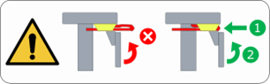 | Warning, retract stirrups fully before raising calf section. Failure to comply may result in equipment damage or injury.
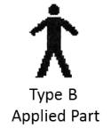 | Applied Part complying with specified requirements IEC 60601-1 to provide protection against electric shock, particularly regarding allowable patient leakage current.
 | Warning/Caution
 | Any terminal which is intended for connection to an external protective conductor for protection against electric shock in case of a fault.
 | In accordance with the European Directive 2002/96/EC on Waste Electrical and Electronic Equipment (WEEE), the product must not be disposed as unsorted municipal waste but should be collected separately. Consult your instructional policies and local regulations regarding disposal. Contact your Medical Positioning, Inc. Service Representative if additional disposal details are required.
 | Manufacturer
 | Agency Mark

WARNING / CAUTION / NOTE Definition

The words WARNING, CAUTION, and NOTE carry special meanings and should be carefully reviewed.

- WARNING

Identifies a situation that could result in injury to the patient or caregiver.

- CAUTION

Identifies a situation that could result in equipment damage.

Note
Provides special information to make an important instruction clearer.

European Union Representative
MDSS GmbH
Schiffgraben 41
30175 Hannover, Germany

Safety Warnings & Cautions

- WARNING:
Obey these safety instructions to help prevent injury and/or equipment damage:

- Read and understand all warnings in this manual and on the unit itself prior to use with a patient.
- The device should be operated by trained persons only.
- Authorized and qualified persons will be those who are approved by Medical Positioning Inc. to repair or modify the product.
- Do not modify this equipment without authorization of the manufacturer.
- Equipment should only be serviced by authorized personnel.
- The procedures in this manual are only manufacturer’s suggestions. The final responsibility for patient care with respect to this device remains with the caregiver.
- Do not use in an oxygen rich environment.
- Do not leave patient unattended while using the product.
- To reduce the risk of electric shock, grounding reliability can only be achieved when the equipment is connected to an equivalent receptacle marked “hospital only” or “hospital grade”.
- If damage has occurred to the power cord, immediately remove the cord from service. Failure to do so could result in serious injury or death.
- The battery should be periodically inspected for damage. If damage has occurred to the battery, immediately remove the battery from service. Failure to do so could result in serious injury or death.
- Removal of secured covers may increase the risk of electrical shock. Refer servicing to qualified and approved personnel.
- The potential for electrical shock exists with electrical equipment. Failure to follow facility protocols may cause death or serious injury.
- Ensure the patient is properly secured prior to using the equipment.
- To reduce the risk of a potential injury, lock casters before using equipment.
- Once the product and patient have been properly positioned for the procedure, ensure the casters are locked and the hand controller is placed in a safe position to prevent unwanted contact and unwanted movement of the support surface.
- To reduce the risk of the product becoming unbalanced, always position the product in the lowest reasonable height when moving.

- Verify the area around the product is free of impediments before operating to prevent injury or equipment damage.
- Keep hands and feet clear from beneath the patient surface when lowering surface height or making positioning adjustments in order to avoid possible injury.
- Keep hands clear of any hinges during operation to avoid possible injury.
- Sitting at the end of the patient surfaces can result in device instability. Do not allow a patient to sit at the head end of the patient surface.
- Standing on the footrest may result in device instability. Do not allow a patient to stand on the footrest while the product is in a chair position.
- Verify the stirrups are fully stored before raising the calf section. Failure to fully store the stirrups prior to moving the calf section may result in equipment damage or injury.
- Protect vinyl upholstery from sharp objects and abrasion to avoid damage.
- Always read manufacturer’s instructions and warnings before using any cleaning product or disinfectant. Refer to instructions located in this manual for vinyl cleaning recommendations.
- Substances such as imaging gels and alcohol will not damage the vinyl surface when immediately removed. Extended exposure for longer than a few minutes can damage the top coat and will eventually discolor vinyl.
- Do not use abrasives to clean painted surfaces.
- It is recommended that the product be cleaned between patients; please follow your facility’s documented policy.
- Keep this manual available for future reference.
- If the product is used adjacent to other electrical equipment, observe the product and the other electrical equipment to ensure they operate as intended.
- Failure to latch Drop Sections may result in patient injury. Verify Drop Section is locked in position before and after use.
- Verify the head rest is secure prior to using the product.
- Verify the handrails are secure prior to using the product and after each handrail adjustment.
- Verify the stirrups are secure prior to using the product and after each stirrup adjustment.
- Do not exceed the weight capacity of the product.

Intended Use

This product is intended to be used in an environment where ultrasound and diagnostic equipment is present, including hospitals, and outpatient facilities. The product is intended to be used by healthcare professionals who possess the ability to operate the product safely. The product’s movements are controlled both manually and electronically via the product’s hand control.
The product is not intended for use in oxygen rich environments.

Safety Features

- This product is equipped with multiple automated safety features to prevent danger or damage during use. The entire system is electrically isolated to UL/IEC 60601-1 and CAN/CSA C22.2 No. 60601-1:14 basic safety standards.
- The actuator assemblies are current overload protected. If overloaded, the actuators will stop and reset automatically.
- The sealed hand control operates the actuators by directing small amounts of low voltage D.C. current to the control box. All actuator drives are equipped with internal limit switches which automatically prevent over-extension.

Set Up

The product has been shipped in “plug and play” condition. Initial testing should be performed to ensure that all functions are in correct working order. After performing the test and reviewing this manual the product is ready for use.

STEP | ACTION
1 | After removing packaging materials, locate the primary power supply cord and attach to a suitable grounded power outlet.
2 | To test actuator function, locate the hand control and depress each button one at a time.
3 | If any function does not operate, perform the test procedures listed in the Troubleshooting Guide.

Transport Position

It is recommended that the patient surfaces be in a horizontal position if the product is used to transport patients.
Product Illustration

Models 287 and 295

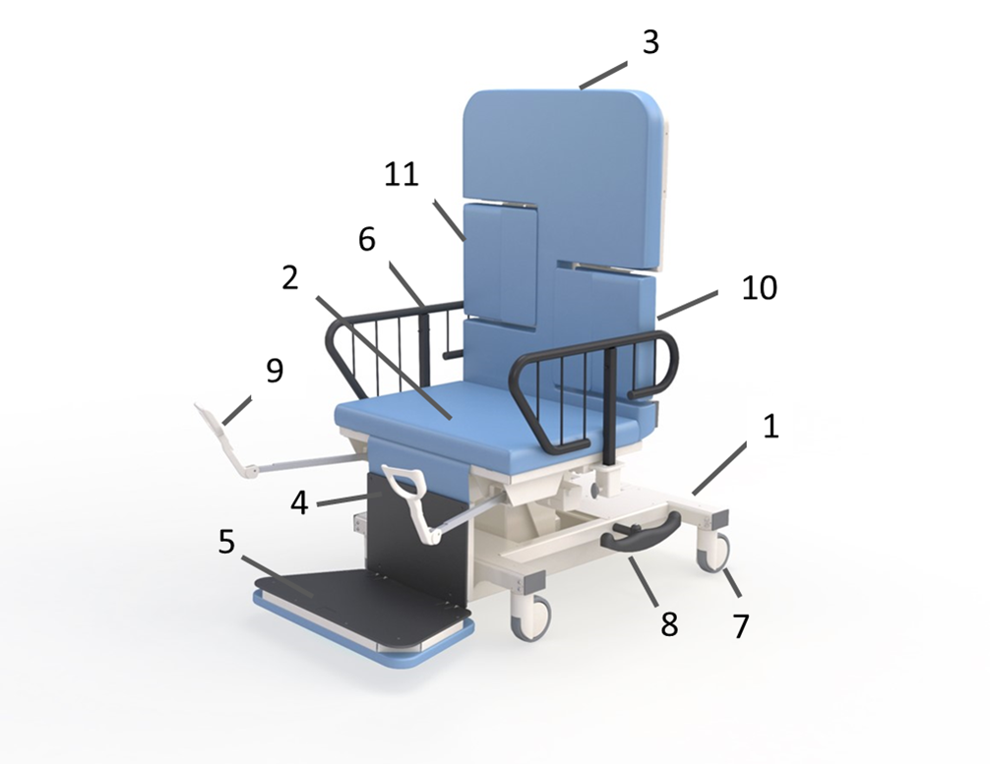

Item # | Description
1 | Base
2 | Seat Section
3 | Fowler Section
4 | Calf Section
5 | Footboard
6 | Handrail
7 | Caster
8 | Pedal
9 | Stirrup
10 | Imaging Drop Section
11 | Sonographer’s Drop Section

*Optional features may be shown

Models 987 and 995

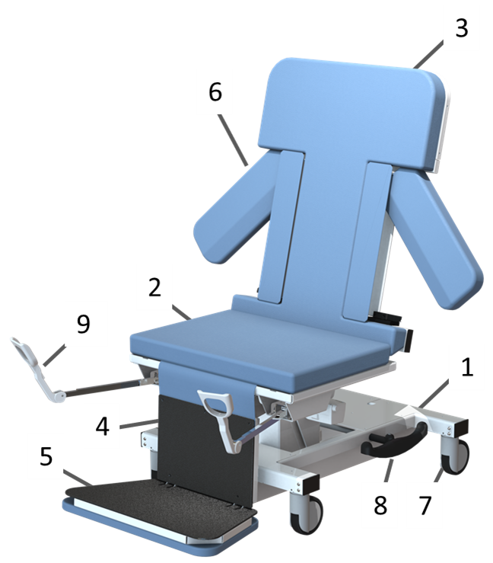

Item # | Description
1 | Base
2 | Seat Section
3 | Fowler Section
4 | Calf Section
5 | Footboard
6 | Integrated Armboard
7 | Caster
8 | Pedal
9 | Stirrup

*Optional features may be shown

Models 087, 095, and 092

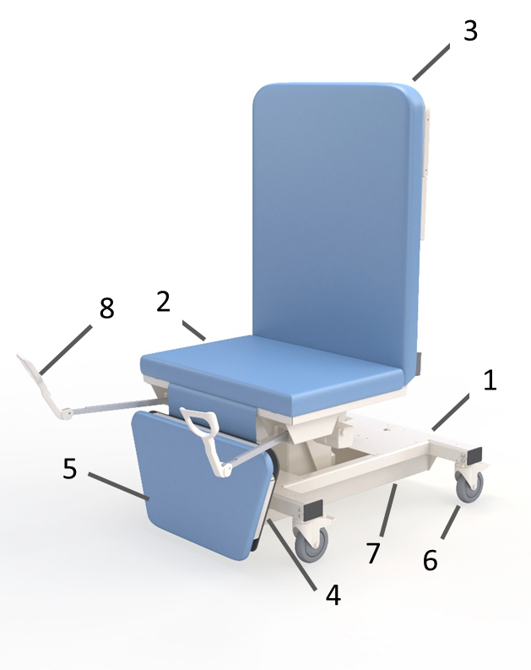

Item # | Description
1 | Base
2 | Seat Section
3 | Fowler Section
4 | Calf Section
5 | Footboard
6 | Caster
7 | Pedal
8 | Stirrup

*Optional features may be shown

Controls and Indicators

Unique Device Identification Label

- Serial #
- Item #
- Item Description
- Unique Identifier
Certification Label | 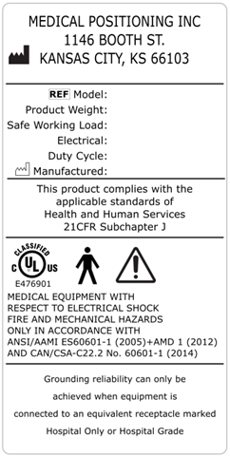
Refer to Manual Label

No Sitting label
No Sitting/No Standing Label
Stirrup Retract Warning Label
Hand Control | 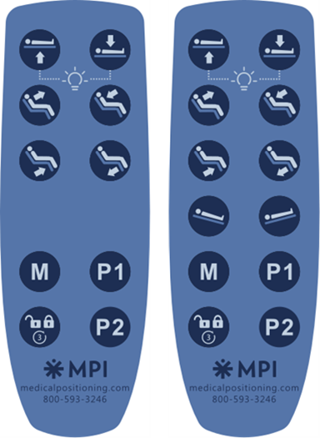
Note: Hand control buttons may vary depending on table model.

AC Input | 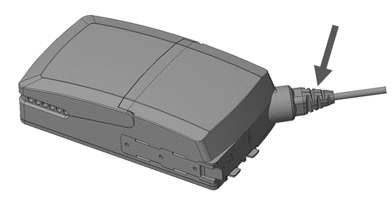
Battery  (Optional) | 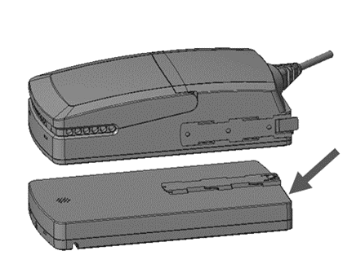
Handrail Release | 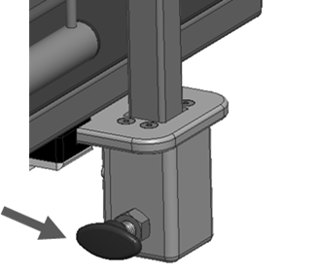
Single Pedal Braking  (Optional) | 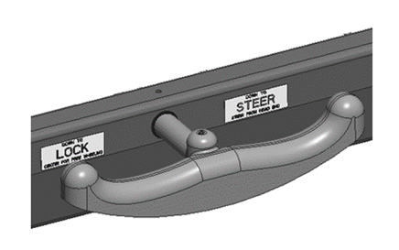

Drop Section/Back Rest Release | 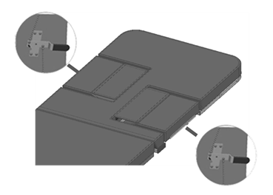
Drop Section Remote Release | 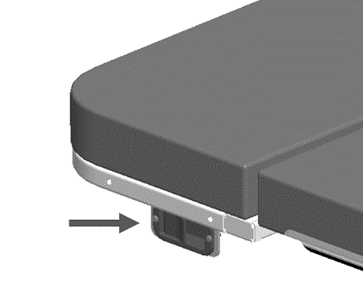
Integrated Arm Board Release | 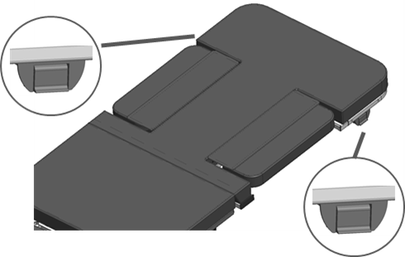

Use Instructions

Powering the Product
The product may be powered by AC power from a wall outlet or by DC power via the optional battery. The product is “on” when plugged into AC power or when a charged battery is installed. The product should not be positioned in a way that would make it difficult to remove power by unplugging the AC power cord or unplugging the battery.

See the section “Battery Information” for indicator information and proper care for batteries.

- WARNING

- To reduce the risk of electrical shock, grounding reliability can only be achieved when the equipment is connected to an equivalent receptacle marked “hospital only” or “hospital grade.”
- If damage has occurred to the power cord, immediately remove the cord from service. Failure to do so could result in serious injury or death.
- If damage has occurred to the battery, immediately remove the battery from service. Failure to do so could result in serious injury or death.
- The battery should be periodically inspected for damage. Replace the battery if necessary.

Locking the Casters

In the locked position casters are prevented from both rolling and swiveling.

Single Pedal Braking

If equipped, pedals are located on each side of the base and are used to adjust the caster function.

Individual Locking Casters  The locking tab is located on each caster. Push down to lock, lift to unlock. | 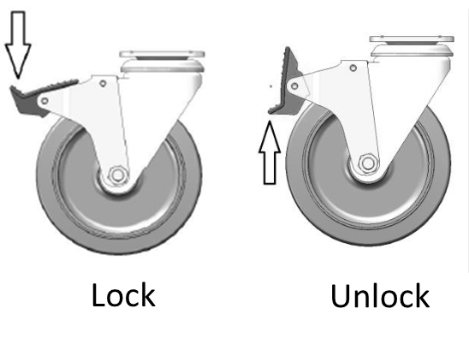

- WARNING

- To reduce the risk of a potential injury, lock casters before using equipment.
- Once the product and patient have been properly positioned for the procedure, ensure the casters are locked and the hand controller is placed in a safe position to prevent unwanted contact and unwanted movement of the product surface during the procedure.

Hand Control Functions
Hand control functions vary depending on the model purchased, your hand control may not include all functions shown.
The control system will limit the product’s motion for certain models. This is done to prevent unwanted contact between support surface and the base frame. The control box will emit a “beep” sound when the motion is limited. If a beep sounds, adjusting the Trendelenburg or extending the calf section closer to level will allow for additional motion.
For the product to reach the lowest chair position, the seat section must be level or in a Trendelenburg position. Level position may be achieved using the Trendelenburg function on the hand control. The product will pause motion when a level position is achieved.

Surface Height Adjustment
The surface height may be adjusted between 24” and 38”.

Press and hold the applicable hand control function to adjust the seat height.

Fowler Adjustment
The Fowler section may be adjusted between 0° and 90°.

Press and hold the applicable hand control function to independently adjust the Fowler.

Calf Adjustment
The calf section may be adjusted between 0° and 88°.

Press and hold the applicable hand control function to independently adjust the calf angle.

Trendelenburg Adjustment
The table may be adjusted between 15° Trendelenburg and 25° Reverse Trendelenburg, depending on model. The Trendelenburg adjustment will pause when seat section is in a level position.

Press and hold the applicable hand control function to independently adjust the Trendelenburg angle.

Press and hold both Trendelenburg buttons simultaneously to activate the “Manual Trendelenburg Leveling” function. This feature will return the table to a level position from any Trendelenburg or reverse Trendelenburg angle.

Memory Function
The product has the ability for the user to set two unique memory positions.

Set the product to the desired position.  To set a memory position, press and hold the “M” button and then simultaneously press and hold either “P1” or “P2”. The control box will beep 1 time when the memory position has been set. Setting a memory function takes approximately 3-4 seconds.  The memory positions can be reset by following the instructions above. | 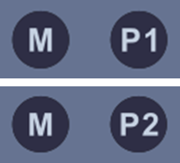

Hand Control Lock/Unlock
The hand control function may be locked to prevent unwanted movement.

Press and hold the lock/unlock button for 3 seconds to lock functions. The control box will beep 2 times to indicate the controls are locked.

Press and hold the lock/unlock button for 3 seconds to unlock functions. The control box will beep 2 times to indicate the control box is unlocked.

Under-bed Lights
The product may be equipped with optional under-bed lights.

Press both height up-down buttons to turn on/off the under-bed lights.

- WARNING

- Verify the area around the product is free of impediments before operating to prevent injury or equipment damage.
- Keep hands and feet clear from beneath the patient surface when lowering surface height or making positioning adjustments in order to avoid possible injury.
- Keep hands clear of any hinges during operation to avoid possible injury.
- Verify the stirrups are fully stored before raising the calf section. Failure to fully store the stirrups prior to moving the calf section may result in equipment damage.

Using the Drop Sections

Some products may be equipped with drop sections in the Fowler section. These drop sections may be lowered to provide the sonographer access to the patient. They may also be raised to act as a back rest.

The drop sections may be lowered by using the release lever. | 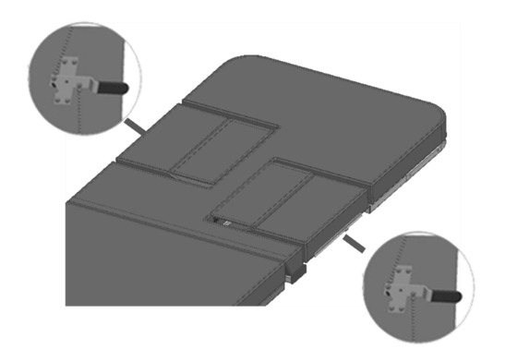
The imaging drop section may also be lowered using the remote release handle.
To close the drop section, lift up on the drop section up until the latch engages. | 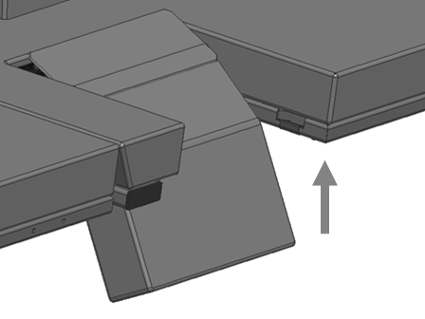

To use the drop section as a back-rest lift the drop section until it locks into position. There are two back rest positions to choose from. | 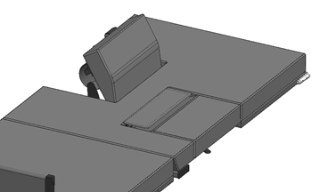
To lower from the back-rest position, rotate the lever to release the back-rest lock. Hold the handle while lowering the drop section until it returns to its stored position. | 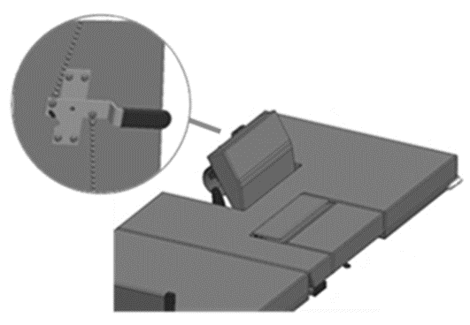

- WARNING

- Failure to latch Drop Sections may result in patient injury. Verify Drop Sections are locked in position before and after use.

Using the Integrated Arm Boards
Some products may be equipped with integrated arm boards on the Fowler section. These arm boards may also be raised into a backrest position.

To position the arm board, lift and rotate outward to the desired position.  To store the arm board, rotate inward until the arm board is in its locked position. | 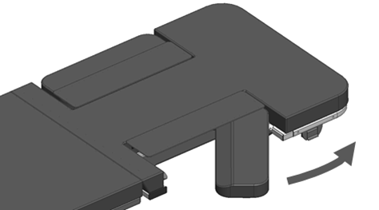
To use the backrest feature, pull up on the outer edge of the arm board until it locks into the backrest position. | 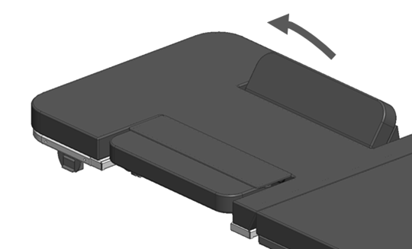
Use the release lever to lower the backrest. | 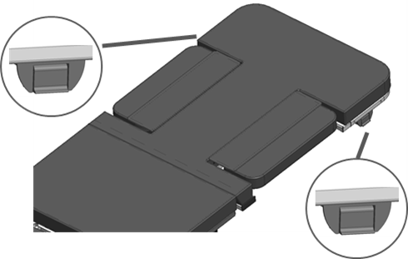

Using the Stirrups
Some products may be equipped with stirrups. The calf section must be fully lowered to use the stirrups. Ensure the stirrups are in the stored position before raising the calf section.
To release the stirrup, push down on stirrup lightly to unlock then pull out. | 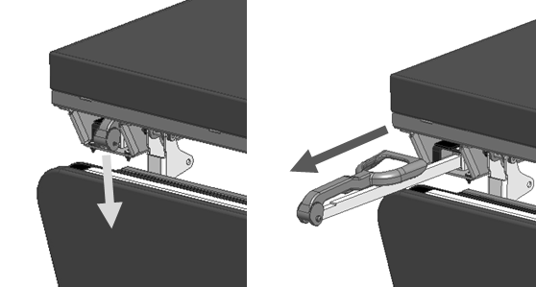
Fold the stirrup open to the procedural position. | 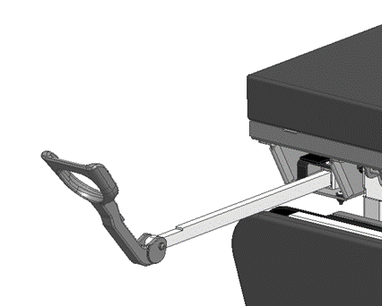
To adjust the stirrup position, lift slightly on the stirrup bar and rotate outward until the bar clicks into the next position. | 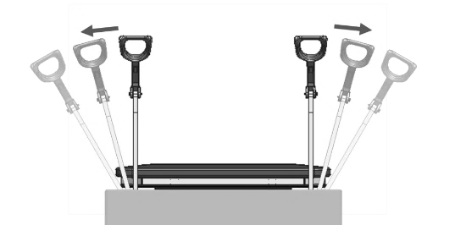
Once the procedure is complete, rotate the stirrup back to its initial position. Lower the stirrup onto the stirrup bar and push inward until the stirrup is locked into its stored position.  Ensure stirrup is fully retracted before raising the calf section. Failure to comply may result in equipment damage or injury. | 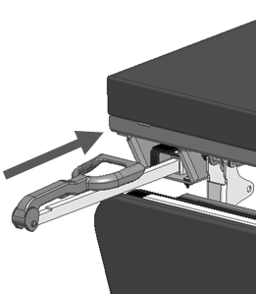

- WARNING

- Verify the stirrups are secure prior to using the product and after each stirrup adjustment.
- Verify the stirrups are fully stored before raising the calf section. Failure to fully store the stirrups prior to moving the calf section may result in equipment damage or injury.

Using the Footboard
The product may be equipped with an optional footboard.

Rotate downward for procedural use.  Note: The footboard is not intended for standing. The footboard should be raised to its stored position when a patient enters the product in a chair position. | 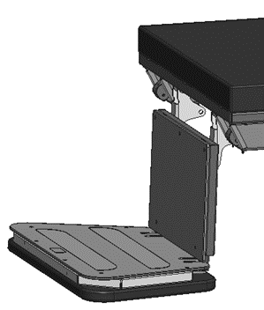
Raise upward for storage. | 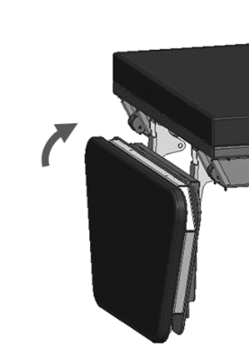

- WARNING

- Standing on the footrest may result in device instability. Do not allow a patient to stand on the footrest while the product is in a chair position.

Using the Handrails
The product may be equipped with optional handrails.

Pull the handrail mounting bracket outward. | 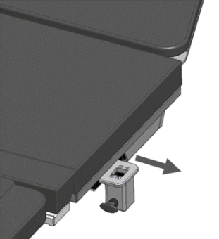
Place the handrail into the mounting bracket. | 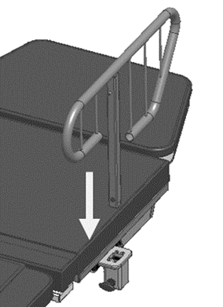
Pull the release lever and lower the handrail so the locking pin engages the hole in the handrail. | 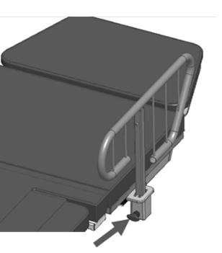
The handrails may be lowered or removed by pulling on the release lever. | 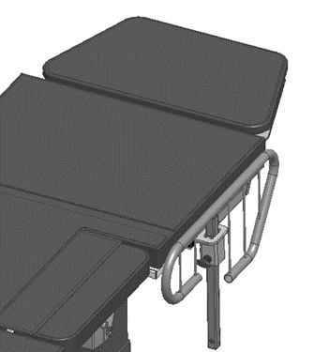

- WARNING

- Verify the handrails are secure prior to using the product and after each handrail adjustment.

Storing the Hand Control
The hand control may be hung on the hook located underneath the support surface. The hook may be moved to the end user’s preference. | 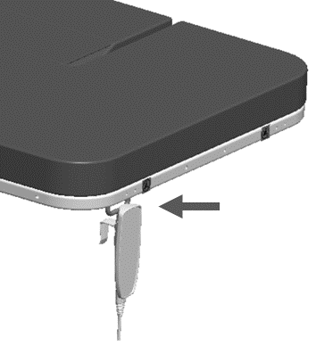

Optional Battery
The product may be equipped with an optional battery. The battery is located underneath the control box and will be charged when the product is plugged into AC power.

Note: The lifting capacity and speed of the product may be reduced while on battery power.

- WARNING

- Equipment should only be serviced by authorized personnel.
- The battery should be periodically inspected for damage. If damage has occurred to the battery, immediately remove the battery from service. Failure to do so could result in serious injury or death.
- The potential for electrical shock exists with electrical equipment. Failure to follow facility protocols may cause death or serious injury.

Preventative Maintenance

The following Preventative Maintenance should be performed at a minimum annually. If any of these checks fail, repair or replace the part as applicable.
- Visually inspect all mechanical assemblies and moving parts on the product ensuring smooth, steady operation.
- Visually inspect all fasteners (bolts, nuts, screws, etc.) to ensure all are fully installed. Tighten as necessary.
- Visually inspect all electrical cables and wires for signs of abrasion or other damage. If damaged, replace.
- Visually inspect all electrical connections to ensure they are fully and properly connected. Reconnect as necessary.
- Visually inspect the hand control. If damaged, replace.
- Operate all latch mechanisms to ensure proper engagement of latch into receiver. Adjust if necessary.
- Operate all motors to ensure full extension, retraction and correct operation. The motors are permanently lubricated and require no additional lubrication.
- Operate the braking system to ensure proper engagement of the wheel and swivel lock mechanism. Replace as necessary.
- Operate all accessories to ensure proper attachment and operation. Tighten, adjust or replace if necessary.
- Inspect the footboard to ensure that it has resistance to lowering. If necessary, tighten hinge screws to increase resistance.
- Visually inspect the battery for damage. Replace the battery if necessary.
- Unauthorized modification of this product voids any applicable warranty.

- WARNING

- No modification of this equipment is allowed.
- Equipment should only be serviced by authorized personnel.
- Removal of secured covers may increase the risk of electrical shock. Refer servicing to qualified and authorized personnel.
- The potential for electrical shock exists with electrical equipment. Failure to follow facility protocols may cause death or serious injury.

Battery Information

The product may be equipped with an optional Li-Ion rechargeable battery. The battery must be charged periodically to protect the battery from fully discharging. If the battery is not charged for an extended period of time, it may lose its ability to hold a charge and will require replacement. The battery has an integrated charger and must be connected to the control box to be charged. When the battery is connected, plugging the control box into AC power will charge the battery.

The battery buzzer will make a warning when a button on the hand control is pressed, and the battery capacity is low.

Duty Cycle | 5 %, 1 minute continuous use followed by 19 minutes not in use
Charge Time | Approx. 10 hours
Recharging During Storage | First recharge of the battery must be no later than 12 months after production date stated on the label. Hereafter the battery must be recharged at least every 12 months.
Operating Temperature | + 5 °C to + 30 °C
Storage Temperature | - 10 °C to + 40 °C (+ 10 °C to + 25 °C recommended)  The batteries must be stored in an applicable storage room without direct sunlight.
Approvals | IEC60601-1, ANSI/AAMI ES60601-1, CAN/CSA-22.2 No 60601-1, IEC62133, UL2054, UN38.3 (needed for transport of lithium batteries)

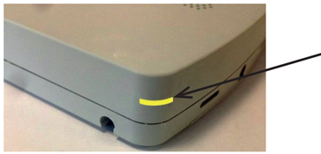 | LED Indication of Operation  Solid Yellow Charging  No LED light Fully charged  Flashing Yellow Error during charging

Deep discharge protection
- The Li-Ion battery has a deep discharge protection to protect the battery life. The deep discharge protection is activated when the battery is discharged.
- Charge the battery to exit the deep discharge mode. Ensure that the battery is sufficiently charged before use.
- If the battery is completely discharged, the charging will be started at a very small rate to protect the battery. In this case the yellow LED will be flashing. If the battery does not stop flashing and start charging normally within 12 hours (LED ON), the battery is defect and must be disposed according to disposal instructions.

Safety feature
The Li-Ion battery contains several mechanisms to protect itself from being damaged due to excessive use.

In case of overheating, the device will activate a thermal protection. No power output will be available until the temperature has returned to normal operating range. Overheating may occur by extensive use at high temperature or by exceeding the 1/19 duty cycle.

BA21 safety
The Li-Ion batteries for medical use are designed and manufactured to be safe through the product life. The battery manufacturer has performed various tests of the batteries in normal use, abuse and failure situations to verify the design and production methods. These tests have not shown any unacceptable risks.

- WARNING
Lithium ion batteries differ from the lead acid technology as they have a built-in deep discharge protection.

- Loss of power might happen due to the battery deep discharge protection and will only happen in case of continuous use of the battery despite warnings. In this event, there may be no warning and the application may not be able to move when expected.
- Do not open the battery housing as damaging the cell or circuitry may develop excessive heat. Lithium ion batteries that are defective, have been damaged or might produce excessive heat or fire are not allowed for transportation. (contact your local transportation provider)
- For safety reasons, please adhere to the indicated charging and operation temperature.
- In case the battery turns hot, disconnect it and evacuate the room and wait for 2 hours before taking further steps.
- Recharge batteries every 12 months at a minimum.
- Dispose of batteries in accordance with local regulations.

DO NOT:
- heat or burn the battery
- short circuit the battery
- expose the battery to high impact
- crush or puncture the battery
- use batteries with signs of damage or corrosion
- charge or store the battery near combustible material
- expose the battery to water or other liquids

Disconnecting the Battery
If equipped, the battery is installed underneath the control box. When storing the product extended periods, the battery should be disconnected from the control box.

Remove the rear base cover. | 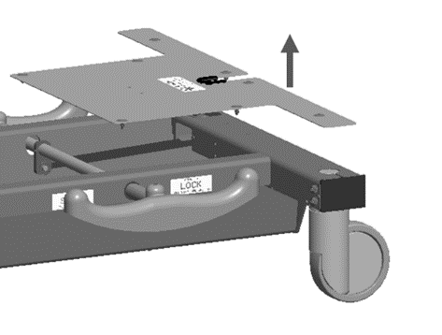
Open the top cover on the control box. | 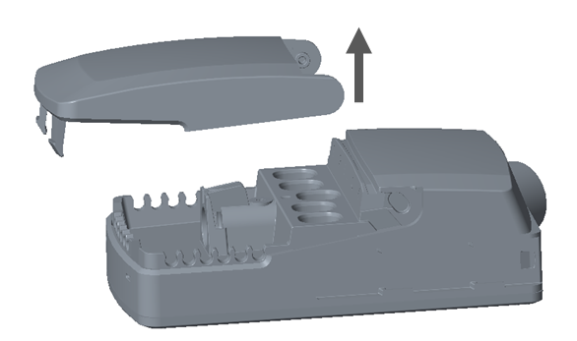
Unplug the battery cable from port 5 in the control box. | 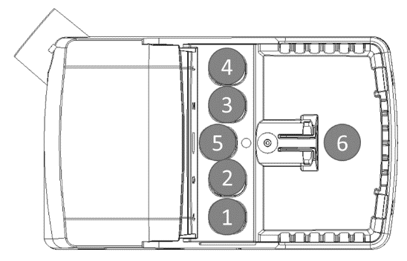
Replace the control box cover.  Replace the rear base cover. | 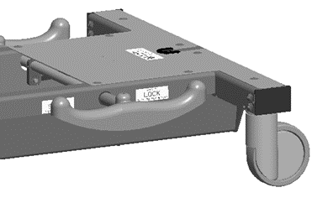

- WARNING

- Equipment should only be serviced by authorized personnel.
- Removal of secured covers may increase the risk of electrical shock. Refer servicing to qualified and authorized personnel.

Expected Life
The expected life of the product is 7 years of normal use. Some components may have a shorter life and require replacement.

Note: See Warranty section for warranty information.

Discard the Unit
Upon reaching the end of its useful life the product may be discarded in accordance with local and federal standards. Recycle when possible.

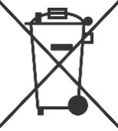 | In accordance with the European Directive 2002/96/EC on Waste Electrical and Electronic Equipment (WEEE), the product must not be disposed as unsorted municipal waste but should be collected separately. Consult your instructional policies and local regulations regarding disposal. Contact your Medical Positioning, Inc. Service Representative if additional disposal details are required.

Cleaning
Plastic and Painted Surfaces
The painted metal and plastic surfaces can be cleaned with normal cleaners and disinfectant.
STEP | ACTION
1 | Clean and/or disinfect with liquid cleaner of choice being careful to follow label instructions provided with cleaner. (Always test a small area first to determine suitability of solution)
2 | Wipe the surface clean with a damp cloth after applying cleaners and disinfectant to remove excess residue buildup.

Vinyl

The vinyl upholstered surfaces can be cleaned in one of the following ways:
The preferred method of everyday cleaning is using a soft cloth or sponge with mild soap and water or disinfectant. Spills and accidents require immediate attention for best results. When caught quickly, most stains such as grease, blood and felt tip pens can be wiped right off. Mild soap and water is the preferred method; however, typical hospital-grade antiseptic wipes work as well. For more stubborn stains, a variety of concentrated and solvent type cleansers may be used without damaging the surface as long as they are thoroughly rinsed off with water.

Always start with the mildest cleaning agents first. Never use harsh powdered abrasive cleansers or steel wool. Products containing bleach, ammonia or alcohol should be wiped from the surface with a wet cloth after use. Residue from these products will damage vinyl surfaces.

STEP | ACTION
1 | Clean and/or disinfect with liquid cleaner while being careful to follow label instructions provided with cleaner. (Always test a small area first to determine suitability of solution)
2 | Wipe the surface clean with a damp cloth after applying cleaners and disinfectant to remove excess residue buildup.

RECOMMENDED MAXIMUM CLEANER TO WATER SOLUTIONS
Mildest | 1:1 mix of mild soap and water. Wipe surface with damp cloth with water only after cleaning.
 | Straight application of common disinfectants. Wipe surface with damp cloth with water only after cleaning.
 | 1:1 mix of ammonia and water. Use a soft cotton cloth saturated with the cleaning material. Wipe surface with damp cloth with water only after cleaning.
 | 1:4 mix of bleach and water. Use a soft cotton cloth saturated with the cleaning material. Wipe surface with damp cloth with water only after cleaning.
 | 1:1 mix of isopropyl alcohol and water. Use a soft cotton cloth saturated with the cleaning material. Wipe surface with damp cloth with water only after cleaning.
 | Straight application of isopropyl alcohol. Use a soft cotton cloth saturated with the cleaning material. Wipe surface with damp cloth with water only after cleaning.
Strongest | 1:1 mix of acetone and water. Use a soft cotton cloth saturated with the cleaning material. Wipe surface with damp cloth with water only after cleaning.

This information is not a guarantee and does not relieve the user from the responsibility of proper and safe use of the product and all cleaning agents.

- WARNING

- It is recommended that the product be cleaned between patients; please follow your facility’s documented policy.
- CAUTION

- Substances such as imaging gels and alcohol will not damage the vinyl surface when
immediately removed. Studies have shown that exposure for longer than a few minutes can
damage the top coat and will eventually discolor vinyl.
- Always read manufacturer’s instructions and warnings before using any cleaning product or disinfectant.
- Do not use abrasives to clean painted surfaces.

Service Calls
A “Troubleshooting Guide” is included to instruct you in the event of a malfunction. If you are experiencing any of the following symptoms, this guide may help you quickly solve the problem. If, after consulting this guide, you are still unable to operate your product please contact MPI at 1-800-593-3246. Please have the following information ready when you call:
- Model Number or Name of Product
- Serial Number
- Date Received
- Condition When Received
- Symptom (or problem) Encountered & Result of Troubleshooting Procedure

Complaint Reporting Procedure
In the event of a product malfunction or patient injury, please immediately report the incident to:

1. __________________________________________________________
(The distributor from whom the product was purchased)
2. Medical Positioning, Inc.
1146 Booth Street
Kansas City, KS 66103
www.MedicalPositioning.com
816-474-1555
800-593-3246 (ECHO)

Troubleshooting Guide

SYMPTOM | PROBABLE CAUSE | SUGGESTION
No Actuator Function  Actuator(s) Not Running | - Power cord not plugged all the way into wall receptacle. | - Push power cord securely into receptacle.
 | - Power outlet receptacle not supplying AC power. | - Check power availability or plug unit into another receptacle.
 | - The power cord may be separated from the control box. | - Securely press power cord into control box.
 | - Battery may be drained. | - Replace or charge battery.
 | - Actuator cord may be unplugged. | - Push actuator cords securely into actuator receptacle.
 | - Product was overloaded and tripped internal fuse in control box. | - Replace control box.
 | - Product motion is limited at certain heights and angles. | - Return the surface to a level position to restore full range of motion
 | - The product will not move when hand control buttons are pressed. | - The hand control buttons may be locked. Press and hold the control lock/unlock button for 3 seconds until a beep is heard.
Control box beeps | - Control system limits certain product positions. Beeps indicate limit positions. | - Return the surface to a level position to restore full range of motion
 | - Control box will beep when memory function is set | - Normal operation, no action necessary.
 | - Control box will beep 2 times when control lock/unlock function is activated. | - Normal operation, no action necessary.
 | - Battery may be drained. | - Replace or charge battery.

SYMPTOM | PROBABLE CAUSE | SUGGESTION
Squeaking noises during operation. | - Actuator pins are not sufficiently lubricated | - Apply WD40 or similar lubricant to actuator pins.
The footrest opens too easily. | - Footrest hinge may need to be adjusted. | - Tighten footboard hinge bolts.

- WARNING
- Do not modify this equipment without authorization of the manufacturer.
- Removal of secured covers may increase the risk of electrical shock. Refer servicing to qualified personnel.
- The battery should be periodically inspected for damage. Replace the battery if necessary.

Specifications

Product Models & Attributes
UltraScan VersaTM

ATTRIBUTE | 087/287 | 092 | 095/295 | 987 | 995
Base Width | 28.5” | 28.5” | 28.5” | 28.5” | 28.5”
Base Length | 33.5” | 33.5” | 33.5” | 33.5” | 33.5”
Surface Width | 28” | 28” | 28” | 28” | 28”
Surface Length | 72” | 72” | 72” | 72” | 72”
Surface Height Range  *To top of cushion | 22” – 38” | 22” – 38” | 22” – 38” | 22” – 38” | 22” – 38”
Fowler Range | 0°-90° | 0°-90° | 0°-90° | 0°-90° | 0°-90°
Calf Range | 0° - 88° | 0° - 88° | 0° - 88° | 0° - 88° | 0° - 88°
Trendelenburg Range | N/A | 15° / 25° | 15° / 15° | N/A | 15° / 15°
# of Drop Sections | 0 / 2 | 0 | 0 / 2 | 0 | 0
# of Integrated Armboards | 0 | 0 | 0 | 2 | 2
Maximum Patient Weight | 500lb | 500lb | 500lb | 500lb | 500lb
Maximum Safe Working Load | 527lb | 527lb | 527lb | 527lb | 527lb
Approximate Product Weight | 350lb | 350lb | 350lb | 350lb | 350lb

Environmental Conditions
ATTRIBUTE | Range for Use | Range for Storage and Transport
Ambient Temperature | +5° to 40° C | -10° to +40° C
Relative Humidity | 20% to 80% @ 30°C  non-condensing | 20% to 80% @ 30°C  non-condensing
Atmospheric Pressure | 700 to 1060 hPa | 700 to 1060 hPa

Upholstery
ATTRIBUTE | SPECIFICATION
Foam | California Technical Bulletin 117
Vinyl | California Technical Bulletin 117

Power Requirements
ATTRIBUTE | SPECIFICATION
Electrical, Product | 100–240 VAC, 50/60 Hz, max 4.5 A
Battery Option | 25.9V, 2.25Ah, 58.28Wh
Duty Cycle | 10% max, 2 min. on / 18 min. off
Battery Duty Cycle | 5% max, 1 min on / 19 min off

- All electrical circuitry is isolated from chassis.
- Grounding reliability can only be achieved when the equipment is connected to an equivalent receptacle marked “Hospital Only” or “Hospital Grade.”
- The power cord is to be used for mains disconnection.
- Attached power supply cord set is not allowed to be diverted to other equipment.

Classifications and Standards
ATTRIBUTE | SPECIFICATION
Standards | - IEC 60601-1:2005 + A1:2012  - ANSI/AAMI ES60601-1:2005/(R)2012 and A1:2012, C1:2009/(R)2012 and A2:2010/(R)2012  - CAN/CSA-C22.2 NO. 60601-1:14  - EN 60601-1:2006 +A11:2011 +A1:2013 +AC:2014  - IEC 60601-1-2:2007  - EN/ISO 14971:2012
Protection against Electrical Shock | - Class I equipment  - Type B applied part
Degree of protection against Dust and Fluid intrusion | - IPX0

Applied Parts (in accordance with IEC 60601-1)
- All padded surfaces
- Arm rests
Electromagnetic Emissions Guidance
The product use components that meet the requirements for
IEC 60601-1-2. Other products that are used in the vicinity of this product should also comply with this standard. If they do not comply, electromagnetic interference between the products could cause the products to operate incorrectly. If problems do occur, contact the product manufacturer(s).
Make sure the product operates correctly when used near other electronic devices. Portable and mobile radio frequency (RF) communications equipment can affect electrical equipment.

- WARNING

- If the product is used adjacent to other electrical equipment, observe this product and the other electrical equipment to make sure they operate as intended.

Electromagnetic Compatibility
Medical electrical equipment needs special precautions regarding electromagnetic compatibility (EMC) and needs to be installed and put into service according to the EMC information provided in this user manual.

Portable and mobile radio frequency (RF) communications equipment can affect medical electrical equipment.

Guidance and Manufacturer's Declaration - Electromagnetic Emissions
The product is intended for use in the electromagnetic environments specified below. The customer or the user of the product should assure it is used in such an environment.
Emissions Test | Compliance | Guidance
RF Emissions  CISPR 11 | Group 1 | This product uses RF energy only for its internal function. Therefore, its RF emissions are very low and are not likely to cause any interference in nearby electronic equipment.
RF Emissions  CISPR 11 | Class A | The product is suitable for use in all establishments other than domestic and those directly connected to the public low-voltage power supply network that supplies buildings used for domestic purposes.
Harmonic  Emissions  IEC 61000-3-2 | N/A
Voltage  Fluctuations/  Flicker Emissions  IEC 61000-3-3 | N/A

Guidance and Manufacturer's Declaration - Electromagnetic Immunity
The product is intended for use in the electromagnetic environments specified below. The customer or the user of the product should assure it is used in such an environment.
Immunity  Test | IEC 60601  Test Level | Compliance Level | Guidance
Electrostatic  Discharge  IEC 61000- 4-2 | ± 6 kV Contact  ± 8 kV Air | ± 6 kV Contact  ± 8 kV Air | Floors should be wood, concrete, or ceramic tile. If floors are covered with synthetic material, the relative humidity should be at least 30%.
Electrical  Fast Transient/  Burst  IEC 61000-4-4 | ± 2 kV on power  Supply Lines  ± 1 kV on Input/Output Lines | ± 2 kV on Power  Supply Lines  ± 1 kV on  Input/Output Lines | Mains power quality should be that of a typical commercial or hospital environment
Surge  IEC 61000-4-5 | ± 1 kV Differential  Mode  ± 2 kV Common  Mode | ± 1 kV Differential  Mode  ± 2 kV Common  Mode | Mains power quality should be that of a typical commercial or hospital environment
Voltage Dips, Short Interrupts,  & Variations on Power Supply Lines  IEC 61000-4-11 | < 5% U_{T}  (95% dip in  U_{T} for 0.5 cycles)  < 40% U_{T}  (60% dip in  U_{T} for 5 cycles)  < 70% U_{T}  (30% dip in  U_{T} for 25 cycles) | < 5% U_{T}  (95% dip in  U_{T} for 0.5 cycles)  < 40% U_{T}  (60% dip in  U_{T} for 5 cycles)  < 70% U_{T}  (30% dip in  U_{T} for 25 cycles) | Mains power quality should be that of a typical commercial or hospital environment. If the user of the product requires continued operation during mains interruptions, it is recommended that the product be powered from an uninterruptible power supply or a battery.
Power Frequency  Magnetic Fields  IEC 61000-4-8 | 3 A/m | 3 A/m | Power frequency magnetic fields should be at levels characteristic of a typical location in a typical commercial or hospital environment.
NOTE U_{T} is the a.c. mains voltage prior to application of the test level

Guidance and Manufacturer's Declaration - Electromagnetic Immunity
The product is intended for use in the electromagnetic environments specified below. The customer or the user of the product should assure it is used in such an environment.
Immunity  Test | IEC 60601  Test Level | Compliance Level | Guidance
Conducted RF  IEC 61000-4-6  Radiated RF IEC 61000-4-3 | 3 Vrms  150 kHz to 80 Mhz  3 Vrms  80 MHz to 2.5 GHz | 3 Vrms  3 V/m | Portable and mobile RF communications equipment should be used no closer to any part of the product, including cables, than the recommended separation distance calculated from the equation applicable to the frequency of the transmitter.  Recommended separation distance  80 MHz to 800 MHz  800 MHz to 2.5 GHz  Where P is the maximum output power rating of the transmitter in watts (W) according to the transmitter manufacturer and d is the recommended separation distance in meters (m).  Filed strengths from fixed RF transmitters, as determined by an electromagnetic site survey,ª should be less than the compliance level in each frequency range.^{b}  Interference may occur in the vicinity of equipment marked with the following symbol:
NOTE 1 At 80 MHz and 800 MHz, the higher frequency range applies.

NOTE 2 These guidelines may not apply in all situations. Electromagnetic propagation is affected by absorption and reflection from structures, objects and people.
ª Field strengths from fixed transmitters, such as base stations for radio (cellular/cordless) telephones and land mobile radios, amateur radio, AM and FM radio broadcast and TV broadcast cannot be predicted theoretically with accuracy. To assess the electromagnetic environment due to fixed RF transmitters, an electromagnetic site survey should be considered. If the measured field strength in the location in which the product is used exceeds the applicable RF compliance level above, the product should be observed to verify normal operation. If abnormal performance is observed, additional measures may be necessary, such as reorienting or relocating the product.

^{b} Over the frequency range 150 kHz to 80 MHz, field strengths should be less than [V1] V/m.

Recommended separation distances between
portable and mobile RF communications equipment and the MPI Echo Products
The product is intended for use in an electromagnetic environment in which radiated RF disturbances are controlled. The customer or the user of the product can help prevent electromagnetic interference by maintaining a minimum distance between portable and mobile RF communications equipment (transmitters) and the product as recommended below, according to the maximum output power of the communications equipment.
Rated maximum output power of transmitter | Separation distance according to frequency of transmitter  (m)
 | 150 kHz to 80 MHz | 80 MHz to 800 MHz | 800 MHz to 2.5 GHz
0.01 | 0,12 | 0,12 | 0,23
0.1 | 0,38 | 0,38 | 0,73
1 | 1,2 | 1,2 | 2,3
10 | 3,8 | 3,8 | 7,3
100 | 12 | 12 | 23
For transmitters rated at a maximum output power not listed above, the recommended separation distance d in meters (m) can be estimated using the equation applicable to the frequency of the transmitter, where P is the maximum output power rating of the transmitter in watts (W) according to the transmitter manufacturer.

NOTE 1 At 80 MHz and 800 MHz, the separation distance for the higher frequency range applies.

NOTE 2 These guidelines may not apply in all situations. Electromagnetic propagation is affected by absorption and reflection from structures, objects and people.

Replacement Parts and Upgrade Kits
The following items are replacements parts or upgrade kits for UltraScan Versa. Some of the items below may not be suitable for all models of product.

Part Description | Part #
5 Function Hand Control | 15749
6 Function Hand Control | 15747
1 Function Foot Control (Height)¹ | 15755
2 Function Foot Control (Fowler/Calf)¹ | 15756
2 Function Foot Control (Height/Fowler)¹ | 15792

Kit Description | Part #
Multi-Function Control Kit | 15836
Battery Functionality Kit | 15837
Underbed Light Kit² | 15838
IV Pole Kit | 15604
Carotid Headrest Kit | 15507
Head Rail Kit | 15602
Stirrup Kit | 15839
Armboard Kit | 11020
Underbed Hook Kit | 15510
Sonographer Extension Kit | 15767
Handrail Kit | 15819
Paper Roll Holder Kit | 10098
Footboard Upgrade Kit | 15841
Safety Strap Kit | 15843
Push Bar Kit | 15844
¹The Multi-Function Control Kit is required to use multiple foot/hand controls.
²The Multi-Function Control Kit is required with the Under-bed Light Kit.

Warranty
Warranty

UltraScan Versa™
2
YEAR WARRANTY

Medical Positioning, Inc. (“MPI”) warrants and represents that this product will be free from material and workmanship defects during the period indicated above (the “Warranty Period”), commencing with tender of delivery as defined in Uniform Commercial Code § 2-503, irrespective of any inspection period and provided that the product is maintained and operated in accordance with MPI’s specifications.

If the product fails due to a manufacturing defect, MPI will, at its sole expense and discretion, repair the product, authorize repairs to the product, or replace the product. MPI will ship any replacement products or parts using standard shipping rates; if the customer requires expedited shipping of replacement products or parts, the customer is responsible for paying shipping costs above standard rates.

Preventative maintenance and repairs due to damage by use, accident, improper care, negligence, or other non-defect related failures are not covered by this warranty. This warranty is void as to products that have been modified without the advance written permission of MPI.

OTHER THAN AS SET FORTH HEREIN, MPI MAKES NO WARRANTY WHATSOEVER, EITHER EXPRESSED OR IMPLIED, WITH RESPECT TO THIS PRODUCT. MPI SPECIFICALLY DISCLAIMS THE (a) IMPLIED WARRANTY OF MERCHANTABILITY; (b) WARRANTY OF FITNESS FOR A PARTICULAR PURPOSE; AND (c) WARRANTY AGAINST INFRINGEMENT OF ANY PATENT, COPYRIGHT, TRADEMARK, TRADE SECRET OR OTHER PROPRIETARY RIGHTS OF A THIRD PARTY; WHETHER ARISING BY LAW, COURSE OF DEALING, COURSE OF PERFORMANCE, USAGE OF TRADE OR OTHERWISE.

This warranty is nontransferable. The remedies provided under this warranty are the customer’s sole and exclusive remedies. In no event will MPI be liable for any direct, indirect, special, incidental, consequential damages or lost profits or income whether based on contract, tort, or any other legal theory.

Medical Positioning, Inc.
1146 Booth Street
Kansas City, Kansas 66103
(816) 474-1555
(800) 593-3246
Fax (816) 474-7755
WAR069-B

Return Policy

MPI accepts returns of unused products within 30 days from the date of delivery, irrespective of any inspection period. Returns are subject to a 30% restocking fee, any applicable duties or taxes and quality inspection. No product may be returned without prior written authorization from MPI. The customer is responsible for all shipping charges and any applicable duties or taxes incurred in connection with a return.

WAR093-A

