Owner’s Manual
Models: 60012, 60232, 60362

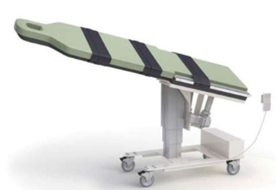

Owner _____________________

Model _____________________

Serial # _____________________

Date _____________________

Table of Contents

Symbols and Definitions 3
Safety Warnings & Cautions 5
Intended Use 7
Set Up 7
Transport Position 7
Product Labels 8
Use Instructions 9
Powering the Product 9
Locking the Casters 9
Hand Control Functions 10
Adjusting Surface Height 10
Adjusting Trendelenburg 10
Adjusting Lateral Roll 10
Preventative Maintenance 11
Expected Life 12
Discard the Unit 12
Cleaning 13
Service Calls 15
Troubleshooting Guide 16
Specifications 17
Warranty 20
Return Policy 21

Symbols and Definitions

 | Warning, follow instructions for use. Failure to comply may result in injury.
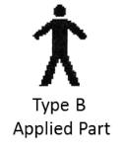 | Applied Part complying with specified requirements IEC 60601-1 to provide protection against electric shock, particularly regarding allowable patient leakage current.
 | Warning/Caution
 | Any terminal which is intended for connection to an external protective conductor for protection against electric shock in case of a fault.
 | In accordance with the European Directive 2002/96/EC on Waste Electrical and Electronic Equipment (WEEE), the product must not be disposed as unsorted municipal waste but should be collected separately. Consult your instructional policies and local regulations regarding disposal. Contact your Medical Positioning, Inc. Service Representative if additional disposal details are required.
 | Manufacturer
 | Agency Mark
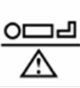 | Maximum Patient Weight. Indicates the maximum patient weight that may be placed on the product.
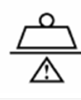 | Safe Working Load. Indicates the sum of the patient weight and accessories that may be placed on the product.

WARNING / CAUTION / NOTE Definition

The words WARNING, CAUTION, and NOTE carry special meanings and should be carefully reviewed.

- WARNING

Identifies a situation that could result in injury to the patient or caregiver.

- CAUTION

Identifies a situation that could result in equipment damage.

Note
Provides special information to make an important instruction clearer.

Safety Warnings & Cautions

- WARNING:
Obey these safety instructions to help prevent injury and/or equipment damage:

- Read and understand all warnings in this manual and on the unit itself prior to use with a patient.
- The device should be operated by trained persons only.
- Authorized and qualified persons will be those who are approved by Medical Positioning Inc. to repair or modify the product.
- Do not modify this equipment without authorization of the manufacturer.
- Equipment should only be serviced by authorized personnel.
- The procedures in this manual are only manufacturer’s suggestions. The final responsibility for patient care with respect to this device remains with the attending physician.
- Do not use in an oxygen rich environment.
- Do not leave patient unattended while using the product.
- To reduce the risk of electric shock, grounding reliability can only be achieved when the equipment is connected to an equivalent receptacle marked “hospital only” or “hospital grade”.
- If damage has occurred to the power cord, immediately remove the cord from service. Failure to do so could result in serious injury or death.
- Removal of secured covers may increase the risk of electrical shock. Refer servicing to qualified and approved personnel.
- The potential for electrical shock exists with electrical equipment. Failure to follow facility protocols may cause death or serious injury.
- Ensure the patient is properly secured prior to using the equipment.
- To reduce the risk of a potential injury, lock casters before using equipment.
- Once the product and patient have been properly positioned for the procedure, ensure the casters are locked and the hand controller is placed in a safe position to prevent unwanted contact and unwanted movement of the support surface.
- To reduce the risk of the product becoming unbalanced, always position the product in the lowest reasonable height when moving.
- Verify the area around the product is free of impediments before operating to prevent injury or equipment damage.
- Keep hands and feet clear from beneath the patient surface when lowering surface height or making positioning adjustments in order to avoid possible injury.
- Sitting at the end of the patient surfaces can result in device instability. Do not allow a patient to sit at the head end of the patient surface.
- Protect upholstery from sharp objects and abrasion to avoid damage.
- Always read manufacturer’s instructions and warnings before using any cleaning product or disinfectant. Refer to instructions located in this manual for cleaning recommendations.
- Substances such as imaging gels and alcohol will not damage the upholstered surface when immediately removed. Extended exposure for longer than a few minutes can damage the top coat and will eventually discolor the upholstery.
- Do not use abrasives to clean painted surfaces.
- It is recommended that the product be cleaned between patients; please follow your facility’s documented policy.
- Keep this manual available for future reference.
- If the product is used adjacent to other electrical equipment, observe the product and the other electrical equipment to ensure they operate as intended.
- Do not exceed the weight capacity of the product.

Intended Use

The GSPM™ Table is designed to be used for fluoroscopic examination and treatment requiring positioning of the patient with a C-arm imaging device. This product is intended to be used in an environment where C-arms and other such diagnostic equipment is present, including hospitals, outpatient facilities, and doctor’s offices. The product is intended to be used by trained healthcare professionals who possess the ability to operate the product safely. The product’s movements are controlled electronically via the product’s hand control.
The product is not intended for use in oxygen rich environments.

Set Up

After unpacking the product, an initial test should be performed to ensure that each function is in correct working order. After performing the test and reviewing this manual the product is ready for use.

STEP | ACTION
1 | After removing padding and packaging materials locate primary power supply cord and attach to suitable grounded power outlet.
2 | To test actuator function, locate the hand control and depress each button one at a time. (Depressing multiple buttons simultaneously will prevent the actuators from operating.)
3 | If any function does not operate, perform the test procedures listed in the Troubleshooting Guide.

Transport Position

This product is not intended as a patient transport device.

Product Labels

Unique Device Identification Label

- Serial #
- Item #
- Item Description
- Unique Identifier
Certification Label | 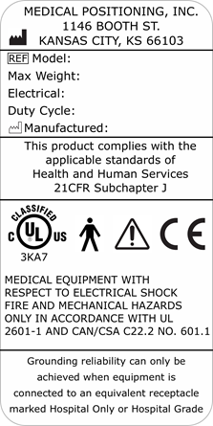
Refer to Manual Label
Warning Label  Do Not Leave Patient Unattended | 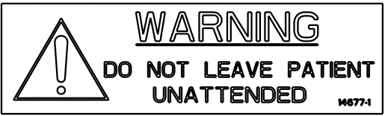
Hand Control | 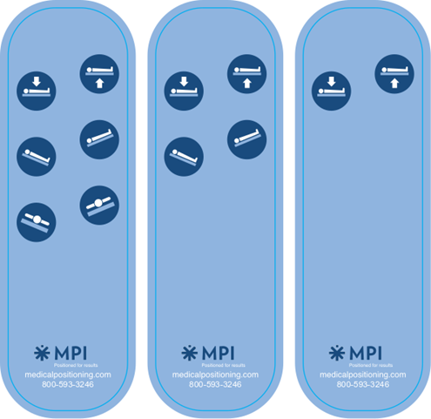

Use Instructions

Powering the Product
The product is powered by AC power from a wall outlet. The product is “on” whenever it is plugged into AC power. The product should not be positioned in a way that would make it difficult to remove power by unplugging the AC power cord.

- WARNING

- To reduce the risk of electrical shock, grounding reliability can only be achieved when the equipment is connected to an equivalent receptacle marked “hospital only” or “hospital grade.”
- If damage has occurred to the power cord, immediately remove the cord from service. Failure to do so could result in serious injury or death.

Locking the Casters

In the locked position casters are prevented from both rolling and swiveling.

Individual Locking Casters  The locking tab is located on each caster. Push down to lock, lift to unlock. | 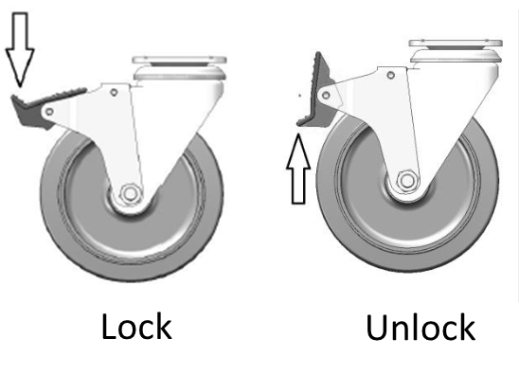

- WARNING

- Once the product and patient have been properly positioned for the procedure, ensure the casters are locked and the hand controller is placed in a safe position to prevent unwanted contact and unwanted movement of the product surface during the procedure.

Hand Control Functions
Hand control functions will vary depending on the model purchased. Your hand control may not include all the functions listed below.

Adjusting Surface Height
The table surface height may be adjusted between 31” and 41”.

Press and hold the applicable hand control function to adjust the seat height.

Adjusting Trendelenburg
The table surface may be tilted between 20° Trendelenburg and 20° reverse Trendelenburg.

Press and hold the applicable hand control function to independently adjust the Trendelenburg angle.

Adjusting Lateral Roll
The table surface may be laterally tilted 20° to the left or right.

Press and hold the applicable hand control function to independently adjust the Fowler.

- WARNING

- Verify the area around the product is free of impediments before operating to prevent injury or equipment damage.
- Keep hands and feet clear from beneath the patient surface when lowering surface height or making positioning adjustments in order to avoid possible injury.

Preventative Maintenance

The following Preventative Maintenance should be performed at a minimum annually. If any of these checks fail, repair or replace the part as applicable.
- Visually inspect all mechanical assemblies and moving parts on the product ensuring smooth, steady operation.
- Visually inspect all fasteners (bolts, nuts, screws, etc.) to ensure all are fully installed. Tighten as necessary.
- Visually inspect all electrical cables and wires for signs of abrasion or other damage. If damaged, replace.
- Visually inspect all electrical connections to ensure they are fully and properly connected. Reconnect as necessary.
- Visually inspect the hand control. If damaged, replace.
- Operate all motors to ensure full extension, retraction and correct operation. The motors are permanently lubricated and require no additional lubrication.
- Operate the braking system to ensure proper engagement of the wheel and swivel lock mechanism. Replace as necessary.
- Operate all accessories to ensure proper attachment and operation. Tighten, adjust or replace if necessary.
- Unauthorized modification of this product voids any applicable warranty.

- WARNING

- No modification of this equipment is allowed.
- Equipment should only be serviced by authorized personnel.
- Removal of secured covers may increase the risk of electrical shock. Refer servicing to qualified and authorized personnel.
- The potential for electrical shock exists with electrical equipment. Failure to follow facility protocols may cause death or serious injury.

Expected Life
The expected life of the product is 7 years of normal use. Some components may have a shorter life and require replacement.

Note: See Warranty section for warranty information.

Discard the Unit
Upon reaching the end of its useful life the product may be discarded in accordance with local and federal standards. Recycle when possible.

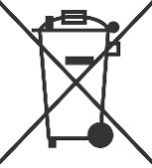 | In accordance with the European Directive 2002/96/EC on Waste Electrical and Electronic Equipment (WEEE), the product must not be disposed as unsorted municipal waste but should be collected separately. Consult your instructional policies and local regulations regarding disposal. Contact your Medical Positioning, Inc. Service Representative if additional disposal details are required.

Cleaning
Plastic and Painted Surfaces
The painted metal and plastic surfaces can be cleaned with normal cleaners and disinfectant.
STEP | ACTION
1 | Clean and/or disinfect with liquid cleaner of choice being careful to follow label instructions provided with cleaner. (Always test a small area first to determine suitability of solution)
2 | Wipe the surface clean with a damp cloth after applying cleaners and disinfectant to remove excess residue buildup.

Upholstery

The upholstered surfaces can be cleaned in one of the following ways:
The preferred method of everyday cleaning is using a soft cloth or sponge with mild soap and water or disinfectant. Spills and accidents require immediate attention for best results. When caught quickly, most stains such as grease, blood and felt tip pens can be wiped right off. Mild soap and water is the preferred method; however, typical hospital-grade antiseptic wipes work as well. For more stubborn stains, a variety of concentrated and solvent type cleansers may be used without damaging the surface as long as they are thoroughly rinsed off with water.

Generally speaking, always start with the mildest cleaning agents first. Never use harsh powdered abrasive cleansers or steel wool. Products containing bleach, ammonia or alcohol should be wiped from the surface with a wet cloth after use. Residue from these products will damage upholstery surfaces.

STEP | ACTION
1 | Clean and/or disinfect with liquid cleaner while being careful to follow label instructions provided with cleaner. (Always test a small area first to determine suitability of solution)
2 | Wipe the surface clean with a damp cloth after applying cleaners and disinfectant to remove excess residue buildup.

RECOMMENDED MAXIMUM CLEANER TO WATER SOLUTIONS
Mildest | 1:1 mix of mild soap and water. Wipe surface with damp cloth with water only after cleaning.
 | Straight application of common disinfectants. Wipe surface with damp cloth with water only after cleaning.
 | 1:1 mix of ammonia and water. Use a soft cotton cloth saturated with the cleaning material. Wipe surface with damp cloth with water only after cleaning.
 | 1:4 mix of bleach and water. Use a soft cotton cloth saturated with the cleaning material. Wipe surface with damp cloth with water only after cleaning.
 | 1:1 mix of isopropyl alcohol and water. Use a soft cotton cloth saturated with the cleaning material. Wipe surface with damp cloth with water only after cleaning.
 | Straight application of isopropyl alcohol. Use a soft cotton cloth saturated with the cleaning material. Wipe surface with damp cloth with water only after cleaning.
Strongest | 1:1 mix of acetone and water. Use a soft cotton cloth saturated with the cleaning material. Wipe surface with damp cloth with water only after cleaning.

This information is not a guarantee and does not relieve the user from the responsibility of proper and safe use of the product and all cleaning agents.

- WARNING

- It is recommended that the product be cleaned between patients; please follow your facility’s documented policy.
- CAUTION

- Always read manufacturer’s instructions and warnings before using any cleaning product or disinfectant.
- Substances such as imaging gels and alcohol will not damage the upholstered surface when
immediately removed. Studies have shown that exposure for longer than a few minutes can damage the top coat and will eventually discolor the upholstery.
- Do not use abrasives to clean painted surfaces.

Service Calls
A “Troubleshooting Guide” is included to instruct you in the event of a malfunction. If you are experiencing any of the following symptoms, this guide may help you quickly solve the problem. If, after consulting this guide, you are still unable to operate your product please contact Medical Positioning at 1-800-593-3246. Please have the following information ready when you call:
- Model Number or Name of Product
- Serial Number
- Date Received
- Condition When Received
- Symptom (or problem) Encountered & Result of Troubleshooting Procedure

Adverse Event Reporting
Any serious incident that has occurred in relation to the device should be reported immediately to Medical Positioning. If located in the European Union, please immediately contact Medical Positioning and the competent authority of the Member State in which the user and/or patient is established.

Medical Positioning, Inc.
1146 Booth Street
Kansas City, KS 66103
www.MedicalPositioning.com
816-474-1555
800-593-3246 (ECHO)

Troubleshooting Guide

SYMPTOM | PROBABLE CAUSE | SUGGESTION
No Actuator Function  Actuator(s) Not Running. | - Power cord not plugged all the way into wall receptacle. | - Push power cord securely into receptacle.
 | - Power outlet receptacle not supplying 120 VAC power. | - Check power availability or plug unit into another receptacle.
 | - The power cord may be separated from the control box. | - Securely press power cord into control box.
 | - Actuator cord may be unplugged. | - Push actuator cords securely into actuator receptacle.
 | - Product was overloaded and tripped internal fuse in control box. | - Replace control box.
Squeaking noises during operation. | - Actuator pins are not sufficiently lubricated | - Apply WD40 or similar lubricant to actuator pins.

- WARNING
- Do not modify this equipment without authorization of the manufacturer.
- Removal of secured covers may increase the risk of electrical shock. Refer servicing to qualified personnel.

Specifications

Product Attributes

GSPM Table Specifications
 | 60012 | 60232 | 60362
Base Width | 22” | 22” | 22”
Base Length | 39” | 39” | 39”
Surface Width | 22” | 22” | 22”
Surface Length | 84” | 84” | 84”
Surface Height Range  *To top of cushion | 31”-41” | 31”-41” | 31”-41”
Lateral Tilt Range | N/A | N/A | 20°/20°
Trendelenburg Range | N/A | 20°/20° | 20°/20°
Maximum Patient Weight | 500lb | 500lb | 500lb
Approximate Product Weight | 556lb | 556lb | 556lb

Replacement Parts and Upgrade Kits
The following items are replacements parts or upgrade kits for the GSPM Table. Some of the items below may not be suitable for all models of product.

Part Description | Part #
Foot Control | 11942
Carbon Fiber Arm boards | 11322
Safety Straps | 11430

Environmental Conditions
ATTRIBUTE | Range for Use | Range for Storage and Transport
Ambient Temperature | +0° to 40° C | -40° to +70° C
Relative Humidity | 20% to 90% @ 30°C – not condensing | 10% to 100%
Atmospheric Pressure | 860 to 1060 hPa | 500 to 1060 hPa

Upholstery
ATTRIBUTE | SPECIFICATION
Foam | California Technical Bulletin 117

Power Requirements
ATTRIBUTE | SPECIFICATION
Electrical, Product | 120VAC, 60 Hz, max 1.6A
Duty Cycle | 10%, 1 min. on / 9 min. off

- All electrical circuitry is isolated from chassis.
- Grounding reliability can only be achieved when the equipment is connected to an equivalent receptacle marked “Hospital Only” or “Hospital Grade.”
- The power cord is to be used for mains disconnection.
- Attached power supply cord set is not allowed to be diverted to other equipment.

Classifications and Standards
ATTRIBUTE | SPECIFICATION
Standards | - UL 60601-1  - CAN/CSA C22.2 No 601.1
Protection against Electrical Shock | - Class I equipment  - Type B applied part
Degree of protection against Dust and Fluid intrusion | - IPX0

Applied Parts (in accordance with IEC 60601-1)
- All padded surfaces
Electromagnetic Emissions Guidance
The product use components that meet the requirements for
IEC 60601-1-2. Other products that are used in the vicinity of this product should also comply with this standard. If they do not comply, electromagnetic interference between the products could cause the products to operate incorrectly. If problems do occur, contact the product manufacturer(s).
Make sure the product operates correctly when used near other electronic devices. Portable and mobile radio frequency (RF) communications equipment can affect electrical equipment.

- WARNING

- If the product is used adjacent to other electrical equipment, observe this product and the other electrical equipment to make sure they operate as intended.

Warranty
Warranty

GSPM™ Table
5
YEAR WARRANTY

Medical Positioning, Inc. (“MPI”) warrants and represents that this product will be free from material and workmanship defects during the period indicated above (the “Warranty Period”), commencing with tender of delivery as defined in Uniform Commercial Code § 2-503, irrespective of any inspection period and provided that the product is maintained and operated in accordance with MPI’s specifications.

If the product fails due to a manufacturing defect, MPI will, at its sole expense and discretion, repair the product, authorize repairs to the product, or replace the product. MPI will ship any replacement products or parts using standard shipping rates; if the customer requires expedited shipping of replacement products or parts, the customer is responsible for paying shipping costs above standard rates.

Preventative maintenance and repairs due to damage by use, accident, improper care, negligence, or other non-defect related failures are not covered by this warranty. This warranty is void as to products that have been modified without the advance written permission of MPI.

OTHER THAN AS SET FORTH HEREIN, MPI MAKES NO WARRANTY WHATSOEVER, EITHER EXPRESSED OR IMPLIED, WITH RESPECT TO THIS PRODUCT. MPI SPECIFICALLY DISCLAIMS THE (a) IMPLIED WARRANTY OF MERCHANTABILITY; (b) WARRANTY OF FITNESS FOR A PARTICULAR PURPOSE; AND (c) WARRANTY AGAINST INFRINGEMENT OF ANY PATENT, COPYRIGHT, TRADEMARK, TRADE SECRET OR OTHER PROPRIETARY RIGHTS OF A THIRD PARTY; WHETHER ARISING BY LAW, COURSE OF DEALING, COURSE OF PERFORMANCE, USAGE OF TRADE OR OTHERWISE.

This warranty is nontransferable. The remedies provided under this warranty are the customer’s sole and exclusive remedies. In no event will MPI be liable for any direct, indirect, special, incidental, consequential damages or lost profits or income whether based on contract, tort, or any other legal theory.

Medical Positioning, Inc.
1146 Booth Street
Kansas City, Kansas 66103
(816) 474-1555
(800) 593-3246
Fax (816) 474-7755
WAR069-B

Return Policy

MPI accepts returns of unused products within 30 days from the date of delivery, irrespective of any inspection period. Returns are subject to a 30% restocking fee, any applicable duties or taxes and quality inspection. No product may be returned without prior written authorization from MPI. The customer is responsible for all shipping charges and any applicable duties or taxes incurred in connection with a return.

WAR093-A

