

Owner’s Manual

DBI™ Table

Owner \_\_\_\_\_\_\_\_\_\_\_\_\_\_\_\_\_\_\_\_\_

Model \_\_\_\_\_\_\_\_\_\_\_\_\_\_\_\_\_\_\_\_\_

Serial # \_\_\_\_\_\_\_\_\_\_\_\_\_\_\_\_\_\_\_\_\_

Date \_\_\_\_\_\_\_\_\_\_\_\_\_\_\_\_\_\_\_\_\_

Medical Positioning, Inc.

9732 Pflumm Road, Lenexa, KS 66215 | T: 816-474-1555 | 1-800-593-3246

[www.MedicalPositioning.com](http://www.MedicalPositioning.com)

Table of Contents

[Table of Contents 2](#_Toc36821671)

[Symbols and Definitions 4](#_Toc36821672)

[European Union Representative 5](#_Toc36821673)

[Precautions 5](#_Toc36821674)

[Intended Use 7](#_Toc36821675)

[Training and Qualifications 7](#_Toc36821676)

[Patient Positioning 8](#_Toc36821677)

[Set Up 10](#_Toc36821678)

[Safety Features 10](#_Toc36821679)

[Operation 11](#_Toc36821680)

[Hand-Wand 11](#_Toc36821681)

[Individual Lock Casters 12](#_Toc36821682)

[Single Pedal Brake (optional) 13](#_Toc36821683)

[Drop Section 14](#_Toc36821684)

[Non-Pinch Closure 15](#_Toc36821685)

[Accessories 16](#_Toc36821686)

[Patient Back Rest 16](#_Toc36821687)

[Patient Headrest (small & large) 18](#_Toc36821688)

[Patient Footrest 19](#_Toc36821689)

[IV Pole and Holder 19](#_Toc36821690)

[Preventive Maintenance 20](#_Toc36821691)

[Expected Life 21](#_Toc36821692)

[Discard of the Unit 21](#_Toc36821693)

[Cleaning 22](#_Toc36821694)

[Troubleshooting Guide 24](#_Toc36821695)

[DBI Table Parts List 26](#_Toc36821696)

[Specifications, Warranty, and Return Policy 27](#_Toc36821697)

[Specifications 27](#_Toc36821698)

[Warranty 29](#_Toc36821699)

[Return Policy 30](#_Toc36821700)

**MEDCIAL POSITIONING, INC**

9732 Pflumm Road

Lenexa, KS 66215

**DBI™ Table**

|  |  |  |  |  |
| --- | --- | --- | --- | --- |
| **Attribute** | **US Model** | **EU Model** | **UK Model** | **Japan Model\*** |
| Voltage | 120 VAC | 240 VAC | 240 VAC | 120 VAC |
| Amperage | 1.6 Amps | 1.0 Amps | 1.0 Amps | 1.6 Amps |
| Cycle | 50/60 Hz | 50/60 Hz | 50/60 Hz | 50/60 Hz |
| Duty Cycle | 10%, 1 min. on/9 min. off | | | |
| Leakage Current | < 100 µA | | | |
| Maximum Distributed Load | 1000 Lbs. | | | |

\*The 120 VAC system safely functions in a voltage range including 100 VAC

**UL 60601-1 CLASSIFICATIONS:**

* Class 1 Equipment
* Type B Applied Part
* Degree of Protection Against Ingress of Water / IPXO
* Equipment Not Suitable for Use in Flammable Anesthetic Mixture

All electrical circuitry is isolated from chassis.

Grounding reliability can only be achieved when the equipment is connected to an equivalent receptacle marked “Hospital Only” or “Hospital Grade”

The power cord is to be used for mains disconnection.

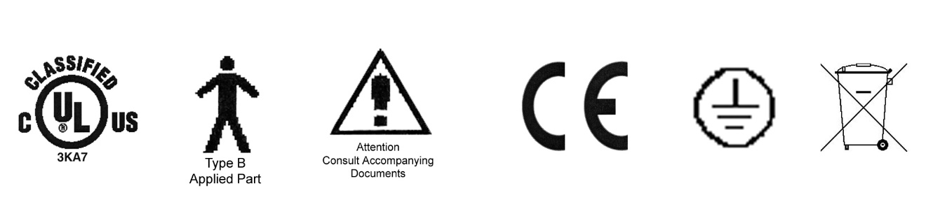

MEDICAL EQUIPMENT WITH RESPECT TO ELECTRICAL SHOCK, FIRE AND MECHANICAL HAZARDS ONLY IN ACCORDANCE WITH UL 60601-1 AND CAN/CSA C22.2 NO. 601.1

**Environment Operating Range**

Temperature range within +5 to +40 C

Relative humidity range within 15% to 95%

Atmospheric pressure range within 700 to 1060 hPa

**Transportation and storage:**

Temperature range within -40 to 70 C

Relative humidity range within 10% to 100%

Atmospheric pressure range within 500 to 1080 hPa

Symbols and Definitions

|  |  |
| --- | --- |
| Blue circle with white figure holding book | Warning, follow instructions for use. Failure to comply may result in injury. |
| Red circle with line through it with black figure in background | Warning, sitting is prohibited. Failure to comply may result in injury. |
| Description: TypeB  Type B Applied Part | Applied Part complying with specified requirements for protection against electric shock. Type B Applied Parts are those parts, which are usually Earth referenced. Type B are those parts not suitable for direct cardiac application |
| Description: Attention  Attention | Attention, consult accompanying documents |
| Description: earth  Protective Earth | Any terminal which is intended for connection to an external protective conductor for protection against electric shock in case of a fault |
| Description: weee_symbol | This device contains materials that are potentially hazardous to the environment. In accordance with the DIRECTIVE 2002/96/EC OF THE EUROPEAN PARLIAMENT AND OF THE CONCIL on waste electrical and electronic equipment (WEEE), the DBI™ electrical system and accessories should not be disposed as unsorted municipal waste. Consult your instructional policies and local regulations regarding disposal. Contact your Medical Positioning, Inc. Service Representative if additional disposal details are required. |

European Union Representative



MDSS GmbH

Schiffgraben 41

30175 Hannover, Germany

Precautions

Your DBI™Table has been pre-assembled and tested to ensure operation on day one. Please closely inspect it when you receive it to ensure no damage has occurred during shipment. Because it is a complex piece of equipment, make note of the following precautions.

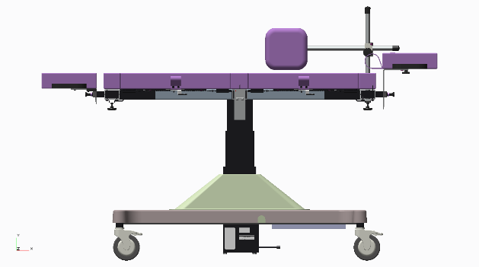

**Figure 1**

* WARNING, POTENTIAL FOR INJURY OR DEATH. Do not leave patient unattended while using the table.
* WARNING, POTENTIAL FOR INJURY OR DEATH. Do not modify this equipment without authorization of the manufacturer.
* WARNING, POTENTIAL FOR INJURY OR DEATH. Do not use in oxygen rich environment.
* WARNING, POTENTIAL FOR INJURY OR DEATH.  Placing, removing, or transferring a patient with a weight that exceeds 500 lbs. has the potential to cause injury or death. Utilize a patient lift to place and remove the patient on the DBI Table.
* **WARNING, POTENTIAL FOR INJURY OR DEATH. To reduce the risk of electrical shock, grounding reliability can only be achieved when the equipment is connected to an equivalent receptacle marked “hospital only” or “hospital grade”.**
* **WARNING, POTENTIAL FOR INJURY OR DEATH. To reduce the risk of electrical shock, do not remove secured covers. Refer servicing to qualified personnel.**
* **WARNING, POTENTIAL FOR INJURY OR DEATH. To reduce the risk of a potential fall, lock all casters before using equipment.**
* **WARNING, POTENTIAL FOR INJURY OR DEATH. Once the table and patient have been properly positioned for compression, ensure the casters are locked and the hand-wand is placed in a safe position to prevent incidental contact and unwanted movement of the table surface during compression.**
* **WARNING, POTENTIAL FOR INJURY. To reduce the risk of a potential fall, do not use the product to transport patient between rooms or over thresholds.**
* **WARNING, POTENTIAL FOR INJURY. Avoid placing your hand in or near the drop section mechanism during operation**
* **WARNING, POTENTIAL FOR INJURY OR DEATH. After closing, always lift up on the drop section to assure that it is totally locked before patient entry or exit.**
* **WARNING, POTENTIAL FOR INJURY. Do not operate drop section if non-pinch closure flap is absent. The flap is attached to the bed with hook and loop tape and can easily be adjusted whenever necessary.**
* **WARNING, POTENTIAL FOR INJURY OR DEATH. Once the table and patient have been properly positioned for compression, ensure the casters are locked and the foot switch is placed in a safe position to prevent incidental contact and unwanted movement of the table surface during compression.**
* **WARNING, POTENTIAL FOR INJURY. Once the table and patient have been properly positioned for compression, avoid any side impact to the side of the table. A side impact load even with the non-activated 4-Way Float may result in unwanted movement of the table surface during compression.**
* **WARNING, POTENTIAL FOR INJURY. Securely tighten the Hand Wheel for the Patient Back Rest prior to performing any procedures utilizing the Patient Back Rest.**
* **WARNING, POTENTIAL FOR INJURY. Securely tighten the Patient Back Rest Pivot Release Lever prior to performing any procedures utilizing the Patient Back Rest.**
* **WARNING, POTENTIAL FOR INJURY. To reduce the risk of a potential fall, do not sit on the headrest or footrest.**
* **CAUTION, PRODUCT DAMAGE MAY RESULT. Secure hand-wand with hook and loop fastener when not in use. Keep cable clear of moving parts.**
* **CAUTION, PRODUCT DAMAGE MAY RESULT. It is not necessary to "slam" the drop section closed. Slamming the drop section closed will startle the patient and may result in damage to the mechanism.**
* **CAUTION, PRODUCT DAMAGE MAY RESULT. Protect vinyl upholstery from sharp objects and abrasion to avoid damage.**
* **CAUTION, PRODUCT DAMAGE MAY RESULT. Refer to instructions located in this manual for vinyl cleaning recommendations.**
* **CAUTION, PRODUCT DAMAGE MAY RESULT. Do not use abrasives to clean painted surfaces.**
* **WARNING, POTENTIAL FOR INJURY. If the DBITM Table is used adjacent to other electrical equipment, observe the DBITM Table and the other electrical equipment to make sure they operate as intended.**

Intended Use

The DBI™ Table is intended to support a patient for breast biopsy procedures. It is to be used by trained healthcare professionals in an acute care, outpatient imaging, hospital and office setting. The product is contraindicated for patients that cannot safely sit in a chair or lie on an elevated surface.

The DBI™ Table is not intended for use in oxygen rich environments.

Training and Qualifications

It is recommended that the user manual be reviewed prior to using the product. MPI does not require specific training or qualifications for the use this product. It shall be the responsibility of the health care facility to ensure caregivers who use the product are properly trained to the necessary hospital protocols.

Patient Positioning

Decubitus patient positioning and equipment orientation – Lateral Arm



**Inferior Approach – Right “Up” Breast**

**Illustration A**

For patients with a large abdomen, using a slight oblique angle allows more working room.



**Superior Approach – Right “Up” Approach**

**Illustration B**

Superior/Oblique is the most common approach using a slight oblique angle moves the gun away from line of sight and provides more working room.



**Lateral Approach – Right “Up” Breast**

**Medial Approach – Left “Down” Breast**

**Illustration C**

Lateral is the second most common approach.



**Lateral Approach – Left “Up” Breast**

**Medial Approach – Right “Down” Breast**

Set Up

Your DBI™ Table has been shipped to you in “plug and play” condition. After unpacking the product, we recommend performing an initial test of your DBI™ Table to ensure that each function is in correct working order. After reviewing this manual you are ready to begin using your DBI™ Table.

**System Test Procedure**

The hand-wand is a low voltage, DC operated device. The cable begins at the hand-wand and plugs into the control box.

* **WARNING, POTENTIAL FOR INJURY OR DEATH. To reduce the risk of electrical shock, grounding reliability can only be achieved when the equipment is connected to an equivalent receptacle marked “hospital only” or “hospital grade”.**

|  |  |
| --- | --- |
| **STEP** | **ACTION** |
| 1 | After removing padding and packaging materials locate primary power supply cord and attach to suitable grounded outlet. |
| 2 | To test actuator function, locate the hand-wand and depress each function button one at a time. (Depressing multiple buttons simultaneously will prevent the motor from operating.) Figure 2. |
| 3 | If any function does not operate, perform the test procedures listed in the Troubleshooting Guide |

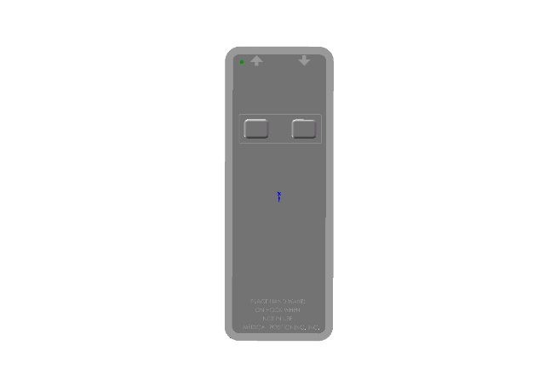

Height Up & Down

**Figure 2**

Safety Features

* This product is equipped with multiple automated safety features to prevent danger or damage during use. The entire system is electrically isolated to UL/IEC 60601-1 and CAN/CSA C22.2 No. 601.1 hospital safety standards
* The actuator assembly is current overload protected. If overloaded, the actuator will stop and reset automatically.
* The sealed hand-wand operates the actuator by directing small amounts of low voltage D.C. current to the control box. The actuator drive is equipped with internal limit switches which automatically prevent over-extension.
* The tables are equipped with total locking, sealed bearing, and braking casters at all four corners.

Operation

Your DBI™ Table is shipped assembled and ready for use. Each function has been pre-tested to ensure perfect working order on day one.

A **“Troubleshooting Guide”** is included in this manual to assist you in the event of a malfunction.

**Functionality in this section**

* Hand-wand
* Individual Lock Casters
* Single Pedal Brake (optional)
* Drop Sections
* Non-Pinch Flap
* 4-Way Float (optional)

Hand-Wand

The hand-wand is a low voltage device. The cable begins at the hand-wand and plugs into the control box on the other end.

* **WARNING, POTENTIAL FOR INJURY OR DEATH. Once the table and patient have been properly positioned for compression, ensure the casters are locked and the Hand-wand is placed in a safe position to prevent incidental contact and unwanted movement of the table surface during compression.**

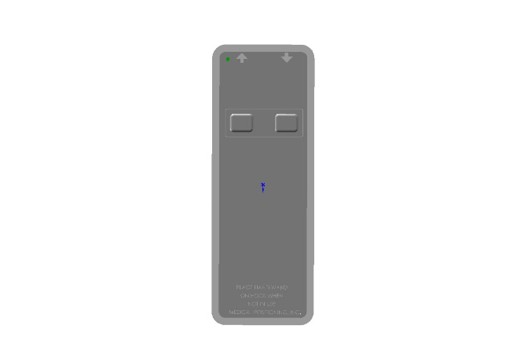

Height Up & Down

**Figure 3**

After each use, gently shake the hand-wand. If shaking causes the table to move up and down, replace the hand-wand prior to the next use by ordering one through Medical Positioning, Inc. at 1-800-593-ECHO (3246).

The hand-wand has a hook strip on the back and the table has a loop strip on the side. Additional hook and loop strips can be used to place the hand-wand in the most convenient place for the end user.

* **CAUTION, PRODUCT DAMAGE MAY RESULT. Secure hand-wand with hook and loop fastener when not in use. Keep cable clear of moving parts.**

Individual Lock Casters

The casters installed on your DBI™ Table are total locking casters. When in the locked position, the caster is prevented from both rolling and swiveling.

* **WARNING, POTENTIAL FOR INJURY OR DEATH. To reduce the risk of a potential fall, lock all casters before using equipment.**
* **WARNING, POTENTIAL FOR INJURY OR DEATH. Once the table and patient have been properly positioned for compression, ensure the casters are locked and the Hand-wand is placed in a safe position to prevent incidental contact and unwanted movement of the table surface during compression.**
* **WARNING, POTENTIAL FOR INJURY. To reduce the risk of a potential fall, do not use the product to transport patient between rooms or over thresholds.**

|  |  |
| --- | --- |
| **STEP** | **ACTION** |
| 1 | To lock the caster, step down on the outermost edge of the locking tab located at the top of the caster wheel. (See Figure 4) |
| 2 | To unlock the caster step down on the top, innermost edge of the locking tab OR lift up on the outermost edge of the tab. (See Figure 5) |

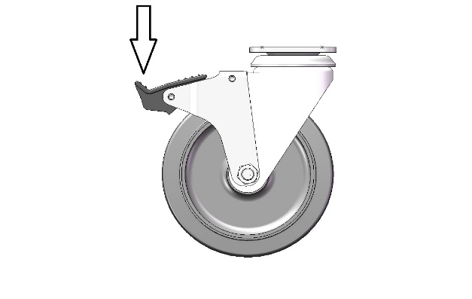

**Figure 4**

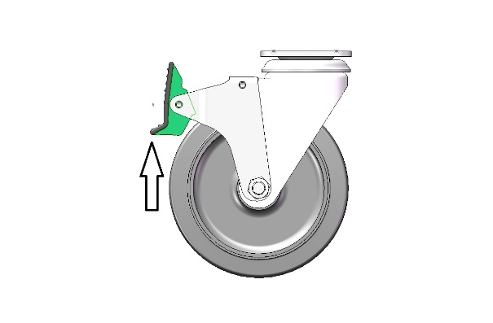

**Figure 5**

Single Pedal Brake (optional)

The casters installed on your DBI™ Table with the optional Single Pedal Brake are total locking casters when in the locked position; the caster is prevented from both rolling and swiveling. When in the neutral position, all casters are free to roll and swivel. The last position is the steer position; with the casters at the head end free to swivel and roll while the casters at the foot end are free to roll but locked from swiveling.

* **WARNING, POTENTIAL FOR INJURY OR DEATH. To reduce the risk of a potential fall, lock all casters before using equipment.**
* **WARNING, POTENTIAL FOR INJURY OR DEATH. Once the table and patient have been properly positioned for compression, ensure the casters are locked and the Hand-wand is placed in a safe position to prevent incidental contact and unwanted movement of the table surface during compression.**
* **WARNING, POTENTIAL FOR INJURY. To reduce the risk of a potential fall, do not use the product to transport patient between rooms or over thresholds.**

|  |  |
| --- | --- |
| **STEP** | **ACTION** |
| 1 | To lock the casters, step down on pedal labeled lock on either side of the table. (See Figure 6) |
| 2 | To unlock the casters and obtain the neutral position, step down on the raised pedal on either side of the table until the pedals are level. |
| 3 | To utilize the steer function, step down on the pedal labeled steer on either side of the table. |

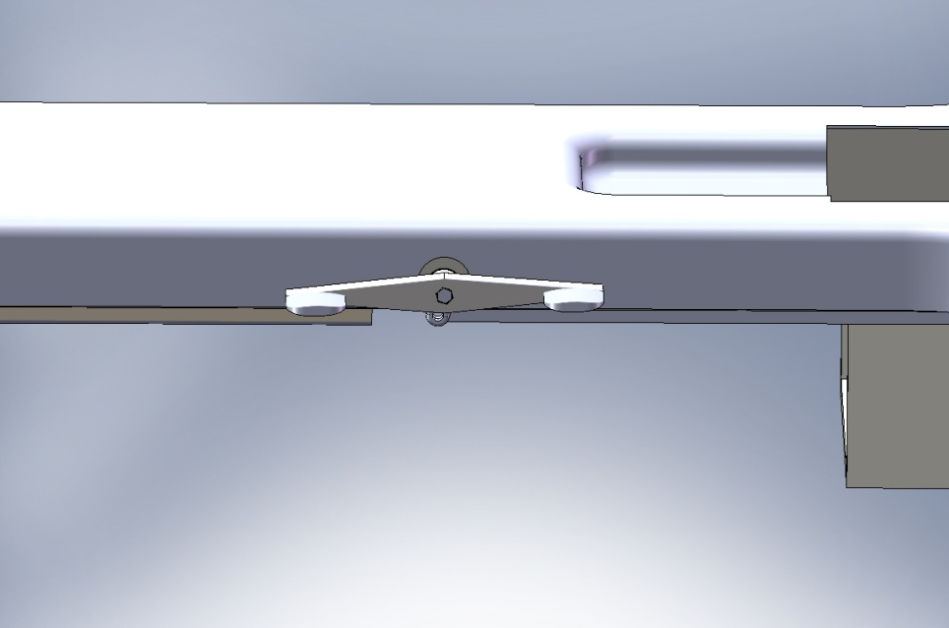

**Steer**

**Lock**

**Figure 6**

Drop Section

The drop section is designed to be opened or closed easily with one hand.

* **WARNING, POTENTIAL FOR INJURY. Avoid placing your hand in or near the drop section mechanism during operation**
* **WARNING, POTENTIAL FOR INJURY OR DEATH. After closing, always lift up on the drop section to assure that is totally locked before patient entry or exit.**

|  |  |
| --- | --- |
| **STEP** | **ACTION** |
| 1 | To open the drop section, locate the metal handle mounted on the bottom of the drop section at the front edge. (See Figure 7) |
| 2 | Pulling the handle outward, from under the drop section, will release the latch mechanism and allow the drop section to swing open. Do not abruptly yank or jerk on handle, it is designed to work with a smooth, steady pull |
| 3 | To close the drop section lift the drop section smoothly until it is securely in the full, upright and locked position. |

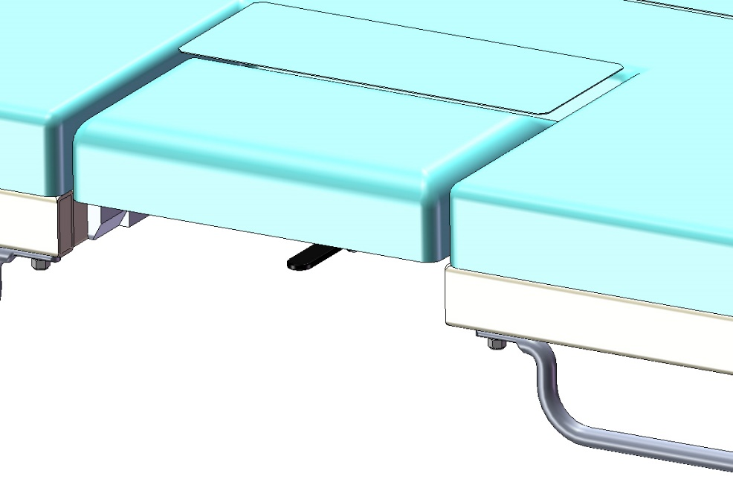

Release Lever

**Figure 7**

* **CAUTION, PRODUCT DAMAGE MAY RESULT. It is not necessary to "slam" the drop section closed. Slamming the drop section closed will startle the patient and may result in damage to the mechanism.**

Non-Pinch Closure

The non-pinch closure flaps located at the back edge of both drop sections and are designed to reduce the possibility of the patient from being pinched when either drop section is closed after imaging.

* **WARNING, POTENTIAL FOR INJURY. Do not operate drop section if non-pinch closure flap is absent. The flap is attached to the bed with hook and loop tape and can easily be adjusted whenever necessary.**

Examine the non-pinch closure flap with the drop section open and closed. The flap attaches to the bed surface with hook and loop tape that has been permanently attached to the surface. (See Figure 8)

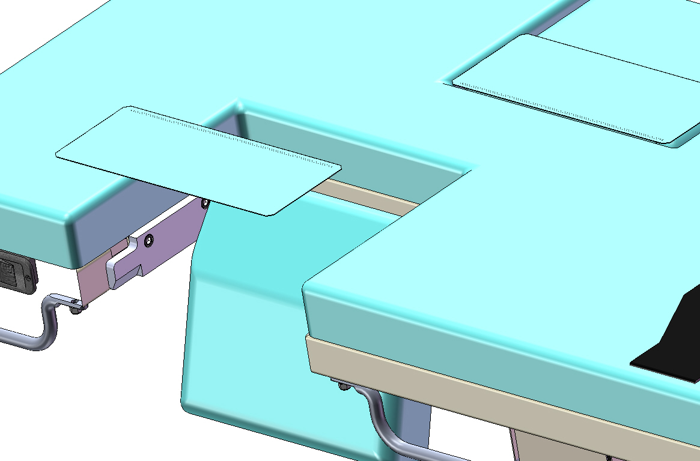

Flap

**Figure 8**

Occasionally the flap may become bent or creased. When that occurs, remove the flap from the bed surface by separating the hook and loop strips. (See Figure 8) Next, return the flap back to original shape by bending it farther in the opposite direction of the bend or crease and allowing it to spring back to flat.

Should the flap require replacement, you may order one through Medical Positioning, Inc. at 1-800-593-ECHO (3246).

Accessories

**Functionality in this section**

* Patient Back Rest
* Patient Headrest (small & large)
* Patient Footrest
* IV Pole and Holder

Patient Back Rest

The DBI™ Table Back Rest is packaged separately during shipment to avoid possible damage. The Back Rest easily installs and is reversible and fully adjustable.

The Back Rest allows the patient to be comfortable while remaining properly positioned on their side. The Backrest can be used from either side of the table and positioned from either end of the table.

* **WARNING, POTENTIAL FOR INJURY. Securely tighten the Hand Wheel for the Patient Back Rest prior to performing any procedures utilizing the Patient Back Rest.**
* **WARNING, POTENTIAL FOR INJURY. Securely tighten the Patient Back Rest Pivot Release Lever prior to performing any procedures utilizing the Patient Back Rest.**

**Patient Back Rest Installation**

|  |  |
| --- | --- |
| **STEP** | **ACTION** |
| 1 | Loosen the Hand Wheel on the bottom of one of the Receivers a few turns counter-clockwise to allow the CONNECTING PLATE to be placed fully into the Receiver. (Figure 10) |
| 2 | Tighten the Hand Wheel securely to lock the CONNECTING PLATE in the Receiver. |

**Patient Back Rest Removal**

|  |  |
| --- | --- |
| **STEP** | **ACTION** |
| 1 | Loosen the Hand Wheel on the bottom of the Receiver a few turns counter-clockwise to allow the CONNECTING BAR to be removed from the Receiver. |

**Patient Back Rest Adjustment**

|  |  |
| --- | --- |
| **STEP** | **ACTION** |
| 1 | Release the Pivot Release Lever to allow radial motion about the Vertical Support Tube. (Figure 10) |
| 2 | Rotate the Horizontal Support Tube with Pad to fit comfortably against the patient’s back. Tighten the Pivot Release Lever to lock back rest into position. (Figure 10) |



**Figure 10**

Patient Headrest (small & large)

The DBI™ Table is provided with two adjustable and removable Headrests. One is small and the other is the same width as the table. Both Headrests are vertically adjustable to accommodate different patient sizes. The Headrests can be installed at either end of the table.

* **WARNING, POTENTIAL FOR INJURY. To reduce the risk of a potential fall, do not sit on the headrest or footrest.**

**Patient Headrest Installation**

|  |  |
| --- | --- |
| **STEP** | **ACTION** |
| 1 | Insert the bottom end of the Support Bar into the opening on top of the Receiver. (see Figure 11) |
| 2 | Holding the Headrest by the Strap, Pull out on the spring loaded Plunger to allow the Headrest to lower through the Receiver. (See Figure 11) |
| 3 | Release the Plunger when the Headrest is at the desired height. |

**Patient Headrest Removal**

|  |  |
| --- | --- |
| **STEP** | **ACTION** |
| 1 | Pull the Plunger so that it is no longer engaged with the support bracket. (See figure 11) |
| 2 | With the Plunger disengaged from the support bracket, hold the Headrest by the Strap and pull upward on the strap until the support bracket has been removed from the receiver. |

**Patient Headrest Adjustment**

|  |  |
| --- | --- |
| **STEP** | **ACTION** |
| 1 | While holding the Strap, pull out on the spring loaded Plunger and lift the Headrest to the desired height. (See Figure 11) |
| 2 | Release the Plunger and slightly raise or lower the Headrest so the plunger can enter one of the adjustment holes on the Support Bar. |

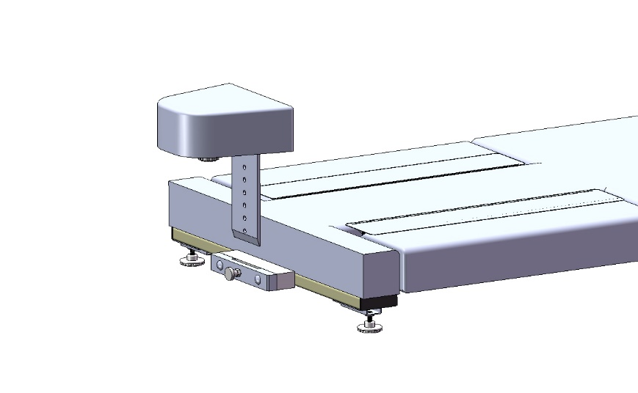

PLUNGER

HEADREST

RECEIVER

**Figure 11**

Patient Footrest

The DBI™ Table is provided with a removable Footrest. The Footrest is does not have a vertical adjustment as the Headrests. The Footrest can be installed at either end of the table.

* **WARNING, POTENTIAL FOR INJURY. To reduce the risk of a potential fall, do not sit on the headrest or footrest.**

**Patient Footrest Installation**

|  |  |
| --- | --- |
| **STEP** | **ACTION** |
| 1 | Insert the bottom end of the Footrest’s support bracket into the opening on top of the Receiver. (see Figure 11) |

**Patient Footrest Removal**

|  |  |
| --- | --- |
| **STEP** | **ACTION** |
| 1 | Hold the Footrest on each side and pull upward until the support bracket has been removed from the receiver. |

IV Pole and Holder

The DBI™ Table can be equipped with a removable IV Pole and Holder accessory.

**IV Pole and Holder Installation**

|  |  |
| --- | --- |
| **STEP** | **ACTION** |
| 1 | Loosen the Hand Wheel on the bottom of the Receiver a few turns counter-clockwise to allow the Mounting Bar of the IV Pole Holder to be placed fully into the Receiver. |
| 2 | Tighten the Hand Wheel securely to lock the Mounting Bar in the Receiver. |
| 3 | Insert the IV Pole into the Holder. |

**IV Pole and Holder Removal**

|  |  |
| --- | --- |
| **STEP** | **ACTION** |
| 1 | Remove the IV Pole from the Holder. |
| 2 | Loosen the Hand Wheel on the bottom of the Receiver a few turns counter-clockwise to allow the Mounting Bar to be removed from the Receiver. |

Preventive Maintenance

* WARNING, POTENTIAL FOR INJURY OR DEATH. Do not modify this equipment without authorization of the manufacturer.

The following Preventative Maintenance should be performed at a minimum annually:

* Visually inspect all mechanical assemblies and moving parts on the product ensuring smooth, steady operation
* Visually inspect all upholstered surfaces for tears or excessive wear. Replace if necessary.
* Visually inspect all fasteners (bolts, nuts, screws, etc.) to insure all are fully installed. Tighten as necessary.
* Visually inspect all electrical cables and wires for signs of abrasion or other damage. If damaged, replace.
* Visually inspect all electrical connections to insure they are fully and properly connected. Reconnect as necessary.
* Visually inspect and operate the hand-wand. If damaged, or if shaking of the hand-wand causes the table to move up and down, replace.
* Operate all drop-section latch mechanisms to insure proper engagement of latch into receiver. Adjust if necessary.
* Operate all motors to insure full extension, retraction and correct operation. The motors are permanently lubricated and require no lubrication. Replace if necessary.
* Operate the casters to ensure proper engagement of the wheel and swivel lock mechanism. Replace as necessary.
* Operate all accessories to insure proper attachment and operation. Tighten, adjust or replace if necessary.

Expected Life

The expected life of the product is 7 years of normal use from the date of manufacture. Some components may have a shorter life and require replacement.

Discard of the Unit

Upon reaching the end of its useful life the product may be discarded in accordance with local and federal standards. Recycle when possible.

|  |  |
| --- | --- |
| Description: weee_symbol | In accordance with the European Directive 2002/96/EC on Waste Electrical and Electronic Equipment (WEEE), the product must not be disposed as unsorted municipal waste, but should be collected separately. Consult your instructional policies and local regulations regarding disposal. Contact your Medical Positioning, Inc. Service Representative if additional disposal details are required. |

Cleaning

**NOTE:** Substances such as imaging gels and alcohol will not damage the vinyl surface when immediately removed. Studies have shown that exposure for longer than a few minutes can damage the top coat and will eventually discolor vinyl.

**NOTE:** Always read manufactures instructions and warnings before using any cleaning product or disinfectant.

The painted metal and plastic surfaces can be cleaned with normal cleaners and disinfectant.

|  |  |
| --- | --- |
| **STEP** | **ACTION** |
| 1 | Clean and/or disinfect with liquid cleaner of choice being careful to follow label instructions provided with cleaner. (Always test a small area first to determine suitability of solution) |
| 2 | Wipe the surface clean with a wet cloth after applying cleaners and disinfectant to remove excess residue buildup. |

The vinyl upholstered surfaces can be cleaned in one of the following ways:

**NOTE:** It is recommended that the product be cleaned between patients; please follow your facilities documented policy.

|  |  |
| --- | --- |
| **STEP** | **ACTION** |
| 1 | When caught quickly, most everyday stains like grease, blood and black felt tip pens can be wiped right off. Use mild soap and water. For more stubborn stains, a variety of concentrated and solvent type cleansers may be used without damaging the surface (including alcohol, naphtha and bleach), as long as they are thoroughly rinsed off with water. Abrasive household cleaners and steel wool should never be used. |
| 2 | Everyday soil can usually be removed using a soft cloth or sponge with mild soap and water. Spills and accidents require immediate attention for best results. In many cases, stains may be cleaned simply with warm water alone. If the stain is allowed to set, more concentrated cleaners may be required. |

The following guide covers many of the most common staining agents. During independent laboratory testing, many were allowed to stand for up to 40 hours with excellent cleaning results.

Generally speaking, always start with the mildest cleaning agents first. Never use harsh powdered abrasive cleansers or steel wool. Products containing bleach, ammonia or alcohol (Lysol™) should be wiped from the surface with a wet cloth after use. Residue from these products will damage vinyl surfaces

|  |  |
| --- | --- |
| **STEP** | **ACTION** |
| 1 | Remove excess spill with damp cloth. Clean with 1:1 mix of Ivory™ soap and water. Rinse with clean water and dry. |
| 2 | Use straight application of concentrated cleaners such as Formula 409™ or Fantastik™ Spray Cleaner. Then wipe with clean cloth. |
| 3 | Use a 1:1 mix of ammonia and water or a 1:4 mix of bleach and water. Rinse with clean water and dry. |
| 4 | Use straight application of naphtha (lighter fluid). Rinse thoroughly with clean water and pat surface dry. (see note below) |
| 5 | Use 1:1 mix of isopropyl alcohol and water. If stain persists, use straight alcohol. Rinse thoroughly with clean water pat surface dry. If stains remain, use a 1:1 mix of acetone and water. Rinse with clean water and pat surface dry. (see note below) |

**Note:** For cleaning that requires steps 4 or 5 - use a soft cotton cloth saturated with the cleaning material, rub the stain in circles 10 times. Pat area dry with another soft cotton cloth and check results.

This information is not a guarantee and does not relieve the user from the responsibility of the proper and safe use of the product and all cleaning agents.

* Formula 409™ is a trademark of the Clorox Company.
* Fantastik™ Spray Cleaner is a trademark of the Texize Division of Dow consumer Products, Inc.
* Ivory™ is a trademark of Procter and Gamble
* Lysol™ is a trademark of Reckitt & Colman Inc.

Troubleshooting Guide

A **“Troubleshooting Guide”** is included to instruct you in the event of a malfunction. If you are experiencing any of the following symptoms, this guide may help you quickly solve the problem. If, after consulting this guide, you are still unable to operate your table please contact Medical Positioning at   
1-800-593-3246. Please have the following information ready when you call:

1. Model Number or Name of Product
2. Date Received
3. Condition When Received
4. Symptom (or problem) Encountered & Result of Troubleshooting Procedure

**Adverse Event Reporting**

Any serious incident that has occurred in relation to the device should be reported immediately to Medical Positioning. If located in the European Union, please immediately contact Medical Positioning and the competent authority of the Member State in which the user and/or patient is established.

Medical Positioning, Inc.

9732 Pflumm Road

Lenexa, KS 66215

www.MedicalPositioning.com

011-816-474-1555

800-593-3246 (ECHO)

|  |  |  |
| --- | --- | --- |
| **SYMPTOM** | **PROBABLE CAUSE** | **SUGGESTION** |
| No Actuator Function  Actuator(s) Not Running | * Power cord not plugged all the way into wall receptacle | * Push power cord securely into receptacle. |
| * Power outlet receptacle not supplying 120 VAC power | * Check power availability or plug unit into another receptacle |
| * The power cord may be separated from the control box | * Securely press power cord into control box (Figure 12 ) |
| * Hand-wand not properly connected to control box | * Securely press end of hand-wand into control box(Figure 11 and 12) |
| * Actuator power cord not fully connected to control box | * Securely press end of actuator power cord into control box (Figure 12) |



Height Up & Down

**Figure 11**



**Figure 12**

DBI Table Parts List

|  |  |
| --- | --- |
| **Part Number** | **Description** |
|
| 10728 | KOM 33-20A-000 BOX, 120 VAC |
| 11214 | KOM 33-10A-000 BOX, 230 VAC |
| 12277 | CASTER, 5" EXPANDING STEM, TTL |
| 12278 | CASTER, TOTAL LOCK 4.TJR.DRA |
| 12279 | CASTER, STEER LOCK 4.TJR.DRA |
| 14097 | ASSEMBLY, UPHOLSTERED, HEADREST |
| 14090 | UPHOLSTERY, DROP SECTIONS, DBI |
| 14096 | UPHOLSTERED, BACKREST, DBI |
| 10347 | LATCH COVER |
| 10348 | DROP SECTION STOP BAR |
| 10351 | HANDLE, PIN#100 |
| 11054 | SPRING LOADED PLUNGER, NON-LOCKING |
| 10598 | HINGE |
| 11060 | HANDLE, MOLDED |
| 10740 | HAND SWITCH, 1 MOTOR #EHA11-21B10J-524 |
| 14055 | SMALL HEAD REST ASSEMBLY |
| 14056 | LARGE HEAD REST ASSEMBLY |
| 14057 | FOOT REST ASSEMBLY |
| 10755 | ACTUATOR HEIGHT COLUMN, DBI TABLE |
| 11481 | COVER, DROP SECTION LATCH HANDLE |
| 11425 | HAND WHEEL |
| 14286 | MOUNTING POST, 14 INCH |
| 14290 | ARM REST MOUNT |
| 14280 | MOUNTING POST, 10 INCH |
| 11050 | CLAMP |
| 12270 | POWER CORD, TYPE B NEMA 5-15 PLUG, US & JP |
| 12272 | POWER CORD, TYPE E/F CEE 7/7 PLUG, EU |
| 14142 | POWER CORD, TYPE G BS1363 PLUG, UK |
| 14083 | KIT, IV POLE |

**This device is covered by one or more**

**of the following U.S. Patents:**

6,353,949 B1; 5,950,262; 5,919,131;

6,367,104 B1; 6,832,399 B2; 6,557,196

Specifications, Warranty, and Return Policy

Specifications

|  |  |
| --- | --- |
| **ATTRIBUTE** | **SPECIFICATION** |
| Electrically Adjustable Height | 24” to 36” |
| Electrically Isolated Hand-wand | 24 VDC |
| Dynamic Load Capacity, Table | 500 Lbs. |
| Static Load Capacity, Table | 1000 Lbs. |
| Load Capacity, IV Pole | 33 Lbs. |
| Casters | 5” 2-way locking |
| Length | 70.5” |
| Width | 27” |
| Weight | 315 Lbs. |
| Foam | Cal. B.F.T.B. #117 |
| Electrical | * 120 VAC, 50/60 Hz, 1.6 A * 240 VAC, 50/60 Hz, 1.0 A |

**Standard and Optional Configurations**

|  |  |  |
| --- | --- | --- |
| **ATTRIBUTE** | **STANDARD** | **OPTIONAL** |
| Patient Back Rest | Yes |  |
| Patient Headrest (small) | Yes |  |
| Patient Headrest (large) | Yes |  |
| Patient Footrest | Yes |  |
| IV Pole |  | Yes |

**Applied Parts (in accordance with IEC 60601-1)**

The following parts are intended to contact the patient during normal product use.

|  |  |
| --- | --- |
| **Item** | **Material** |
| Padded Surfaces | Vinyl fabric |
| Footrest | Plastic |
| Straps | Nylon webbing |

**Electromagnetic Emissions Guidance**

The DBITM Table uses components that meet the requirements for   
IEC 60601-1-2. Other products that are used in the vicinity of the DBITM Table should also comply with this standard. If they do not comply, electromagnetic interference between the products could cause the products to operate incorrectly. If problems do occur, contact the product manufacturer(s).

Make sure the DBITM Table operates correctly when used near other electronic devices. Portable and mobile radio frequency (RF) communications equipment can affect electrical equipment.

* WARNING, POTENTIAL FOR INJURY. If the DBITM Table is used adjacent to other electrical equipment, observe the DBITM Table and the other electrical equipment to make sure they operate as intended.

Warranty

|  |
| --- |
| **WARRANTY**  **DBI™ Table**  **1 YEAR WARRANTY**  Medical Positioning, Inc. (“MPI”) warrants and represents that this product will be free from material and workmanship defects during the period indicated above (the “Warranty Period”), commencing tender of delivery as defined in Uniform Commercial Code § 2-503, irrespective of any inspection period and provided that the product is maintained and operated in accordance with MPI’s specifications.  If the product fails due to a manufacturing defect, MPI will, at its sole expense and discretion, repair the product, authorize repairs to the product, or replace the product. MPI will ship any replacement products or parts using standard shipping rates; if the customer requires expedited shipping of replacement products or parts, the customer is responsible for paying shipping costs above standard rates.  Preventative maintenance and repairs due to damage by use, accident, improper care, negligence, or other non-defect related failures are not covered by this warranty. This warranty is void as to products that have been modified without the advance written permission of MPI.  OTHER THAN AS SET FORTH HEREIN, MPI MAKES NO WARRANTY WHATSOEVER, EITHER EXPRESSED OR IMPLIED, WITH RESPECT TO THIS PRODUCT. MPI SPECIFICALLY DISCLAIMS THE (a) IMPLIED WARRANTY OF MERCHANTABILITY; (b) WARRANTY OF FITNESS FOR A PARTICULAR PURPOSE; AND (c) WARRANTY AGAINST INFRINGEMENT OF ANY PATENT, COPYRIGHT, TRADEMARK, TRADE SECRET OR OTHER PROPRIETARY RIGHTS OF A THIRD PARTY; WHETHER ARISING BY LAW, COURSE OF DEALING, COURSE OF PERFORMANCE, USAGE OF TRADE OR OTHERWISE.  This warranty is nontransferable. The remedies provided under this warranty are the customer’s sole and exclusive remedies. In no event will MPI be liable for any direct, indirect, special, incidental, consequential damages or lost profits or income whether based on contract, tort, or any other legal theory.  **Medical Positioning, Inc.**  9732 Pflumm Road  Lenexa, KS 66215  (816) 474-1555  (800) 593-3246  Fax (816) 474-7755  WAR069-B |

Return Policy

MPI accepts returns of unused products within 30 days from the date of delivery, irrespective of any inspection period. Returns are subject to a 30% restocking fee, any applicable duties or taxes and quality inspection. No product may be returned without prior written authorization from MPI. The customer is responsible for all shipping charges and any applicable duties or taxes incurred in connection with a return.

WAR093-A