Owner’s Manual
RR HUT

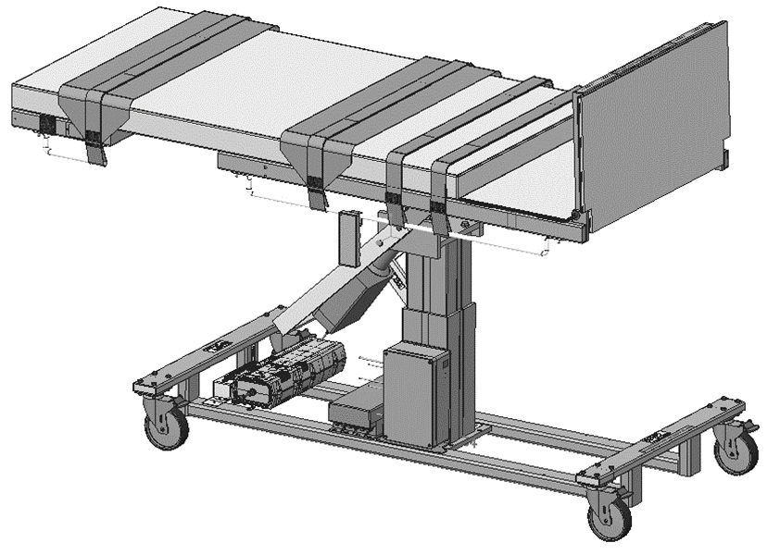

Owner _____________________

Model _____________________

Serial # _____________________

Date _____________________

Table of Contents

Symbols and Definitions 3
Safety Warnings & Cautions 5
Intended Use 7
Set Up 7
Transport Position 7
Product Illustration 8
Controls and Indicators 9
Use Instructions 13
Powering the Product 13
Locking the Casters 14
Hand Control Functions 15
Adjusting Surface Height 15
Adjusting Trendelenburg 15
Emergency Down Function 15
Home Function 16
Using the Tilt Angle Selector 16
Battery 23
Positioning Wedge 24
Pediatric Adaptor 24
Preventative Maintenance 25
Battery Information 26
Expected Life 27
Discard the Unit 27
Cleaning 28
Service Calls 30
Troubleshooting Guide 31
Specifications 32
Warranty 38
Return Policy 39

Symbols and Definitions

 | Warning, follow instructions for use. Failure to comply may result in injury.
 | Warning, sitting is prohibited. Failure to comply may result in injury.
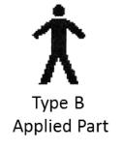 | Applied Part complying with specified requirements IEC 60601-1 to provide protection against electric shock, particularly regarding allowable patient leakage current.
 | Warning/Caution, consult accompanying documents.
 | Any terminal which is intended for connection to an external protective conductor for protection against electric shock in case of a fault.
 | In accordance with the European Directive 2002/96/EC on Waste Electrical and Electronic Equipment (WEEE), the product must not be disposed as unsorted municipal waste, but should be collected separately. Consult your instructional policies and local regulations regarding disposal. Contact your Medical Positioning, Inc. Service Representative if additional disposal details are required.
 | Manufacturer
 | Agency Mark

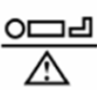 | Maximum Patient Weight. Indicates the maximum patient weight that may be placed on the product.
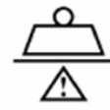 | Safe Working Load. Indicates the sum of the patient weight and accessories that may be placed on the product.

WARNING / CAUTION / NOTE Definition

The words WARNING, CAUTION, and NOTE carry special meanings and should be carefully reviewed.

- WARNING

Identifies a situation that could result in injury to the patient or caregiver.

- CAUTION

Identifies a situation that could result in equipment damage.

Note
Provides special information to make an important instruction more clear.

Safety Warnings & Cautions

- WARNING:
Obey these safety instructions to help prevent injury and/or equipment damage:

- Read and understand all warnings in this manual and on the unit itself prior to use with a patient.
- The device should be operated by trained persons only.
- Authorized and qualified persons will be those who are approved by Medical Positioning Inc. to repair or modify the product.
- Do not modify this equipment without authorization of the manufacturer.
- Equipment should only be serviced by authorized personnel.
- The procedures in this manual are only manufacturer’s suggestions. The final responsibility for patient care with respect to this device remains with the attending physician.
- Do not use in an oxygen rich environment.
- Do not leave patient unattended while using the product.
- To reduce the risk of electric shock, grounding reliability can only be achieved when the equipment is connected to an equivalent receptacle marked “hospital only” or “hospital grade”.
- If damage has occurred to the power cord, immediately remove the cord from service. Failure to do so could result in serious injury or death.
- The battery should be periodically inspected for damage. If damage has occurred to the battery, immediately remove the battery from service. Failure to do so could result in serious injury or death.
- The battery functionality should be verified regularly to ensure the product works as intended.
- If damage has occurred to the battery, immediately remove the battery from service. Failure to do so could result in serious injury or death.
- Removal of secured covers may increase the risk of electrical shock. Refer servicing to qualified and approved personnel.
- The potential for electrical shock exists with electrical equipment. Failure to follow facility protocols may cause death or serious injury.
- Ensure the patient is properly secured prior to using the equipment.
- To reduce the risk of a potential injury, the casters must be locked before using equipment.

- Once the product and patient have been properly positioned for the procedure, ensure the casters are locked and the hand controller is placed in a safe position to prevent unwanted contact and unwanted movement of the support surface.
- To reduce the risk of the product becoming unbalanced, always position the product in the lowest reasonable height when moving.
- Verify the area around the product is free of impediments before operating to prevent injury or equipment damage.
- Keep hands and feet clear of the product when lowering surface height or making positioning adjustments in order to avoid possible injury.
- Keep hands clear of hinges during operation to avoid possible injury.
- Sitting at the end of patient surfaces can result in device instability. Do not allow a patient to sit at the head end of the patient surface.
- The footboard must be used for steep reverse Trendelenburg positions to ensure patient stability.
- The caregiver must ensure the straps do not pose a safety risk to the patient.
- Protect vinyl upholstery from sharp objects and abrasion to avoid damage.
- Always read manufacturer’s instructions and warnings before using any cleaning product or disinfectant. Refer to instructions located in this manual for vinyl cleaning recommendations.
- Substances such as imaging gels and alcohol will not damage the vinyl surface when immediately removed. Extended exposure for longer than a few minutes can damage the topcoat and will discolor vinyl.
- Do not use abrasives to clean painted surfaces.
- It is recommended that the product be cleaned between patients; please follow your facility’s documented policy.
- Keep this manual available for future reference.
- If the product is used adjacent to other electrical equipment, observe the product and the other electrical equipment to ensure they operate as intended.
- Failure to latch Drop Sections may result in patient injury. Verify Drop Sections are locked in position before and after use.
- Verify the head rest is secure prior to using the product.
- Verify the side rails are secure prior to using the product and after each side rail adjustment.
- Do not exceed the weight capacity of the product.

Intended Use

This product is intended to be used for diagnostic procedures requiring head-up tilt angles of 0°-90°. Some models include features that allow the product to be used as an exam table for cardiac ultrasound. The product is intended to be used in an environment where ultrasound and other such diagnostic equipment is present, including hospitals, outpatient facilities, and doctor’s offices. The product is intended to be used by trained healthcare professionals who possess the ability to operate the product safely. The product’s movements are controlled both manually and electronically via the product’s hand control.
The product is not intended for use in oxygen rich environments.

Set Up

The product has been shipped to you in “plug and play” condition. After unpacking the product, it is recommend performing an initial test of your product to ensure that each function is in correct working order. After reviewing this manual, you are ready to begin using your product.

STEP | ACTION
1 | After removing padding and packaging materials locate primary power supply cord and attach to suitable grounded power outlet.
2 | To test actuator function, locate the hand control and depress each button one at a time. (Depressing multiple buttons simultaneously will prevent the motor from operating.)
3 | If any function does not operate, perform the test procedures listed in the Troubleshooting Guide.

Transport Position

The patient surfaces must be in a horizontal position if the product is used to transport patients.
Product Illustration

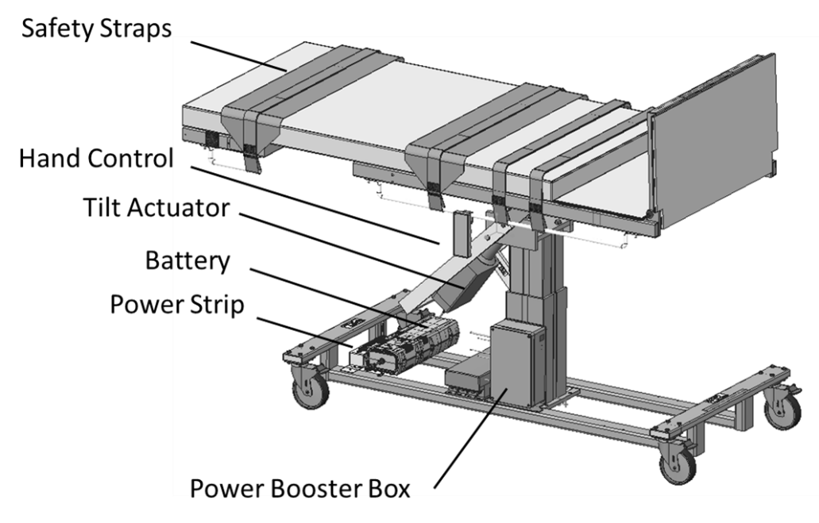

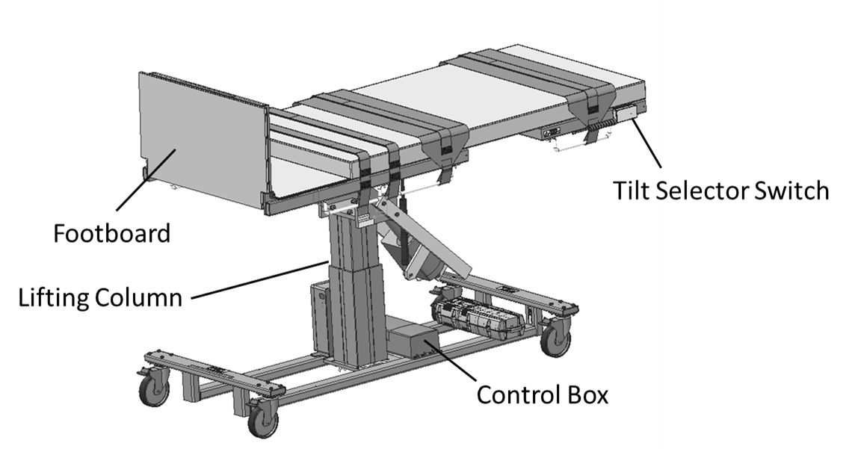

*Optional features may be shown

Controls and Indicators

Unique Device Identification Label

- Serial #
- Item #
- Item Description
- Unique Identifier
Certification Label | 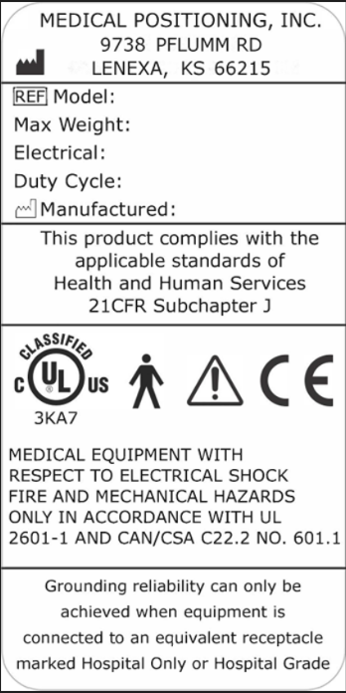
Refer to Manual Label

No Sitting label
Hand Control | 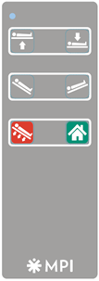

AC Input and Power Strip | 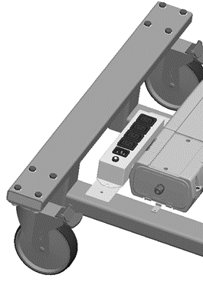
Battery | 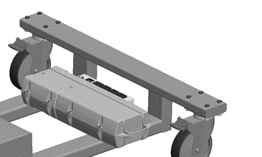
Tilt Angle Selector | 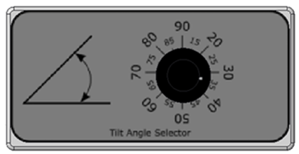
Side Rail Release | 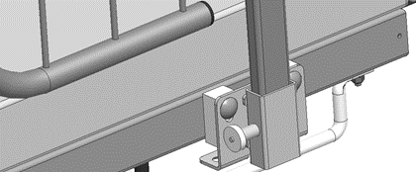

Drop Section Release  (if equipped) | 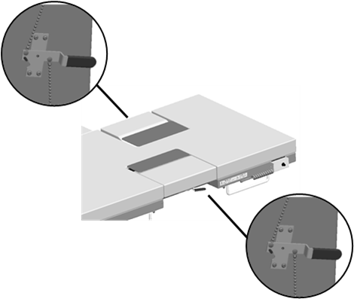
Drop Section Remote Release  (if equipped) | 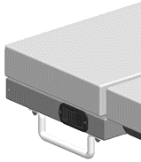

Use Instructions
Powering the Product
The product can be powered by AC power from a wall outlet or by DC power via the battery. The product is “on” whenever it is plugged into AC power or when a charged battery is installed. The product should not be positioned in a way that would make it difficult to remove power by unplugging the AC power cord or removing the battery.
To apply AC power to the product, attach the power cord to the AC input located at the rear of the product.  The product and its components are powered through the attached power strip. | 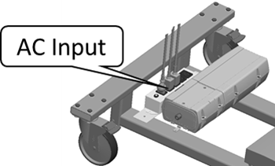
The product is equipped with a battery and will run on DC power whenever the product is removed from AC power.  Note: The battery may be charged while it is installed on the product by plugging the product into AC power. | 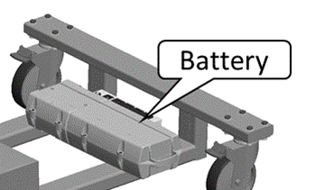
The hand control has an LED in the top left corner that indicates battery status.  Note: See page 26 for additional battery information. | 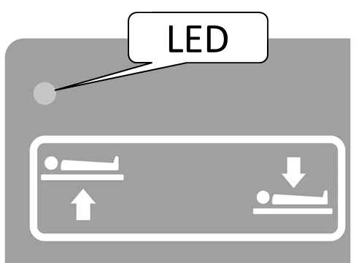

- WARNING
- To reduce the risk of electrical shock, grounding reliability can only be achieved when the equipment is connected to an equivalent receptacle marked “hospital only” or “hospital grade.”
- If damage has occurred to the power cord, immediately remove the cord from service. Failure to do so could result in serious injury or death.
- If damage has occurred to the battery, immediately remove the battery from service. Failure to do so could result in serious injury or death.
- The battery should be periodically inspected for damage. Replace the battery if necessary.
- The battery functionality should be verified regularly to ensure the product works as intended.

Locking the Casters

The product is equipped with individual locking casters.

A locking tab is located on each caster. Push down to lock, lift to unlock. | 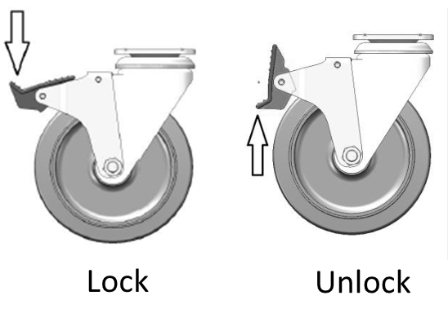

- WARNING

- To reduce the risk of a potential injury, the casters must be locked before using equipment.
- Once the product and patient have been properly positioned for the procedure, ensure the casters are locked and the hand controller is placed in a safe position to prevent unwanted contact and unwanted movement of the product surface during the procedure.

Hand Control Functions
Hand control functions will vary depending on the model purchased. Your hand control may not include all the functions listed below.

Adjusting Surface Height
The surface height may be adjusted from 31-39 inches.

Press and hold the applicable hand control function to adjust the surface height.
Adjusting Trendelenburg
The Trendelenburg / Reverse Trendelenburg angle maybe adjusted between
-15 to 90 degrees.

Press and hold the applicable hand control function to adjust the Trendelenburg angle.

Emergency Down Function
The product is capable of rapidly descending to a level position by using the emergency down function.  To use this feature, press and hold the emergency down button on the hand control until the desired support surface angle is reached.  The rapid descent speed is available when on AC power only. The product will descend at normal speed while on DC power. | 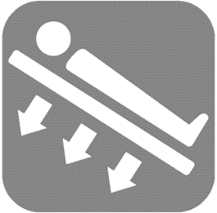

Home Function
The product can move to a preset position by using the home function.

To use this feature, press and hold the home button on the hand control until the table motion stops and home position is reached.

The home position is preset to a level patient surface but can be customized by the user.
To customize the home button, bring the table to the desired position and simultaneously press the Head Up, Head Down, and Home buttons until a beep is heard.

Using the Tilt Angle Selector
The reverse Trendelenburg angle may be set to stop at a desired angle using the tilt angle selector. This function will stop the tilting motion in an upward direction but will not stop motion in a downward direction.

Turn the knob on the tilt angle selector to the desired angle.  Press and hold the head up button on the hand control until the support surface stops moving at the desired angle. | 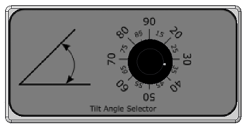

- WARNING

- Verify the area around the product is free of impediments before operating to prevent injury or equipment damage.
- Keep hands and feet clear of the product when lowering surface height or making positioning adjustments in order to avoid possible injury.
- Keep hands clear of hinges during operation to avoid possible injury.

Using the Footboard
The product is equipped with a footboard for use in steep reverse Trendelenburg positions.

Fold the footboard up until it is perpendicular to the support surface. | 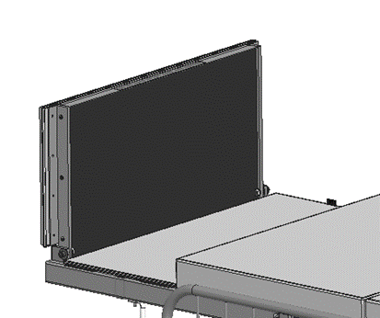

Using the Safety Straps
The product is equipped with safety straps for patients requiring extra support.

The straps may be oriented as shown in the image. It is responsibility of the caregiver to ensure the straps do not pose a safety risk to the patient. | 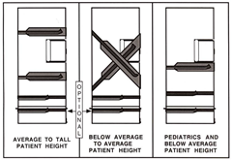

- WARNING

- The footboard must be used for steep reverse Trendelenburg positions to ensure patient stability.
- The caregiver must ensure the straps do not pose a safety risk to the patient.
- Do not leave patient unattended while using the product.

Using the Imaging Drop Section
The imaging drop section is located on the fowler section to allow ergonomic sonographer access to the patient.

Location of Imaging Drop Section | 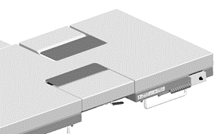
To open the drop section, pull the handle to release drop section latches.  OR  Use the remote release located on the opposite side of the support surface. | 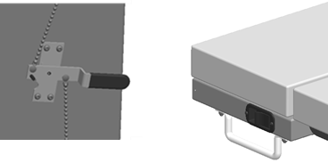
To close the drop section, lift up on the drop section until latch engages. | 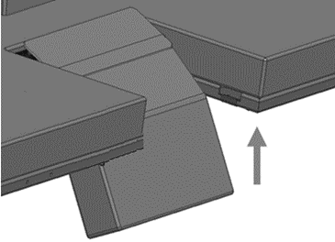

- WARNING

- Failure to latch Drop Sections may result in patient injury. Verify Drop Sections are locked in position before and after use.
- Keep hands clear of hinges during operation to avoid possible injury.

Using the Sonographer Drop Section
The sonographer drop section allows right handed scanners to get closer to the patient. It can also be adjusted to operate as a patient back rest.

To use the sonographer drop section as a back rest, pull up on the drop section until it locks into position. There are two back rest positions to choose from. | 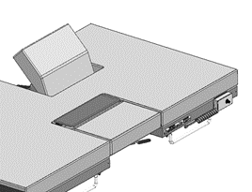
To lower from the back rest position, pull on the handle to release the back rest lock. | 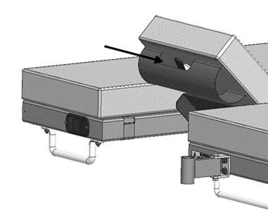
To open the sonographer drop section for better patient access, pull the handle to release the drop section latches. The sonographer may be seated during scanning.  To close the drop section, lift up on the drop section up until latches engages. | 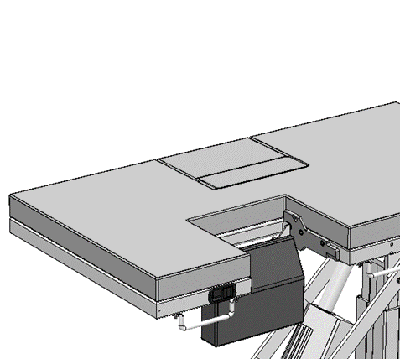

- WARNING

- Failure to latch Drop Sections may result in patient injury. Verify Drop Sections are locked in position before and after use.

Using the Sonographer Extension
The product may be equipped with an optional sonographer seat extension. This seat extension allows for a larger seating area for right-handed sonographers.

The sonographer seat extension bracket is folded next to the support surface when not in use and is rotated out to attach the sonographer’s extension. | 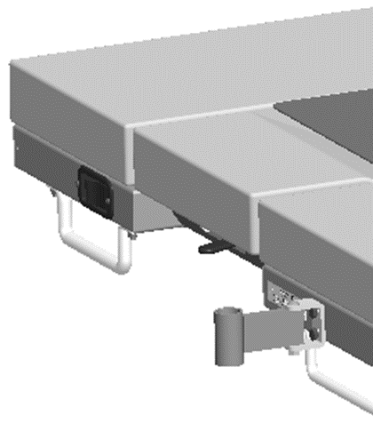
The sonographer seat extension is inserted into the bracket and should fit snugly against the upholstery. | 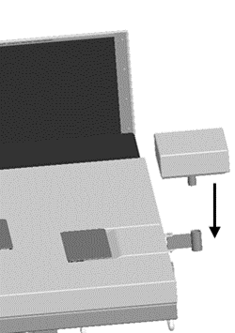
The sonographer drop section should be open to provide the maximum seating area for the sonographer. | 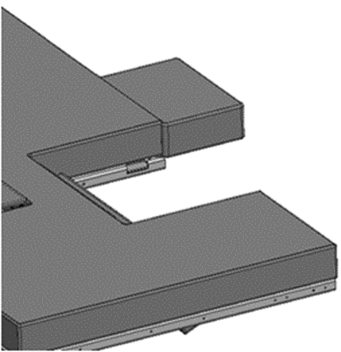

Note: When using the sonographer extension, the combined weight of the patient and sonographer shall not exceed the maximum capacity of the product.

Note: The product should be positioned at the lowest reasonable height when using the sonographer’s extension to ensure maximum stability.

- WARNING

- Do not exceed the weight capacity of the product.

Using the Side Rails
The product may be equipped with optional side rails.

The optional side rails are located on each side of the table. | 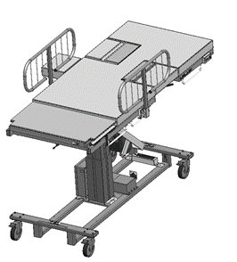
The side rail must be locked in place using the locking pin. | 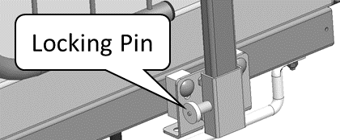
The side rails may be lowered or removed by pulling on the locking pin. | 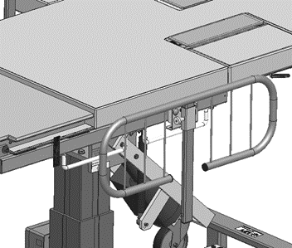

- WARNING

- Verify the side rails are secure prior to using the product and after each side rail adjustment.

Using Head Rest Extension
The product may be equipped with an optional head rest to provide support for taller patients.

The head rest is mounted as shown. | 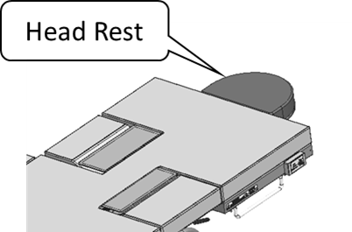

Storing the Hand Control

The hand control may be hung on the rails located underneath the support surface. | 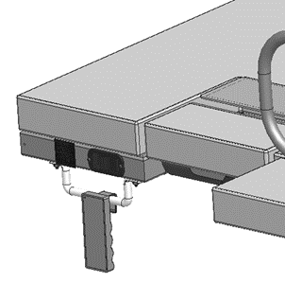

- WARNING

- Verify the head rest is secure prior to using the product.

Battery
The product is equipped with a battery. The battery may be charged by plugging in the product to AC power or by removing the battery and charging it on an external charging station.  To remove the battery, pull the handle and lift the battery away from the mounting bracket.  Note: The lifting capacity of the product may be reduced while on battery power. Use AC power for all patients over 400lb.  Note: See page 26 for additional battery information. | 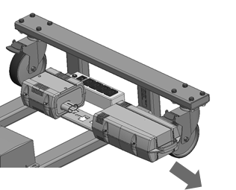

- WARNING
- If damage has occurred to the battery, immediately remove the battery from service. Failure to do so could result in serious injury or death.
- The battery should be periodically inspected for damage. Replace the battery if necessary.
- The battery functionality should be verified regularly to ensure the product works as intended.

Positioning Wedge
The positioning wedge may be used to support the patient at a desired angle.

Pediatric Adaptor
The product may be used with a pediatric/geriatric adaptor. To install use the following steps:  - Lower the Drop Section  - Remove the non- pinch closure flap by grasping one side of the flap and gentle separating the hook and loop fastener.  - Position the adaptor locator flanges within the imaging area.  - Remove the adaptor when not needed.  - With the drop-section lowered, align the top edge of the non-pinch closure flap, (within the access cavity) with the top edge of the support surface.  - Press the hook and loop attachment strips together. | 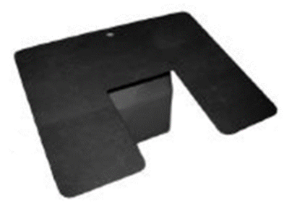

Preventative Maintenance

The following Preventative Maintenance should be performed at a minimum annually. These items should be done by personnel authorized by the hospital to maintain their equipment. If any of these checks fail, repair or replace the part as applicable.
- Visually inspect all mechanical assemblies and moving parts on the product ensuring smooth, steady operation.
- Visually inspect all fasteners (bolts, nuts, screws, etc.) to ensure all are fully installed. Tighten as necessary.
- Visually inspect all electrical cables and wires for signs of abrasion or other damage. If damaged, replace.
- Visually inspect all electrical connections to ensure they are fully and properly connected. Reconnect as necessary.
- Visually inspect the hand control. If damaged, replace.
- Operate all latch mechanisms to ensure proper engagement of latch into receiver. Adjust if necessary.
- Operate all motors to ensure full extension, retraction and correct operation. The motors are permanently lubricated and require no additional lubrication.
- Operate the braking system to ensure proper engagement of the wheel and swivel lock mechanism. Replace as necessary.
- Operate all accessories to ensure proper attachment and operation. Tighten, adjust or replace if necessary.
- Visually inspect the battery for damage. Replace the battery if necessary.
- Unauthorized modification of this product voids any applicable warranty.

- WARNING

- No modification of this equipment is allowed.
- Equipment should only be serviced by authorized personnel.
- Removal of secured covers may increase the risk of electrical shock. Refer servicing to qualified and authorized personnel.
- The potential for electrical shock exists with electrical equipment. Failure to follow facility protocols may cause death or serious injury.

Battery Information

The rechargeable battery must be charged periodically for 12 hours to protect the battery from fully discharging. If the battery is not charged for an extended period of time it may lose its ability to hold a charge and will require replacement. The battery may be charged by plugging the table into AC power or by using the available external battery charger listed in the Replacement Parts and Upgrade Kits section of this manual.

If the product is regularly used it is recommended the battery be charged at least 12 hours every 6 weeks to ensure proper battery function.

If the product is being stored for an extended period of time it is recommended the battery be charged at least 12 hours every 4 months.

The battery charge level is indicated by the hand control LED and audible signals from the control box. The following table provides an overview of battery status:

Operating Mode | LED Indicator | Battery Level
Control powered by AC mains | Lights up green | Full
 | Flashes green | Charging mode
Control powered by battery | Lights green when you press a button on the hand control | Full
 | Lights orange when you press a button on the hand control; an acoustic signal also sounds | Weak charge
 | Flashes orange when you press a button on the hand control; an acoustic signal also sounds | Very weak charge

Expected Life
The expected life of the product is 7 years of normal use. Some components may have a shorter life and require periodic replacement.

Note: See Warranty section for warranty information.

Discard the Unit
Upon reaching the end of its useful life the product may be discarded in accordance with local and federal standards. Recycle when possible.

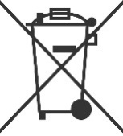 | In accordance with the European Directive 2002/96/EC on Waste Electrical and Electronic Equipment (WEEE), the product must not be disposed as unsorted municipal waste, but should be collected separately. Consult your instructional policies and local regulations regarding disposal. Contact your Medical Positioning, Inc. Service Representative if additional disposal details are required.

Cleaning
Plastic and Painted Surfaces
The painted metal and plastic surfaces can be cleaned with normal cleaners and disinfectant.
STEP | ACTION
1 | Clean and/or disinfect with liquid cleaner of choice being careful to follow label instructions provided with cleaner. (Always test a small area first to determine suitability of solution)
2 | Wipe the surface clean with a damp cloth after applying cleaners and disinfectant to remove excess residue buildup.

Vinyl
The vinyl upholstered surfaces can be cleaned in one of the following ways:
Spills and accidents require immediate attention for best results. When caught quickly, most stains such as grease, blood and felt tip pens can be wiped off. Mild soap and water is the preferred method; however, typical hospital-grade antiseptic wipes work as well. For more stubborn stains, a variety of concentrated and solvent type cleansers may be used without damaging the surface so long as it is thoroughly rinsed off with water.

In general, always start with the mildest cleaning agents first. Never use harsh powdered abrasive cleansers or steel wool. Products containing bleach, ammonia or alcohol should be wiped from the surface with a wet cloth after use. Residue from these products may damage vinyl surfaces.

STEP | ACTION
1 | Clean and/or disinfect with liquid cleaner while being careful to follow label instructions provided with cleaner. (Always test a small area first to determine suitability of solution)
2 | Wipe the surface clean with a damp cloth after applying cleaners and disinfectant to remove excess residue buildup.

RECOMMENDED MAXIMUM CLEANER TO WATER SOLUTIONS
Mildest | 1:1 mix of mild soap and water. Wipe surface with damp cloth with water only after cleaning.
 | Straight application of common disinfectants. Wipe surface with damp cloth with water only after cleaning.
 | 1:1 mix of ammonia and water. Use a soft cotton cloth saturated with the cleaning material. Wipe surface with damp cloth with water only after cleaning.
 | 1:4 mix of bleach and water. Use a soft cotton cloth saturated with the cleaning material. Wipe surface with damp cloth with water only after cleaning.
 | 1:1 mix of isopropyl alcohol and water. Use a soft cotton cloth saturated with the cleaning material. Wipe surface with damp cloth with water only after cleaning.
 | Straight application of isopropyl alcohol. Use a soft cotton cloth saturated with the cleaning material. Wipe surface with damp cloth with water only after cleaning.
Strongest | 1:1 mix of acetone and water. Use a soft cotton cloth saturated with the cleaning material. Wipe surface with damp cloth with water only after cleaning.

This information is not a guarantee and does not relieve the user from the responsibility of proper and safe use of the product and all cleaning agents.

- WARNING

- It is recommended that the product be cleaned between patients; please follow your facility’s documented policy.

- CAUTION

- Always read manufacturer’s instructions and warnings before using any cleaning product or disinfectant.
- Substances such as imaging gels and alcohol will not damage the vinyl surface when immediately removed. Studies have shown that exposure for longer than a few minutes can damage the topcoat and will discolor vinyl.
- Do not use abrasives to clean painted surfaces.

Service Calls
A “Troubleshooting Guide” is included to instruct you in the event of a malfunction. If you are experiencing any of the following symptoms, this guide may help you quickly solve the problem. If, after consulting this guide, you are still unable to operate your product, please contact Medical Positioning at 1-800-593-3246. Please have the following information ready when you call:
- Model Number or Name of Product
- Serial Number
- Date Received
- Condition When Received
- Symptom (or problem) Encountered & Result of Troubleshooting Procedure

Complaint Reporting Procedure
In the event of a product malfunction or patient injury, please immediately report the incident to:

1. __________________________________________________________
(The distributor from whom the product was purchased)
2. Medical Positioning, Inc.
9732 Pflumm Road
Lenexa, KS 66215
www.medicalpositioning.com
816-474-1555
800-593-3246

Troubleshooting Guide

SYMPTOM | PROBABLE CAUSE | SUGGESTION
No Actuator Function.  Actuator(s) Not Running. | - Power cord not plugged all the way into wall receptacle. | - Push power cord securely into receptacle.
 | - Power outlet receptacle not supplying AC power. | - Check power availability or plug unit into another receptacle.
 | - The power cord may be separated from the control box. | - Securely press power cord into control box.
 | - Battery may be drained. | - Replace or charge battery.
 | - Actuator cord may be unplugged. | - Push actuator cords securely into actuator receptacle.
 | - Product was overloaded and tripped internal fuse in control box. | - Replace control box.
 | - Product motion is limited to certain angles. | - Check tilt angle selector to determine if it is set to limit tilt motion.
Squeaking noises during operation. | - Actuator pins are not sufficiently lubricated. | - Apply WD40 or similar lubricant to actuator pins.
Emergency down function is slow. | - Table is on DC battery power. Emergency down speed is only available when AC power is present. | - Plug table into AC outlet.

Specifications

Product Models & Attributes
RR HUT Table
ATTRIBUTE | 1056 | 1256 | 1058 | 1258
Base Width | 30” | 30” | 30” | 30”
Base Length | 60” | 60” | 60” | 60”
Surface Width | 30” | 30” | 30” | 30”
Surface Length | 73” | 73” | 73” | 73”
Surface Height Range  *To top of cushion | 31” – 39” | 31” – 39” | 31” – 39” | 31” – 39”
Trendelenburg/  Reverse Trendelenburg | 15° / 90° | 15° / 90° | 15° / 90° | 15° / 90°
# of Drop Sections | 0 | 2 | 0 | 2
Maximum Patient Weight | 600lb | 600lb | 600lb | 600lb
Maximum Safe Working Load | 620lb | 620lb | 620lb | 620lb
Approximate Product Weight | 380lb | 380lb | 380lb | 380lb

Environmental Conditions
ATTRIBUTE | Range for Use | Range for Storage and Transport
Ambient Temperature | +5° to 40° C | +5° to +40° C
Relative Humidity | 20% to 90% @ 30°C – not condensing | 20% to 90% @ 30°C – not condensing
Atmospheric Pressure | 860 to 1060 hPa | 860 to 1060 hPa

Upholstery
ATTRIBUTE | SPECIFICATION
Foam | California Technical Bulletin 117

Power Requirements
ATTRIBUTE | SPECIFICATION
Electrical, Product | 120VAC, 60 Hz, max 6.5 A  230VAC, 50 Hz, max 3.4 A
Electrical, Battery Charger | 120VAC, 60 Hz, max 6.5 A  230VAC, 50 Hz, max 3.4 A
Battery Option | 24 VDC, 4.5 Ah
Duty Cycle | 10%, 1 min. on / 9 min. off

- All electrical circuitry is isolated from chassis.
- Grounding reliability can only be achieved when the equipment is connected to an equivalent receptacle marked “Hospital Only” or “Hospital Grade.”
- The power cord is to be used for mains disconnection.
- Attached power supply cord set is not allowed to be diverted to other equipment.

Classifications and Standards
ATTRIBUTE | SPECIFICATION
Standards | - UL 60601-1, 1st Edition, 2006-04-26 (Medical Electrical Equipment, Part 1: General Requirements for Safety)  - CAN/CSA-C22.2 No. 601.1-M90, 2005 (Medical Electrical Equipment - Part 1: General Requirements for Safety)
Protection against Electrical Shock | - Class I equipment  - Type B applied part
Degree of protection against Dust and Fluid intrusion | - IPX0

Applied Parts (in accordance with IEC 60601-1)
- All padded surfaces
- Footrest
- Straps
Electromagnetic Emissions Guidance
The product use components that are certified for electromagnetic compatibility. Other products that are used in the vicinity of this product should also comply with this standard. If they do not comply, electromagnetic interference between the products could cause the products to operate incorrectly. If problems do occur, contact the product manufacturer(s).
Make sure the product operates correctly when used near other electronic devices. Portable and mobile radio frequency (RF) communications equipment can affect electrical equipment.

- WARNING

- If the product is used adjacent to other electrical equipment, observe this product and the other electrical equipment to make sure they operate as intended.

Standard and Optional Configurations

 | RR HUT Table
ATTRIBUTE | STANDARD | OPTIONAL
Hand control | X | -
Safety Straps | X | -
Battery Functionality | X | -
Side Rails | - | X
Paper Roll Holder | - | X
Positioning Wedge | - | X
Sonographer Extension | - | X
Head Extension | - | X
IV Pole & Holder | - | X
2nd Battery & Charger Kit | - | X

Replacement Parts and Upgrade Kits
The following items are replacement parts or upgrade kits for the RR HUT. Some of the items below may not be suitable for all models of product.

Part Description | Part #
Hand Control – RR HUT | 15568
Paper Roll Holder Kit | 10098
Side Rail Kit (No Drop Sections) | 14489
Side Rail Kit (Drop Sections) | 14685
IV Pole Kit | 10855
Replacement Battery | 15578
Wall Charger Kit | 15580 & 15581
Head Extension Kit | 10553
Sonographer Extension Kit | 11913
Pediatric/Geriatric Adapter | 10097
Positioning Wedge | 11943
Armboard Kit | 10581

Warranty
Warranty

RR HUT Table™
3
YEAR WARRANTY

Medical Positioning, Inc. (“MPI”) warrants and represents that this product will be free from material and workmanship defects during the period indicated above (the “Warranty Period”), commencing with tender of delivery as defined in Uniform Commercial Code § 2-503, irrespective of any inspection period and provided that the product is maintained and operated in accordance with MPI’s specifications.

If the product fails due to a manufacturing defect, MPI will, at its sole expense and discretion, repair the product, authorize repairs to the product, or replace the product. MPI will ship any replacement products or parts using standard shipping rates; if the customer requires expedited shipping of replacement products or parts, the customer is responsible for paying shipping costs above standard rates.

Preventative maintenance and repairs due to damage by use, accident, improper care, negligence, or other non-defect related failures are not covered by this warranty. This warranty is void as to products that have been modified without the advance written permission of MPI.

OTHER THAN AS SET FORTH HEREIN, MPI MAKES NO WARRANTY WHATSOEVER, EITHER EXPRESSED OR IMPLIED, WITH RESPECT TO THIS PRODUCT. MPI SPECIFICALLY DISCLAIMS THE (a) IMPLIED WARRANTY OF MERCHANTABILITY; (b) WARRANTY OF FITNESS FOR A PARTICULAR PURPOSE; AND (c) WARRANTY AGAINST INFRINGEMENT OF ANY PATENT, COPYRIGHT, TRADEMARK, TRADE SECRET OR OTHER PROPRIETARY RIGHTS OF A THIRD PARTY; WHETHER ARISING BY LAW, COURSE OF DEALING, COURSE OF PERFORMANCE, USAGE OF TRADE OR OTHERWISE.

This warranty is nontransferable. The remedies provided under this warranty are the customer’s sole and exclusive remedies. In no event will MPI be liable for any direct, indirect, special, incidental, consequential damages or lost profits or income whether based on contract, tort, or any other legal theory.

Medical Positioning, Inc.
9732 Pflumm Road
Lenexa, Kansas 66215
(816) 474-1555
(800) 593-3246
Fax (816) 474-7755
WAR069-B

Return Policy

MPI accepts returns of unused products within 30 days from the date of delivery, irrespective of any inspection period. Returns are subject to a 30% restocking fee, any applicable duties or taxes and quality inspection. No product may be returned without prior written authorization from MPI. The customer is responsible for all shipping charges and any applicable duties or taxes incurred in connection with a return.

WAR093-A

