

Owner’s Manual
Ultra DBITM
Model: 9400
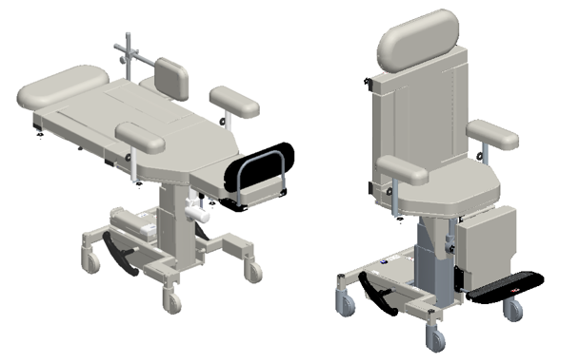

Owner _____________________

Model _____________________

Serial # _____________________

Date _____________________

Table of Contents

Symbols and Definitions 3
Safety Warnings & Cautions 6
Intended Use 8
Training and Qualifications 8
Safety Features 8
Set Up 9
Transport Position 9
Product Illustration 10
Controls and Indicators 11
Use Instructions 14
Powering the Product 14
Locking the Casters 15
Adjusting Table Height 16
Adjusting Fowler 16
Adjusting Trendelenburg 16
Leveling Function 16
Ingress / Egress (Home) Function 17
Hand Control Lock/Unlock 17
Underbody LED Lights 17
Using the Foot Rest 18
Using the Head Rest 20
Using the Back Support 21
Arm Rests 22
IV Pole and Holder 22
Instrument Tray 22
Optional Battery 23
Storing the Hand control 23
Preventative Maintenance 24
Expected Life 25
Discard of the Unit 25
Cleaning 26
Service Calls 28
Troubleshooting Guide 29
Specifications 30
Warranty 39
Return Policy 40

Symbols and Definitions

 | Warning, follow instructions for use. Failure to comply may result in injury.
 | Warning, sitting is prohibited. Failure to comply may result in injury.
 | Warning, standing is prohibited. Failure to comply may result in injury.
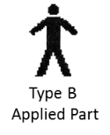 | Applied Part complying with specified requirements of IEC 60601-1 to provide protection against electric shock, including, but not limited to, allowable patient leakage current.
 | Warning/Caution, consult accompanying documents or instructions.
 | Any terminal which is intended for connection to an external protective conductor for protection against electric shock in case of a fault.
 | In accordance with the European Directive 2002/96/EC on Waste Electrical and Electronic Equipment (WEEE), the product must not be disposed as unsorted municipal waste but should be collected separately. Consult your facility policies and local regulations regarding disposal. Contact Medical Positioning, Inc. if additional disposal details are required.
 | Manufacturer
 | Agency Mark
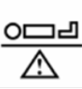 | Maximum Patient Weight. Indicates the maximum patient weight that may be placed on the product.
 | Safe Working Load. Indicates the sum of the patient weight and accessories.

WARNING / CAUTION / NOTE Definition

The words WARNING, CAUTION, and NOTE carry special meanings and should be carefully reviewed.

- WARNING

Identifies a situation that could result in injury to the patient or caregiver.

- CAUTION

Identifies a situation that could result in equipment damage.

Note
Provides special information to make an important instruction more clear.

Medical Positioning Inc
9732 Pflumm Road
Lenexa, KS 66215
USA
1-800-593-3246
 | MDSS GmbH  Schiffgraben 41  30175 Hannover, Germany
 | MDSS CH GmbH  Laurenzenvorstadt 61  5000 Aarau  Switzerland
United Kingdom Responsible Person | Heath & Co Management Services, Ltd.  10 Barn Owl Way  Burghfield Common  Reading  RG7 3XX  United Kingdom
Australian Sponsor | Emergo Australia  Level 20 Tower II  Darling Park  201 Sussex Street  Sydney, NSW 2000  Australia
Türkiye İthalatçısı / Turkish Importer
GE Medical Systems Türkiye Ltd. Şti.
Esentepe Mah. Harman Sok. No: 8
34394 Şişli İstanbul Türkiye

Safety Warnings & Cautions

- WARNING:
Obey these safety instructions to help prevent injury and/or equipment damage:

- Read and understand all warnings in this manual and on the unit itself prior to use with a patient.
- The device should be operated by trained person only.
- Authorized and qualified persons will be those who are approved by MPI to repair or modify the product.
- The procedures in this manual are only manufacturer suggestions. The final responsibility for patient care with respect to this device remains with the attending physician.
- Do not modify this equipment without authorization of the manufacturer.
- Equipment should only be serviced by authorized personnel.
- Do not use in an oxygen rich environment.
- Do not leave patient unattended while using the table.
- To reduce the risk of electrical shock, grounding reliability can only be achieved when the equipment is connected to an equivalent receptacle marked “hospital only” or “hospital grade”.
- If damage has occurred to the power cord, immediately remove the cord from service. Failure to do so could result in serious injury or death.
- If damage has occurred to the battery, immediately remove the battery from service. Failure to do so could result in serious injury or death.
- Removal of secured covers may increase the risk of electrical shock. Refer servicing to qualified personnel.
- The potential for electrical shock exists with electrical equipment. Failure to follow facility protocols may cause death or serious injury.
- Ensure the patient is properly secured prior to using the equipment.
- To reduce the risk of a potential injury, lock casters before using equipment.
- Once the product and patient have been properly positioned for the procedure, ensure the casters are locked and the hand controller is placed in a safe position to prevent unwanted contact and unwanted movement of the table surface during the procedure.
- To reduce the risk of the product becoming unbalanced, always position the product in the lowest reasonable height when moving.
- Verify the area around the product is free of impediments before operating to prevent injury or equipment damage.
- The battery should be periodically inspected for damage. Replace the battery if necessary.
- Keep hands and feet clear from beneath the patient surface when operating to avoid possible injury.
- Keep feet clear from beneath the calf section when operating into the chair position or lowering the height when in the chair position to avoid possible injury.
- Keep hands clear of the Fowler and calf section hinges during operation to avoid possible injury.
- Sitting at the end of the patient surfaces when in the table position can result in device instability. Do not allow a patient to sit at either end of the patient surface when in the table position.
- Standing solely on the patient footrest when in the chair position may result in device instability. Do not allow a patient to stand solely on the footrest when in the chair position.
- Protect vinyl upholstery from sharp objects and abrasion to avoid damage.
- Always read manufacturer’s instructions and warnings before using any cleaning product or disinfectant.
- Refer to instructions located in this manual for vinyl cleaning recommendations.
- Substances such as imaging gels and alcohol will not damage the vinyl surface when immediately removed. Studies have shown that exposure for longer than a few minutes can damage the topcoat and will eventually discolor vinyl.
- Do not use abrasives to clean painted surfaces.
- It is recommended that the product be cleaned between patients; please follow your facility’s documented policy.
- Keep this manual available for future reference.
- If the Ultra DBI is used adjacent to other electrical equipment, observe the Ultra DBI and the other electrical equipment to make sure they operate as intended.
- Failure to latch Drop Sections may result in patient injury. Verify Drop Sections are locked in position before and after use.
- Verify the head rest is secure prior to using the product or transferring a patient.
- Verify the back rest is secure prior to using the product.

Intended Use

The Ultra DBI is intended to support a patient for breast biopsy procedures. It is to be used by trained healthcare professionals in an acute care, outpatient imaging, hospital and office setting. The product is contraindicated for patients that cannot safely sit in a chair or lie on an elevated surface.

The Ultra DBI is not intended for use in oxygen rich environments.

Training and Qualifications

It is recommended that the user manual be reviewed prior to using the product. MPI does not require specific training or qualifications for the use of this product. It shall be the responsibility of the health care facility to ensure caregivers who use the product are properly trained to the necessary hospital protocols.

Safety Features

- This product is equipped with multiple automated safety features to prevent danger or damage during use. The entire system is electrically isolated to UL/IEC 60601-1 and CAN/CSA C22.2 No. 601.1 hospital safety standards.
- The actuator assemblies are current overload protected. If overloaded, the actuators will stop and reset automatically.
- The sealed hand control operates the actuators by directing small amounts of low voltage D.C. current to the control box. All of the actuator drives are equipped with internal limit switches which automatically prevent over-extension.
- The tables are equipped with total locking, sealed bearing, and braking casters at all four corners.

Set Up

The Ultra DBI has been shipped to you in “plug and play” condition. After unpacking the product, we recommend performing an initial test of your Ultra DBI to ensure that each function is in correct working order. After reviewing this manual, you are ready to begin using your Ultra DBI.

STEP | ACTION
1 | After removing padding and packaging materials locate primary power supply cord and attach to suitable grounded power outlet.
2 | To test actuator function, locate the hand control and depress and hold each button one at a time. (Depressing multiple buttons simultaneously will prevent the motor from operating.)
3 | If any function does not operate, perform the test procedures listed in the Troubleshooting Guide.

Transport Position

The Ultra DBI may be used to transport the patient within the procedure room in both the chair and table positions. However, the product may become unstable when moving bariatric patients over thresholds in the chair position. It is recommended that the product be in the table position when transporting patients.

Product Illustration

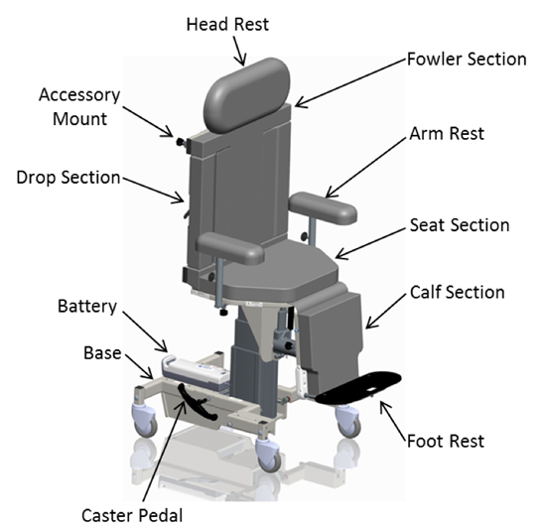

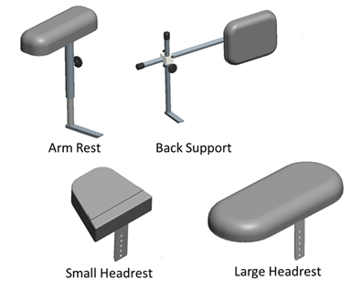
Controls and Indicators

UDI Label  - Serial #  - Item #  - Item Description | 
Certification Label | 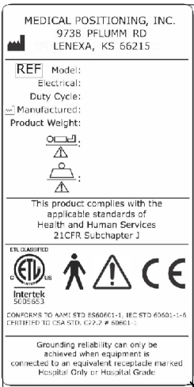
Refer to Manual Label | 

No Sitting / No Standing Label | 
No Sitting Label | 
Hand Control | 

AC Input | 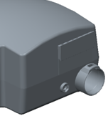
Battery | 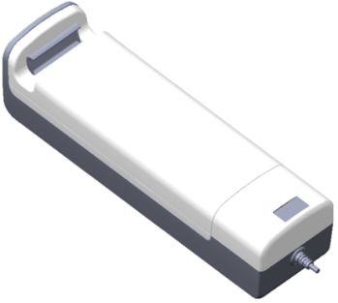
Pedals for Total Lock Casters | 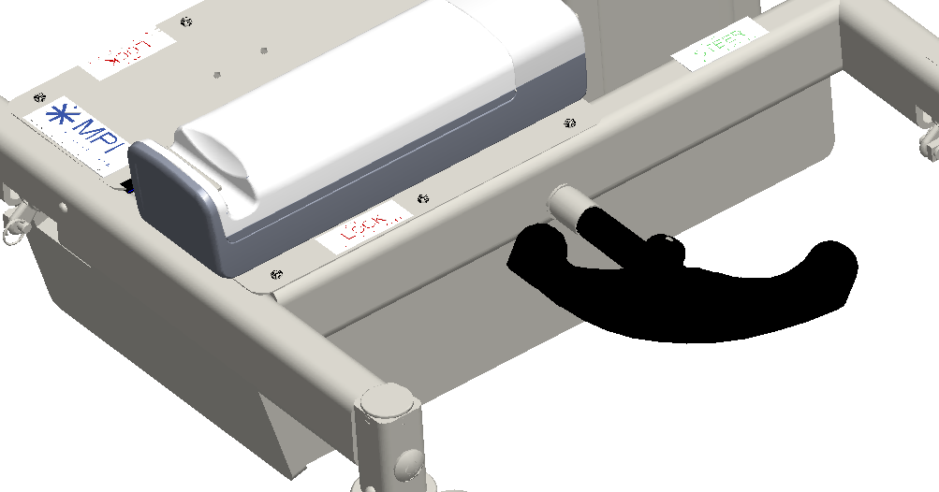

Use Instructions

Powering the Product

The product may be powered by AC power from a wall outlet or by DC power via the optional battery. The product is “on” when it is plugged into AC power or when a charged battery is installed. The product should not be positioned in a way that would make it difficult to remove power by unplugging the AC power cord or removing the battery.

To apply AC power to the product, attach the power cord to the AC input located at the rear of the product. | 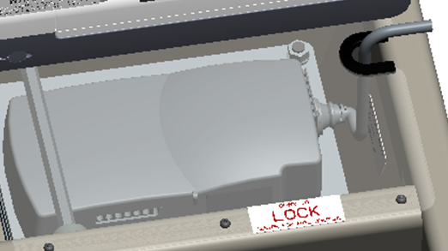
To apply DC power to the product, install a battery at the rear of the product.  Note: The battery may be charged while it is installed onto the product by plugging the product into AC power. | 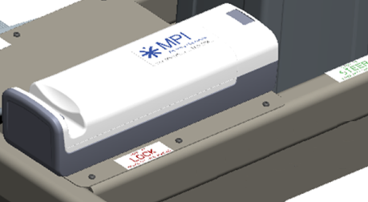

- WARNING

- To reduce the risk of electrical shock, grounding reliability can only be achieved when the equipment is connected to an equivalent receptacle marked “hospital only” or “hospital grade.”
- If damage has occurred to the power cord, immediately remove the cord from service. Failure to do so could result in serious injury or death.
- If damage has occurred to the battery, immediately remove the battery from service. Failure to do so could result in serious injury or death.
- The battery should be periodically inspected for damage. Replace the battery if necessary.

Locking the Casters

The product uses total locking casters with 3 functional positions: full unlock, steer, and full lock.
- In the full unlock position all four casters may swivel and roll.
- In the steer position the rear casters are held in a forward-facing orientation and the front casters are free to swivel.
- In the full lock position, all four casters are prevented from both rolling and swiveling.

Pedals are located on each side of the base and are used to adjust the caster function. | 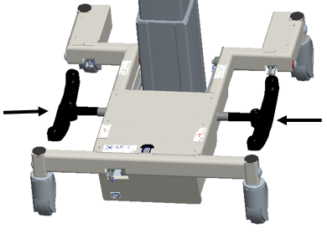

- WARNING

- Once the table and patient have been properly positioned for the procedure, ensure the casters are locked and the hand control is placed in a safe position to prevent unwanted contact and unwanted movement of the table surface during the procedure.

Adjusting Table Height
The seat height is adjusted by the hand control. The minimum seat height is 25” when the seat is level but is limited to approximately 34.5” if the seat is tilted forward from using the Trendelenburg function in order to protect against equipment damage and injury.

Press and hold the applicable hand control button to adjust the seat height. | 

Adjusting Fowler
The Fowler and calf sections are adjusted simultaneously.

Press and hold the applicable hand control button to independently adjust the Fowler. | 

Adjusting Trendelenburg
The Trendelenburg function may be used while the product is in a chair or table position. The angle of Trendelenburg angle may be limited while at low heights in the chair position in order to protect against equipment damage and injury.

Press and hold the applicable hand control button to independently adjust the Trendelenburg angle. | 

Leveling Function
The seat is leveled to 0° in any orientation or height.

Press and hold the applicable hand control button to adjust the angle of the seat section to 0° (level). | 

Ingress / Egress (Home) Function
The seat is leveled to 0°, height is reduced to the lowest level, and the Fowler adjusts to 80°.

Press and hold the applicable hand control button until all adjustments are made. | 

Hand Control Lock/Unlock
The hand control function may be locked during the procedure to prevent unwanted movement if the buttons are inadvertently depressed.

Press and hold the lock button for 3 seconds to lock functions. The green LED at the top of the hand control will light up.  Press and hold the unlock button for 3 seconds to unlock functions. The green LED at the top of the hand control will turn off. | 

Underbody LED Lights
The Ultra DBI may be equipped with optional underbed lights.

Press both buttons to turn on/off the under-bed lights. | 

- WARNING

- Verify the area around the product is free of impediments before operating to prevent injury or equipment damage.
- Keep feet clear from beneath the calf section when operating into the chair position or lowering the height when in the chair position to avoid possible injury.
- Keep hands and feet clear from beneath the patient surface when operating to avoid possible injury.

Using the Footrest
The footrest may be removed if needed to assist patient entry onto the product.

The footrest plugs into the mounting block located on the calf section. The footrest position is adjustable by approximately 4 inches. | 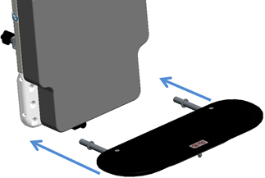

- WARNING

- Standing solely on the patient footrest when in the chair position may result in device instability. Do not allow a patient to stand solely on the footrest when the chair position.

Using the Drop Sections
Drop sections are located on the Fowler section to allow access for imaging equipment.

Pull handle to release drop section latches. | 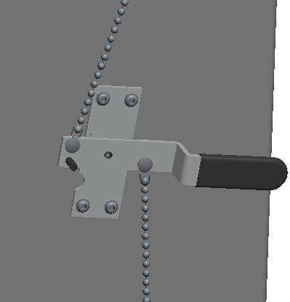
Lift drop section up until latches engage to close the drop sections. | 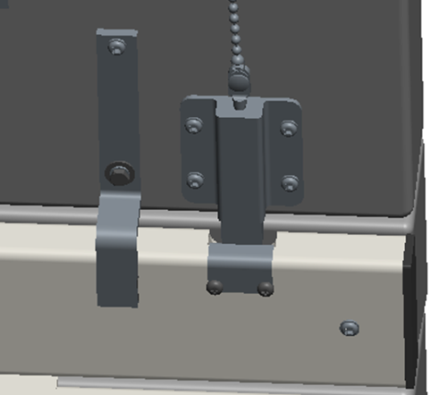

- WARNING

- Failure to latch Drop Sections may result in patient injury. Verify Drop Sections are locked in position before and after use.

Using the Head Rest
The product is compatible with a large and small head rest that can be attached at either end of the product when in the table position.

Rotate cam handle to extend and retract the plunger pin. | 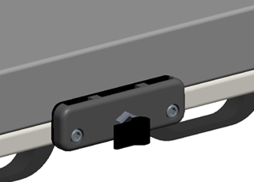
Install the head rest at the desired height and lock in place using the plunger pin. | 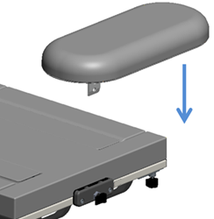
Rotate the plunger pin to the unlocked position to allow for easy removal of the head rest.  Remove the head rest from the calf end before converting to a chair position. | 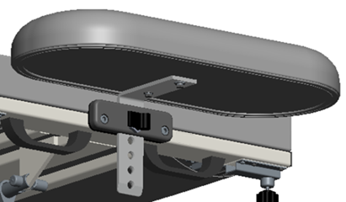

- WARNING

- Verify the head rest is secure prior to using the product or transferring a patient.

Using the Back Support
The back support can be used to provide stability to the patient during the procedure.

The back rest may be installed at any accessory mounting location.  Install the back rest bracket and secure using the knob. | 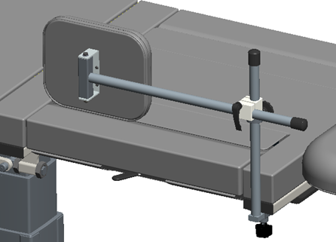
Adjust the position of the back support by loosening the cam and moving the pad to the desired location. Tighten the cam to lock into position. | 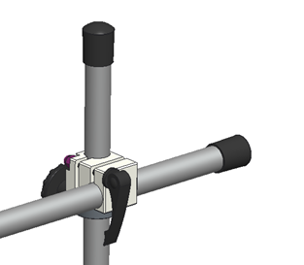

- WARNING

- Verify the back rest is secure prior to using the product.

Arm Rests
The product may be equipped with arm rests. Place the arm rest bracket into the holder and tighten the knob to secure the arm rest to the chair. | 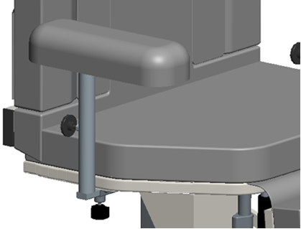

IV Pole and Holder
The product may be equipped with an optional IV pole holder. Place the IV pole bracket into the holder and tighten the knob to secure the IV pole to the chair. | 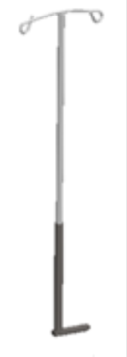

Instrument Tray
The product may be equipped with an optional instrument tray. Place the instrument tray bracket into the mounting bracket and tighten the knob to secure the instrument tray to the chair.  The instrument tray may be installed at any accessory mounting location. | 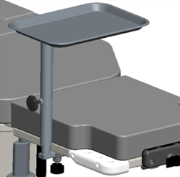

Optional Battery
The product may be equipped with an optional battery. The battery may be removed for charging by pulling the release latch and lifting the battery.

Storing the Hand control
The hand control may be hung from the headrest mount on either side of the lever when not in use. | 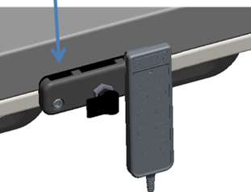

Preventative Maintenance

The following Preventative Maintenance should be performed at a minimum annually. If any of these checks fail, repair or replace the part as applicable.
- Visually inspect all mechanical assemblies and moving parts on the product ensuring smooth, steady operation.
- Visually inspect all upholstered surfaces for tears or excessive wear. Replace if necessary.
- Visually inspect all fasteners (bolts, nuts, screws, etc.) to ensure all are fully installed. Tighten as necessary.
- Visually inspect all electrical cables and wires for signs of abrasion or other damage. If damaged, replace.
- Visually inspect all electrical connections to ensure they are fully and properly connected. Reconnect as necessary.
- Visually inspect the hand control. If damaged, replace.
- Visually inspect the lifting mechanism shroud during raise and lowering. Adjust or replace if necessary.
- Operate all latch mechanisms to ensure proper engagement of latch into receiver. Adjust if necessary.
- Operate all motors to ensure full extension, retraction and correct operation. The motors are permanently lubricated and require no lubrication.
- Operate the braking system to ensure proper engagement of the wheel and swivel lock mechanism. Replace as necessary.
- Operate all accessories to ensure proper attachment and operation. Tighten, adjust or replace if necessary.
- Visually inspect the battery for damage. Replace the battery if necessary.

- WARNING

- No modification of this equipment is allowed.
- Equipment should only be serviced by authorized personnel.
- Removal of secured covers may increase the risk of electrical shock. Refer servicing to qualified personnel.
- The potential for electrical shock exists with electrical equipment. Failure to follow facility protocols may cause death or serious injury.

Expected Life
The expected life of the product is 7 years of normal use from the date of manufacture. Some components may have a shorter life and require replacement.

Discard of the Unit
Upon reaching the end of its useful life the product may be discarded in accordance with local and federal standards. Recycle when possible.

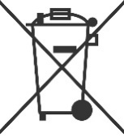 | In accordance with the European Directive 2002/96/EC on Waste Electrical and Electronic Equipment (WEEE), the product must not be disposed as unsorted municipal waste but should be collected separately. Consult your instructional policies and local regulations regarding disposal. Contact your Medical Positioning, Inc. Service Representative if additional disposal details are required.

Cleaning
The product should be kept in a clean condition per facility procedure.

Plastic and Painted Surfaces
The painted metal and plastic surfaces can be cleaned with normal cleaners and disinfectant.
STEP | ACTION
1 | Clean and/or disinfect with liquid cleaner of choice being careful to follow label instructions provided with cleaner. (Always test a small area first to determine suitability of solution)
2 | Wipe the surface clean with a damp cloth after applying cleaners and disinfectant to remove excess residue buildup.

Vinyl

The vinyl upholstered surfaces can be cleaned in one of the following ways:
The preferred method of everyday cleaning is using a soft cloth or sponge with mild soap and water or disinfectant. Spills and accidents require immediate attention for the best results. When caught quickly, most stains such as grease, blood and black felt tip pens can be wiped right off. Mild soap and water is the preferred method; however, typical hospital-grade antiseptic wipes work as well. For more stubborn stains, a variety of concentrated and solvent type cleansers may be used without damaging the surface as long as they are thoroughly rinsed off with water.

In general, always start with the mildest cleaning agents first. Never use harsh powdered abrasive cleansers or steel wool. Products containing bleach, ammonia or alcohol should be wiped from the surface with a wet cloth after use. Residue from these products will damage vinyl surfaces

STEP | ACTION
1 | Clean and/or disinfect with liquid cleaner of choice being careful to follow label instructions provided with cleaner. (Always test a small area first to determine suitability of solution)
2 | Wipe the surface clean with a damp cloth after applying cleaners and disinfectant to remove excess residue buildup.

RECOMMENDED MAXIMUM CLEANER TO WATER SOLUTIONS
Mildest | 1:1 mix of mild soap and water. Wipe surface with damp cloth with water only after cleaning.
 | Straight application of common disinfectants. Wipe surface with damp cloth with water only after cleaning.
 | 1:1 mix of ammonia and water. Use a soft cotton cloth saturated with the cleaning material. Wipe surface with damp cloth with water only after cleaning.
 | 1:4 mix of bleach and water. Use a soft cotton cloth saturated with the cleaning material. Wipe surface with damp cloth with water only after cleaning.
 | 1:1 mix of isopropyl alcohol and water. Use a soft cotton cloth saturated with the cleaning material. Wipe surface with damp cloth with water only after cleaning.
 | Straight application of isopropyl alcohol. Use a soft cotton cloth saturated with the cleaning material. Wipe surface with damp cloth with water only after cleaning.
Strongest | 1:1 mix of acetone and water. Use a soft cotton cloth saturated with the cleaning material. Wipe surface with damp cloth with water only after cleaning.

This information is not a guarantee and does not relieve the user from the responsibility of the proper and safe use of the product and all cleaning agents.

- WARNING

- It is recommended that the product be cleaned between patients; please follow your facility’s documented policy.

- CAUTION

- Always read manufacturer’s instructions and warnings before using any cleaning product or disinfectant.
- Substances such as imaging gels and alcohol will not damage the vinyl surface when immediately removed. Studies have shown that exposure for longer than a few minutes can damage the topcoat and will eventually discolor vinyl.
- Do not use abrasives to clean painted surfaces.

Service Calls
A “Troubleshooting Guide” is included to instruct you in the event of a malfunction. If you are experiencing any of the following symptoms, this guide may help you quickly solve the problem. If, after consulting this guide, you are still unable to operate your table please contact Medical Positioning at
1-800-593-3246. Please have the following information ready when you call:
- Model Number or Name of Product
- Serial Number
- Date Received
- Condition When Received
- Symptom (or problem) Encountered & Result of Troubleshooting Procedure

Adverse Event Reporting

Any serious incident that has occurred in relation to the device should be reported immediately to Medical Positioning. If located in the European Union, please immediately contact Medical Positioning and the competent authority of the Member State in which the user and/or patient is established.

Medical Positioning, Inc.
9732 Pflumm Road
Lenexa, KS 66215
www.MedicalPositioning.com
011-816-474-1555
800-593-3246 (ECHO)

Troubleshooting Guide

SYMPTOM | PROBABLE CAUSE | SUGGESTION
No Actuator Function  Actuator(s) Not Running. | - Power cord not plugged all the way into wall receptacle. | - Push power cord securely into receptacle.
No Actuator Function  Actuator(s) Not Running. | - Power outlet receptacle not supplying 120 VAC power. | - Check power availability or plug unit into another receptacle.
No Actuator Function  Actuator(s) Not Running. | - The power cord may be separated from the control box. | - Securely press power cord into control box.
No Actuator Function  Actuator(s) Not Running. | - Battery may be drained. | - Replace or charge battery.
No Actuator Function  Actuator(s) Not Running. | - Actuator cord may be unplugged. | - Push actuator cords securely into actuator receptacle.
No Actuator Function  Actuator(s) Not Running. | - Product was overloaded and tripped internal fuse in control box. | - Replace control box.
No Actuator Function  Actuator(s) Not Running. | - Product motion is limited at certain heights and angles while in the chair position | - Return the seat to level position to restore full range of motion
No Actuator Function  Actuator(s) Not Running. | - The product will not move when hand control buttons are pressed. | - The hand control buttons may be locked. If the green LED on the hand control is lit then press the unlock button for 3 seconds to unlock the hand control functions.

- WARNING

- Do not modify this equipment without authorization of the manufacturer.
- Removal of secured covers may increase the risk of electrical shock. Refer servicing to qualified personnel.
- The battery should be periodically inspected for damage. Replace the battery if necessary.

Specifications

Model Number | Description
9400, 9400UK, 9400EU, 9400AU, 9400JP | Ultra DBI

Product Attributes
ATTRIBUTE | SPECIFICATION
Base Width | 26” | 660mm
Base Length | 30” | 762mm
Surface Length  *Table position | 78” | 1981mm
Seat Height  *To top of cushion | 25” – 34.5” | 622mm – 876mm
Seat & Seat Back Width | 27” | 686mm
Calf Width | 15.5” | 394mm
Product Weight | 366lb | 166kg
Maximum Patient Weight | 500lb | 227kg
Safe Working Load | 525lb | 238kg

Environmental Conditions
ATTRIBUTE | Range for Use | Range for Storage and Transport
Ambient Temperature | +0° to 40° C | -10° to +50° C
Relative Humidity | 20% to 90% @ 30°C – not condensing | 20% to 90% @ 30°C – not condensing
Atmospheric Pressure | 860 to 1060 hPa | 860 to 1060 hPa

Upholstery
ATTRIBUTE | SPECIFICATION
Foam | California Technical Bulletin 117 – Section E

Power Requirements
ATTRIBUTE | SPECIFICATION
Electrical, Ultra DBI | 100–230 VAC, 50/60 Hz, max 5.0 A
Electrical, Battery Charger | 100–230 VAC, 50/60 Hz
Battery Option | 24 VDC, 2.9 Ah
Duty Cycle | 10%, 2 min. on / 18 min. off

- All electrical circuitry is isolated from chassis.
- Grounding reliability can only be achieved when the equipment is connected to an equivalent receptacle marked “Hospital Only” or “Hospital Grade.”
- The power cord is to be used for mains disconnection.
- Attached power supply cord set is not allowed to be diverted to other equipment.

Classifications and Standards
ATTRIBUTE | SPECIFICATION
Standards | - IEC 60601-1:2005 + A1:2012  - ANSI/AAMI ES60601-1:2005/(R)2012 and A1:2012, C1:2009/(R)2012 and A2:2010/(R)2012  - CAN/CSA-C22.2 NO. 60601-1:14  - EN 60601-1:2006 +A11:2011 +A1:2013 +AC:2014  - IEC 60601-1-2:2007  - EN/ISO 14971:2019
Protection against Electrical Shock | - Class I equipment  - Type B applied part
Degree of protection against Dust and Fluid intrusion | - IPX0
The Ultra DBI product meets the relevant sections of the standards listed above.

Applied Parts (in accordance with IEC 60601-1)
The following parts are intended to contact the patient during normal product use.

Item | Material
Padded Surfaces | Vinyl fabric
Footrest | Plastic
Straps | Nylon webbing
Electromagnetic Emissions Guidance
The Ultra DBI uses components that meet the requirements for
IEC 60601-1-2. Other products that are used in the vicinity of the Ultra DBI should also comply with this standard. If they do not comply, electromagnetic interference between the products could cause the products to operate incorrectly. If problems do occur, contact the product manufacturer(s).
Make sure the Ultra DBI operates correctly when used near other electronic devices. Portable and mobile radio frequency (RF) communications equipment can affect electrical equipment.

- WARNING

- If the Ultra DBI is used adjacent to other electrical equipment, observe the Ultra DBI and the other electrical equipment to make sure they operate as intended.

Electromagnetic Compatibility
Medical electrical equipment requires special precautions regarding electromagnetic compatibility (EMC) and needs to be installed and put into service according to the EMC information provided in this user manual.

Portable and mobile radio frequency (RF) communications equipment can affect medical electrical equipment.

Guidance and Manufacturer's Declaration - Electromagnetic Emissions
The Ultra DBI is intended for use in the electromagnetic environments specified below. The customer or the user of the Ultra DBI should assure it is used in such an environment.
Emissions Test | Compliance | Guidance
RF Emissions  CISPR 11 | Group 1  Group 2 | The Ultra DBI uses RF energy only for its internal function. Therefore, its RF emissions are very low and are not likely to cause any interference in nearby electronic equipment. <1>  The Ultra DBI must emit electromagnetic energy in order to perform its intended function. Nearby electronic equipment may be affected. <2>
RF Emissions  CISPR 11 | Class A | The Ultra DBI is suitable for use in all establishments other than domestic and those directly connected to the public low-voltage power supply network that supplies buildings used for domestic purposes.
Harmonic  Emissions  IEC 61000-3-2 | N/A
Voltage  Fluctuations/  Flicker Emissions  IEC 61000-3-3 | N/A

Guidance and Manufacturer's Declaration - Electromagnetic Immunity
The Ultra DBI is intended for use in the electromagnetic environments specified below. The customer or the user of the Ultra DBI should assure it is used in such an environment.
Immunity  Test | IEC 60601  Test Level | Compliance Level | Guidance
Electrostatic  Discharge  IEC 61000- 4-2 | ± 6 kV Contact  ± 8 kV Air | ± 6 kV Contact  ± 8 kV Air | Floors should be wood, concrete, or ceramic tile. If floors are covered with synthetic material, the relative humidity should be at least 30%.
Electrical  Fast Transient/  Burst  IEC 61000-4-4 | ± 2 kV on power  Supply Lines  ± 1 kV on Input/Output Lines | ± 2 kV on Power  Supply Lines  ± 1 kV on  Input/Output Lines | Mains power quality should be that of a typical commercial or hospital environment
Surge  IEC 61000-4-5 | ± 1 kV Differential  Mode  ± 2 kV Common  Mode | ± 1 kV Differential  Mode  ± 2 kV Common  Mode | Mains power quality should be that of a typical commercial or hospital environment
Voltage Dips, Short Interrupts,  & Variations on Power Supply Lines  IEC 61000-4-11 | < 5% U_{T}  (95% dip in  U_{T} for 0.5 cycles)  < 40% U_{T}  (60% dip in  U_{T} for 5 cycles)  < 70% U_{T}  (30% dip in  U_{T} for 25 cycles) | < 5% U_{T}  (95% dip in  U_{T} for 0.5 cycles)  < 40% U_{T}  (60% dip in  U_{T} for 5 cycles)  < 70% U_{T}  (30% dip in  U_{T} for 25 cycles) | Mains power quality should be that of a typical commercial or hospital environment. If the user of the Ultra DBI requires continued operation during mains interruptions, it is recommended that the Ultra DBI be powered from an uninterruptible power supply or a battery.
Power Frequency  Magnetic Fields  IEC 61000-4-8 | 3 A/m | 3 A/m | Power frequency magnetic fields should be at levels characteristic of a typical location in a typical commercial or hospital environment.
NOTE U_{T} is the a.c. mains voltage prior to application of the test level

Guidance and Manufacturer's Declaration - Electromagnetic Immunity
The Ultra DBI is intended for use in the electromagnetic environments specified below. The customer or the user of the Ultra DBI should assure it is used in such an environment.
Immunity  Test | IEC 60601  Test Level | Compliance Level | Guidance
Conducted RF  IEC 61000-4-6  Radiated RF IEC 61000-4-3 | 3 Vrms  150 kHz to 80 Mhz  3 Vrms  80 MHz to 2.5 GHz | 3 Vrms  3 V/m | Portable and mobile RF communications equipment should be used no closer to any part of the Ultra DBI, including cables, than the recommended separation distance calculated from the equation applicable to the frequency of the transmitter.  Recommended separation distance  80 MHz to 800 MHz  800 MHz to 2.5 GHz  Where P is the maximum output power rating of the transmitter in watts (W) according to the transmitter manufacturer and d is the recommended separation distance in meters (m).  Filed strengths from fixed RF transmitters, as determined by an electromagnetic site survey,ª should be less than the compliance level in each frequency range.^{b}  Interference may occur in the vicinity of equipment marked with the following symbol:  
NOTE 1 At 80 MHz and 800 MHz, the higher frequency range applies.

NOTE 2 These guidelines may not apply in all situations. Electromagnetic propagation is affected by absorption and reflection from structures, objects and people.
ª Field strengths from fixed transmitters, such as base stations for radio (cellular/cordless) telephones and land mobile radios, amateur radio, AM and FM radio broadcast and TV broadcast cannot be predicted theoretically with accuracy. To assess the electromagnetic environment due to fixed RF transmitters, an electromagnetic site survey should be considered. If the measured field strength in the location in which the Ultra DBI is used exceeds the applicable RF compliance level above, the Ultra DBI] should be observed to verify normal operation. If abnormal performance is observed, additional measures may be necessary, such as reorienting or relocating the Ultra DBI.

^{b} Over the frequency range 150 kHz to 80 MHz, field strengths should be less than [V1] V/m.

Recommended separation distances between
portable and mobile RF communications equipment and the Ultra DBI
The Ultra DBI is intended for use in an electromagnetic environment in which radiated RF disturbances are controlled. The customer or the user of the Ultra DBI can help prevent electromagnetic interference by maintaining a minimum distance between portable and mobile RF communications equipment (transmitters) and the Ultra DBI as recommended below, according to the maximum output power of the communications equipment.
Rated maximum output power of transmitter | Separation distance according to frequency of transmitter  (m)
Rated maximum output power of transmitter | 150 kHz to 80 MHz | 80 MHz to 800 MHz | 800 MHz to 2.5 GHz
0.01 | 0,12 | 0,12 | 0,23
0.1 | 0,38 | 0,38 | 0,73
1 | 1,2 | 1,2 | 2,3
10 | 3,8 | 3,8 | 7,3
100 | 12 | 12 | 23
For transmitters rated at a maximum output power not listed above, the recommended separation distance d in meters (m) can be estimated using the equation applicable to the frequency of the transmitter, where P is the maximum output power rating of the transmitter in watts (W) according to the transmitter manufacturer.

NOTE 1 At 80 MHz and 800 MHz, the separation distance for the higher frequency range applies.

NOTE 2 These guidelines may not apply in all situations. Electromagnetic propagation is affected by absorption and reflection from structures, objects and people.

Standard and Optional Configurations
ATTRIBUTE | STANDARD | OPTIONAL
Hand control | X
Single Pedal Brake/Mobility | X
Patient Foot Rest | X
Dual Drop Sections | X
Arm Rests | X
Instrument Tray |  | X
Small Head Rest | X
Large Head Rest | X
Wedge |  | X
Battery Functionality |  | X
IV Pole & Holder |  | X
2nd Battery |  | X
Charger Kit |  | X

Replacement Parts and Upgrade Kits
The following items are replacements parts or upgrade kits for the Ultra DBI.

Part Description | Part #
Ultra DBI Hand control | 16052
Ultra DBI Arm Rests | 16053
Small Head Rest | 16054
Large Head Rest | 16055
Back Support Kit | 15527
Instrument Tray | 14084
Wedge | 14682
IV Pole Kit | 14083
Battery Functionality | 16056
Replacement Battery | 15395
Wall Charger Kit | 15508
Ultra DBI Foot Rest | 16057
Underbed Light Kit | 15511
Multifunction Control Kit | 15505
1 Function Foot Control | 15457
3 Function Foot Control | 15456

Warranty

Warranty

Ultra DBITM

2 YEAR WARRANTY

Medical Positioning, Inc. (“MPI”) warrants and represents that this product will be free from material and workmanship defects during the period indicated above (the “Warranty Period”), commencing with tender of delivery as defined in Uniform Commercial Code § 2-503, irrespective of any inspection period and provided that the product is maintained and operated in accordance with MPI’s specifications.

If the product fails due to a manufacturing defect, MPI will, at its sole expense and discretion, repair the product, authorize repairs to the product, or replace the product. MPI will ship any replacement products or parts using standard shipping rates; if the customer requires expedited shipping of replacement products or parts, the customer is responsible for paying shipping costs above standard rates.

Preventative maintenance and repairs due to damage by use, accident, improper care, negligence, or other non-defect related failures are not covered by this warranty. This warranty is void as to products that have been modified without the advance written permission of MPI.

OTHER THAN AS SET FORTH HEREIN, MPI MAKES NO WARRANTY WHATSOEVER, EITHER EXPRESSED OR IMPLIED, WITH RESPECT TO THIS PRODUCT. MPI SPECIFICALLY DISCLAIMS THE (a) IMPLIED WARRANTY OF MERCHANTABILITY; (b) WARRANTY OF FITNESS FOR A PARTICULAR PURPOSE; AND (c) WARRANTY AGAINST INFRINGEMENT OF ANY PATENT, COPYRIGHT, TRADEMARK, TRADE SECRET OR OTHER PROPRIETARY RIGHTS OF A THIRD PARTY; WHETHER ARISING BY LAW, COURSE OF DEALING, COURSE OF PERFORMANCE, USAGE OF TRADE OR OTHERWISE.

This warranty is nontransferable. The remedies provided under this warranty are the customer’s sole and exclusive remedies. In no event will MPI be liable for any direct, indirect, special, incidental, consequential damages or lost profits or income whether based on contract, tort, or any other legal theory.

Medical Positioning, Inc.
9732 Pflumm Road
Lenexa, KS 66215
(816) 474-1555
(800) 593-3246
Fax (816) 474-7755
WAR069-B
Return Policy

MPI accepts returns of unused products within 30 days from the date of delivery, irrespective of any inspection period. Returns are subject to a 30% restocking fee, any applicable duties or taxes and quality inspection. No product may be returned without prior written authorization from MPI. The customer is responsible for all shipping charges and any applicable duties or taxes incurred in connection with a return.

WAR093-A

